Urdu Back Translation Text Reuse Detection

Final Year Project

Session 2021-2025
A 4th Year Student
A project submitted in partial fulfilment of the
COMSATS University Degree
of
BS in Software Engineering (CUI)


Department of Computer Science
COMSATS University Islamabad, Lahore Campus

Project Detail
Type (Nature of project) |  |  | [ ] Development [✔ ] Research & Development
Area of specialization |  |  | Machine Learning, Natural Language Processing
 |  | Project Group Members
Sr.# | Reg. # | Student Name |  | Email ID | *Signature
(i) | FA21-BSE-114 | Muhammad  Umer Aamir |  | FA21-BSE-114@cuilahore.edu.pk | Umer Aamir
(ii) | FA21-BSE-120 | Malik Ashas |  | FA21-BSE-120@cuilahore.edu.pk | Ashas
(iii) | FA21-BSE-053 | Usama Tufail |  | FA21-BSE-053@cuilahore.edu.pk | Usama
*The candidates confirm that the work submitted is their own and appropriate credit has been given where reference has been made to the work of others.
Plagiarism Free Certificate
This is to certify that, I am Muhammad Umer Aamir S/o Chaudhary Aamir Riaz group leader of FYP under registration no CIIT/FA21-BSE-114/LHR at Computer Science Department, COMSATS University Islamabad, Lahore Campus. I declare that my FYP report is checked by my supervisor and the similarity index is 7% that is less than 20%, an acceptable limit by HEC. Report is attached herewith as Appendix A.
Date: Jun 12, 2025 Name of Group Leader: Muhammad Umer Aamir Signature: Umer Aamir

Name of Supervisor: Dr. Muhammad Sharjeel
Designation: | Assistant Professor
Signature: | _____________________
HoD: | _____________________
Signature: | _____________________

Abstract
It is now very easy in today’s world to plagiarize or copy text as well as rephrase it using free information on the web because of huge free information base available on World wide web in different formats. The risk of content misuse without appropriate credit or acknowledgement to owner also arises. There are some tools available for some languages, Urdu has been at the low end due to its being considered a low-resource language. Consequently, the detection of reused texts and plagiarism in Urdu has become difficult for writers and rundown them of the appropriate credit.

This project addresses the problem by developing resources and techniques specifically for detecting Urdu text reuse and plagiarism. Our primary goal is to create Urdu text reuse corpora using a semi-automated back-translation approach, filling an important gap in current Natural language resources. Furthermore, we will design and test a variety of machine learning and deep learning algorithms on these newly created corpora to assess their effectiveness in recognizing Urdu text reuse.

Lastly, our work will integrate these detection methods into web applications for practical, userfriendly access. We believe this project will be a valuable contribution to the Urdu Natural Language Processing community and will provide real-world benefits in academic and professional environments where original Urdu content and proper attribution for writers are essential.

Table of Contents
1 Introduction 14
1.1 Introduction 14
1.2 Objectives 14
1.2.1 Creation of Text Reuse Corpora 14
1.2.2 Apply Machine Learning, Deep Learning Techniques 14
1.2.3 Develop Web-Based Application 15
1.2.4 Contribution in NLP Resources 15
1.3 Problem statement 15
1.3.1 Digitally low resource language 15
1.3.2 Linguistically complex language 15
1.3.3 Weakness of Conventional methods 15
1.3.4 Limited Research on Urdu text reuse detection and plagiarism detection 15
1.4 Assumptions & Constraints 15
1.4.1 Dataset 15
1.4.2 Multi language translation tool 16
1.4.3 Dataset limitation 16
1.4.4 Computational Cost 16
1.4.5 Translation Errors 16
1.5 Project Scope 16
1.5.1 Creation of Text Reuse Corpora 16
1.5.2 Experimentation using ML, DL Techniques 16
1.5.3 Develop Web Application 16
1.5.4 Development of REST API 16
1.5.4 Integration deep learning model into web-based application 16
1.5.5 Multi-lingual tool 17
1.5.6 Use of unsupervised techniques 17
2 Requirements Analysis 19
2.1 Literature review 19
2.1.1 Counter Corpus 19
2.1.2 Novel DNN Approaches for Urdu Paraphrase Detection 19
2.1.3 Urdu Sentential Paraphrases (USP) Corpus and Paraphrase Detection Techniques 20
2.1.4 Urdu Short Text Reuse Detection and Corpus Development 20
2.1.5 Architecture Comparison 21
2.2 Stakeholders list 21
2.2.1 System Admin 21
2.2.2 End-Users 21
2.3 Requirements elicitation 22
2.3.1 FR-01 Login 22
2.3.2 FR-02 Create Account 22
2.3.3 FR-03 Forgot Password 23
2.3.4 FR-04 Change Password 24
2.3.5 FR-05 Profile Management 24
2.3.6 FR-06 API Services 25
2.3.7 FR-07 Rate Limiting and Throttling 25
2.3.8 FR-08 Authorization for API 25
2.3.9 FR-09 API Logging 26
2.3.10 FR-10 User History 26
2.3.11 FR-11 API Key 26
2.3.12 FR-12 API Monitoring 26
2.3.13 FR-13 Text Reuse Detection 27
2.3.14 FR-14 Plagiarism Detection 28
2.3.15 FR-15 Contact 28
2.3.16 FR-16 Notifications 29
2.3.17 FR-17 Admin Dashboard 29
2.3.18 FR-18 System Management 29
2.3.19 FR-19 Report Generation 30
2.3.20 FR-20 Analytics 30
2.3.21 NFR-01 Performance 30
2.3.22 NFR-02 Scalability 31
2.3.23 NFR-03 Usability 31
2.3.24 NFR-04 Availability 31
2.3.25 NFR-05 Security 31
2.3.26 NFR-06 Maintenance 32
2.3.27 NFR-07 Robustness 32
2.3.28 NFR-08 Backup and Recovery 33
2.3.29 NFR-09 Monitoring & logging 33
2.3.30 NFR-10 Interoperability 33
2.4 Requirements traceability matric (RTM) 34
2.5 Use case descriptions 36
2.5.1 Login 36
2.5.2 Create Account 37
2.5.3 Forgot Password 39
2.5.4 Change Password 41
2.5.5 Profile Management 42
2.5.6 API Services 44
2.5.7 Rate Limiting for API 45
2.5.8 Authorization for API 47
2.5.9 API Logging 48
2.5.10 User History 49
2.5.11 API Key Management 50
2.5.12 API Monitoring 52
2.5.13 Reuse Detection 53
2.5.14 Plagiarism Detection 55
2.5.15 Contact From 57
2.5.16 Notifications 59
2.5.17 Admin Dashboard 60
2.5.18 System Management 62
2.5.19 Report Generation 63
2.5.20 Analytics 65
2.6 Use case design 66
2.6.1 Login 66
2.6.2 Create Account 67
2.6.3 Forget Password 67
2.6.4 Change Password 68
2.6.5 Update Profile 68
2.6.6 API Services 69
2.6.7 Rate Limiting for API 69
2.6.8 Authorization for API 70
2.6.9 API logging 70
2.6.10 User history 71
2.6.11 API key management 71
2.6.12 API Monitoring 72
2.6.13 Text Reuse Detection 73
2.6.14 Plagiarism Detection 74
2.6.15 Contact 75
2.6.16 Notifications 76
2.6.17 Admin Dashboard 76
2.6.18 System Management 77
2.6.19 Report Generation 77
2.6.20 Analytics 78
2.7 Software development life cycle model 78
3 System Design 80
3.1 Work breakdown structure (WBS) 80
3.2 Activity diagram 81
3.2.1 Login 81
3.2.2 Create Account 81
3.2.3 Forgot Password 82
3.2.4 Change Password 83
3.2.5 Edit Profile 84
3.2.6 API services 85
3.2.7 Rate Limiting for API 86
3.2.8 Authorization for API 86
3.2.9 API logging 87
3.2.10 User History 88
3.2.11 API Key management 89
3.2.12 API monitoring 90
3.2.13 Text Reuse Detection 91
3.2.14 Plagiarism Detection 92
3.2.15 Contact 93
3.2.16 Notification 94
3.2.17 Admin Dashboard 95
3.2.18 System Management 96
3.2.19 Report Generation 97
3.2.20 Analytics 98
3.3 Sequence diagram 99
3.3.1 Login 99
3.3.2 Create Account 100
3.3.3 Forgot Password 101
3.3.4 Change Password 102
2.1.1. Edit Profile 103
3.3.5 API services 104
3.3.6 Rate Limiting for API 105
3.3.7 Authorization for API 106
3.3.8 API logging 107
3.3.9 User History 108
3.3.10 API Key management 109
3.3.11 API monitoring 110
3.3.12 Text Reuse Detection 111
2.1.2. Plagiarism Detection 112
3.3.13 Contact 113
3.3.14 Notification 114
3.3.15 Admin Dashboard 115
3.3.16 System Management 116
3.3.17 Report Generation 117
3.3.18 Analytics 117
3.4 Software architecture 118
3.5 Model 119
3.6 Class diagram 119
3.7 Database diagram 120
3.8 Network diagram (Gantt chart) 121
3.9 Collaboration Diagram 121
3.9.1 Login 121
3.9.2 Create Account 122
3.9.3 Forgot Password 122
3.9.4 Change Password 123
3.9.5 Edit Profile 123
3.9.6 API services 124
3.9.7 Rate Limiting for API 124
3.9.8 Authorization for API 125
3.9.9 API logging 125
3.9.10 User History 126
3.9.11 API Key management 126
3.9.12 API monitoring 127
3.9.13 Text Reuse Detection 127
3.9.14 Plagiarism Detection 128
3.9.15 Contact 128
3.9.16 Notification 129
3.9.17 Admin Dashboard 129
3.9.18 System Management 130
3.9.19 Report Generation 130
3.9.20 Analytics 131
4 System Testing 133
4.1 Test cases 133
4.1.1 Login 133
4.1.2 Create Account 134
4.1.3 Forget Password 135
4.1.4 Change Password 136
4.1.5 Edit Profile 137
4.1.6 API Services 137
4.1.7 Rate Limit for API 138
4.1.8 Authorization for API 139
4.1.9 API logging 140
4.1.10 User History 141
4.1.11 API Key Management 142
4.1.12 API Monitoring 143
4.1.13 Text Reuse Detection 144
4.1.14 Plagiarism Detection 145
4.1.15 Contact & Query Form 146
4.1.16 Notifications 147
4.1.17 Admin Dashboard 148
4.1.18 System Management 149
4.1.19 Report Generation 150
4.1.20 Analytics Report 151
4.2 Testing 151
4.2.1 Unit Testing 152
4.2.2 Black Box Testing 152
4.2.3 White Box Testing 152
4.2.4 Integration Testing 152
4.2.5 Frontend and Backend 152
4.2.6 Backend and AI Model Server 152
4.2.7 Backend and Database Server 152
4.2.8 Acceptance testing 152
4.2.9 Function Testing 152
4.2.10 Performance Testing 152
4.2.11 Security Testing 153
4.2.12 Usability Testing 153
4.2.13 Compatibility Testing 153
5 Conclusion 155
5.1 Problems Faced & Lessons Learned 155
5.1.1 Dataset Challenges 155
5.1.2 Language Complexity 155
5.1.3 Computational Resources 155
5.1.4 Limited literature 155
5.1.5 Lessons Learned 155
5.1.6 Machine Learning techniques 155
5.1.7 Deep Learning (DL) 155
5.1.8 Transformers and Large Language Models (LLMs) 155
5.2 Project Summary 156
5.3 Future Work 156
5.3.1 Dataset Expansion 156
5.3.2 Cross-Language Detection 156
5.3.3 Model Optimization 156
5.3.4 Mobile Application Development 156
6 Implementation 158
6.1 Home Page: 158
6.2 Contact Us: 159
6.3 About: 160
6.4 Login: 161
6.5 Text Reuse Detection: 162
6.6 API Service: 162
6.7 Plagiarism Detection: 163
6.8 User Management: 163
6.9 Admin Dashboard: 164
7 References 164

List of Tables
Table 1 Comparison of Architectures 22
Table 2 FR-01 Login 23
Table 3 FR-02 Create Account 24
Table 4 FR-03 Forgot Password 24
Table 5 FR-04 Change Password 25
Table 6 FR-05 Profile Management 26
Table 7 FR-06 API Services 26
Table 8 FR-07 Rate Limiting and Throttling 27
Table 9 FR-08 Authorization for API 27
Table 10 FR-09 API Logging 27
Table 11 FR-10 User History 27
Table 12 FR-11 API Key 28
Table 13 FR-12 API Monitoring 28
Table 14 FR-13 Text Reuse Detection 28
Table 15 FR-14 Plagiarism Detection 29
Table 16 FR-15 Contact 30
Table 17 FR-16 Notifications 30
Table 18 FR-17 Admin Dashboard 31
Table 19 FR-18 System Management 31
Table 20 FR-19 Report Generation 31
Table 21 FR-20 Analytics 31
Table 22 NFR-01 Performance 32
Table 23 NFR-02 Scalability 32
Table 24 NFR-03 Usability 33
Table 25 NFR-04 Availability 33
Table 26 NFR-05 Security 33
Table 27 NFR-06 Maintenance 34
Table 28 NFR-07 Robustness 34
Table 29 NFR-08 Backup and Recovery 34
Table 30 NFR-09 Monitoring & logging 35
Table 31 NFR-10 Interoperability 35
Table 32 Requirement Traceability Matrix 35
Table 33 UC-01 Login 38
Table 34 UC-02 Create Account 39
Table 35 UC-03 Forgot Password 41
Table 36 UC-04 Change Password 43
Table 37 UC-05 Profile Management 44
Table 38 UC-06 API Services 46
Table 39 UC-07 Rate Limiting for API 48
Table 40 UC-08 Authorization for API 49
Table 41 UC-09 API Logging 50
Table 42 UC-10 User History 52
Table 43 UC-11 API Key Management 53
Table 44 UC-12 API Monitoring 55
Table 45 UC-13 Reuse Detection 56
Table 46 UC-14 Plagiarism Detection 58
Table 47 UC-15 Contact From 60
Table 48 UC-16 Notifications 62
Table 49 UC-17 Admin Dashboard 63
Table 50 UC-18 System Management 65
Table 51 UC-19 Report Generation 67
Table 52 UC-20 Analytics 69
Table 53 Test Case 01 Login 137
Table 54 Test Case 02 Create Account 138
Table 55 Test Case 03 Forget Password 139
Table 56 Test Case 04 Change Password 140
Table 57 Test Case 05 Edit Profile 141
Table 58 Test Case 06 API Services 141
Table 59 Test Case 07 Rate Limiting 142
Table 60 Test Case 08 Authorization 143
Table 61 Test Case 09 API logging 144
Table 62 Test Case 10 User History 145
Table 63: Test Case 11 API Key Management 146
Table 64 Test Case 12 API Monitoring 147
Table 65 Test Case 13 Text Reuse Detection 148
Table 66 Test Case 14 Plagiarism Detection 149
Table 67 Test Case 15 Contact & Query Form 150
Table 68 Test Case 16 Notifications 151
Table 69 Test Case 17 Admin Dashboard 152
Table 70 Test Case 18 System Management 153
Table 71 Test Case 19 Report Generation 154
Table 72 Test Case 20 Analytics Report 155

List of Figures
Figure 1 Hybrid Architecture using DNN Approach .....................................................................................19
Figure 2 USP Architecture ............................................................................................................................20
Figure 3 Short Text Reuse Detection Architecture ........................................................................................20
Figure 4 Login Use Case Diagram ................................................................................................................66
Figure 5 Create Account Use Case ................................................................................................................67
Figure 6 Forget Password Use Case Diagram ...............................................................................................67
Figure 7 Change Password Use Case Diagram .............................................................................................68
Figure 8 Update Profile Use Case Diagram ..................................................................................................68
Figure 9 API Services Use Case Diagram .....................................................................................................69
Figure 10 Rate Limiting for API Use Case Diagram .....................................................................................69
Figure 11 API Authorization Use Case Diagram ..........................................................................................70
Figure 12 API logging Use Case Diagram ....................................................................................................70
Figure 13 User History Use case Diagram ....................................................................................................71
Figure 14 API key management Use case Diagram ......................................................................................71
Figure 15 API Monitoring Use Case Diagram ..............................................................................................72
Figure 16 Text Reuse Detection Use Case Diagram .....................................................................................73
Figure 17 Plagiarism Detection Use case Diagram .......................................................................................74
Figure 18 Contact Use Case Diagram ...........................................................................................................75
Figure 19 Notifications Use Case Diagram ...................................................................................................76
Figure 20 Admin Dashboard Use Case Diagram...........................................................................................76
Figure 21 System Management Use Case Diagram ......................................................................................77
Figure 22 Report Generation Use Case Diagram ..........................................................................................77
Figure 23 Analytics Use Case Diagram.........................................................................................................78
Figure 24 Agile Diagram ...............................................................................................................................78
Figure 25 Work Break Down Structure .........................................................................................................80
Figure 26 Login Activity Diagram ................................................................................................................81
Figure 27 Create Account Activity Diagram .................................................................................................81
Figure 28 Forgot Password Activity Diagram ...............................................................................................82
Figure 29 Change Password Activity Diagram .............................................................................................83
Figure 30 Edit Profile Activity Diagram .......................................................................................................84
Figure 31 API Services Activity Diagram .....................................................................................................85
Figure 32 API Rate Limiting Activity Diagram ............................................................................................86
Figure 33 API Authorization Activity Diagram ............................................................................................86
Figure 34 API logging Activity Diagram ......................................................................................................87
Figure 35 User history Activity Diagram ......................................................................................................88
Figure 36 API key Management Activity Diagram .......................................................................................89
Figure 37 API monitoring Activity Diagram .................................................................................................90
Figure 38 Text Reuse Detection Activity Diagram .......................................................................................91
Figure 39 Plagiarism Detection Activity Diagram ........................................................................................92
Figure 40 Contact Activity Diagram .............................................................................................................93
Figure 41 Notifications Activity Diagram .....................................................................................................94
Figure 42 Admin Dashboard Activity Diagram ............................................................................................95
Figure 43 System Management Activity Diagram ........................................................................................96
Figure 44 Report Generation Activity Diagram ............................................................................................97
Figure 45 Analytics Activity Diagram ..........................................................................................................98
Figure 46 Login Sequence Diagram ..............................................................................................................99
Figure 47 Create Account Sequence Diagram .............................................................................................100
Figure 48 Forgot Password Sequence Diagram ...........................................................................................101
Figure 49 Change Password Sequence Diagram .........................................................................................102
Figure 50 Update Profile Sequence Diagram ..............................................................................................103
Figure 51 API Services Sequence Diagram .................................................................................................104
Figure 52 Rate Limiting Sequence Diagram ...............................................................................................105 Figure 53 Authorization Sequence Diagram ...............................................................................................106 Figure 54 API logging Sequence Diagram ..................................................................................................107
Figure 55 User History Sequence Diagram .................................................................................................108
Figure 56 API Key Management Sequence Diagram ..................................................................................109
Figure 57 API Monitoring Sequence Diagram ............................................................................................110
Figure 58 Text Reuse Detection Sequence Diagram ...................................................................................111
Figure 59 Plagiarism Detection Sequence Diagram ....................................................................................112
Figure 60 Contact Sequence Diagram .........................................................................................................113
Figure 61 Notification Sequence Diagram ..................................................................................................114
Figure 62 Admin Dashboard Sequence Diagram ........................................................................................115
Figure 63 System Management Sequence Diagram ....................................................................................116
Figure 64 Report Generation Sequence Diagram ........................................................................................117
Figure 65 Analytics Sequence Diagram ......................................................................................................117
Figure 66 Software Architecture Diagram ..................................................................................................118
Figure 67 Machine Learning Model Process ...............................................................................................119
Figure 68 Class Diagram .............................................................................................................................119
Figure 69 Database Diagram .......................................................................................................................120
Figure 70 Network diagram (Gantt chart) ...................................................................................................121
Figure 71 Login Collaboration Diagram .....................................................................................................121
Figure 72 Create Account Collaboration Diagram ......................................................................................122
Figure 73 Forgot Password Collaboration Diagram ....................................................................................122
Figure 74 Change Password Collaboration Diagram ..................................................................................123
Figure 75 Edit Profile Collaboration Diagram ............................................................................................123
Figure 76 API services Collaboration Diagram ...........................................................................................124
Figure 77 Rate Limiting for API Collaboration Diagram ............................................................................124
Figure 78 Authorization for API Collaboration Diagram ............................................................................125
Figure 79 API logging Collaboration Diagram ...........................................................................................125
Figure 80 User History Collaboration Diagram ..........................................................................................126
Figure 81 API Key management Collaboration Diagram ............................................................................126
Figure 82 API monitoring Collaboration Diagram ......................................................................................127
Figure 83 Text Reuse Detection Collaboration Diagram ............................................................................127
Figure 84 Plagiarism Detection Collaboration Diagram .............................................................................128
Figure 85 Contact Collaboration Diagram ..................................................................................................128
Figure 86 Notification Collaboration Diagram ............................................................................................129
Figure 87 Admin Dashboard Collaboration Diagram ..................................................................................129
Figure 88 System Management Collaboration Diagram .............................................................................130
Figure 89 Report Generation Collaboration Diagram .................................................................................130
Figure 90 Analytic Collaboration Diagram .................................................................................................131
Figure 91 Home Page .................................................................................................................................158
Figure 92 Contact us page ...........................................................................................................................159
Figure 93 About Page ..................................................................................................................................160
Figure 94 Login Page ..................................................................................................................................161
Figure 95 Text Reuse Detection ..................................................................................................................162
Figure 96 API Service .................................................................................................................................162
Figure 97 Plagiarism Detection ...................................................................................................................163
Figure 98 User Management .......................................................................................................................163
Figure 99 Admin Dashboard .......................................................................................................................164
Figure 100 - Report .....................................................................................................................................166
Figure 101- AI Report .................................................................................................................................166

Chapter # 01

Introduction

1 Introduction

1.1 Introduction
Nowadays, it is very easy to reuse, rephase or copy text of others due to the availability of large amount of content on internet. Text reuse detection plays a very important role in detecting whether two texts or documents giving the same interpretation using different words, phrases, grammatical and syntactical structures. This task is important in many fields, like Academia, content writing and professional documentation. Availability of the large amount of content on the internet, the need for effective text reuse detection tools has become very significant. For high resource languages like English, Spanish, and French, many advanced text reuses and plagiarism detection tools already exist. But for Urdu language there is not a single tool available on internet due to digitally low resource language. Urdu is a linguistically rich language with unique syntactical structures [1] and vocabulary making it challenging to identify the reuse of text. The traditional approaches to text reuse detection and plagiarism detection are based on lexical [2] and syntactical similarities which cannot handle the contextual variations in text or documents due to linguistically rich language. Recent developments in Natural Language Processing and Machine Learning can address these challenges.
In this FYP Project, we aim to develop the nine text reuse detection datasets for the Urdu language using semi-automated approach. The process includes translation of Urdu text into several different languages and then back translation to Urdu language. Five corpora will be created by translating Urdu text into widely spoken languages, while the remaining four corpora will be created by translating Urdu text into different language families. The back translation technique includes translating a source language A into a target language B and then translating it back into the source language A. By using this method, we can capture diverse contextual and semantic meanings, which are essential for training models. We will apply Machine Learning, Deep Learning and LLM-based techniques to evaluate the strength of multiple Urdu text reuse corpora that shall be created during this project. Additionally, we will create a web application which will detect text reuse and plagiarism of documents.

1.2 Objectives
The following are the Aims and Objectives of our final year project:

1.2.1 Creation of Text Reuse Corpora
We will create of 9 Urdu text reuse corpora. We will construct the corpora using back translation technique. The 5 corpora will be created by applying a 1-3-5-7-9 languages translation method. This process involves translating text from one language to other and then back to corpora will be created its original (e.g., Urdu to Arabic, Arabic to English, and then back in Urdu). The 4by the back translating text using 4 most popular language families. These corpora will have source and reused text classified into 3 classes such as Partially Derived (PD), Wholly Derived (WD), and Non-Derived (ND).

1.2.2 Apply Machine Learning, Deep Learning Techniques
We Will apply Machine Learning (e.g., SVM, KNN, Navie Bayes, etc.) and Deep Learning methods (e.g., Transformers, CNN, LSTM, etc.) to predict text reuse in Urdu language documents.

1.2.3 Develop Web-Based Application
We will develop the web application and integrate our best result model into that application for text reuse detection. This helps user to detect Urdu language text reuse and plagiarism easily and effectively.

1.2.4 Contribution in NLP Resources
By creating on the corpora and experiments on it, we can propose the Urdu text reuse detection architecture with effective results. In this way we can contributing to Natural Language Processing NLP Resources.

1.3 Problem statement
The following are the major problems in our final year project:

1.3.1 Digitally low resource language
For some other languages e.g. English, and French, there are multiple large scaled annotated benchmark datasets available for text reuse detection and plagiarism detection. But for Urdu language, it’s not like that [3]. One the significant problem in Urdu language is the absence of large scale publicly available benchmark dataset for the task of Urdu text reuse detection and plagiarism detection. There is not even a single large scaled annotated benchmark dataset for our task available publicly.

1.3.2 Linguistically complex language
Urdu is a linguistically rich language with unique syntactical structures (grammatical arrangement of words) and vocabulary which makes it challenging to detect reuse of text.

1.3.3 Weakness of Conventional methods
The conventional approaches for text reuse detection and plagiarism detection are based on lexical (vocabulary) and syntactical (grammatical arrangement of words) similarities which can’t handle the contextual variations in text or documents due to linguistically rich language.

1.3.4 Limited Research on Urdu text reuse detection and plagiarism detection
Due to the unavailability of large-scaled benchmark dataset, linguistically complex language and less community of NLP researchers in Urdu, there is not much literature present on internet for text reuse detection and plagiarism detection. So, there is very limited literature available for the task of Urdu text reuse detection and plagiarism detection.

1.4 Assumptions & Constraints

1.4.1 Dataset
For this Final Year Project, we are using COUNTER corpus which consists of 600 Urdu paraphrased documents pairs and each document is annotated as Partially Derived (PD), Wholly Derived (WD), or Non-Derived (ND). By using COUNTER corpus, we are creating 9 more corpus using back translation technique.

1.4.2 Multi language translation tool
We are using already build language translation tool for the creation of 9 corpora using back translation technique.

1.4.3 Dataset limitation
As COUNTER corpus consists of only 600 documents pairs. So, we have very limited corpus for the task of Urdu text reuse detection and plagiarism detection.

1.4.4 Computational Cost
Feature extraction like word embeddings/sentence embedding etc. and training deep learning models may require high computational resources.

1.4.5 Translation Errors
Translation of original COUNTER corpus into 9 corpora may introduce the errors to capture the original context of Urdu text.

1.5 Project Scope

1.5.1 Creation of Text Reuse Corpora
We will create of 9 Urdu text reuse corpora. We will construct the corpora using back translation technique. The 5 corpora will be created by applying a 1-3-5-7-9 languages translation method. This process involves translating text from one language to other and then back to its original (e.g., Urdu to Arabic, Arabic to English, and then back in Urdu). The 4 corpora will be created by the back translating text using 4 most popular language families. These corpora will have source and reused text classified into 3 classes such as Partially Derived (PD), Wholly Derived (WD), and Non-Derived (ND).

1.5.2 Experimentation using ML, DL Techniques
Apply Machine Learning (e.g., SVM, KNN, Navie Bayes, etc.) and Deep Learning methods (e.g., Transformers, CNN, LSTM, etc.) to predict text reuse in Urdu documents.

1.5.3 Develop Web Application
We will develop the web application and integrate Machine Learning and Deep Learning model into that application for text reuse detection.

1.5.4 Development of REST API
We will deploy our model and make API of our trained model. So that users/organizations can access our trained model using API.

1.5.4 Integration deep learning model into web-based application
We will integrate the trained model into web-based application. So that users can use trained model using our web-based application.

1.5.5 Multi-lingual tool
Our Machine Learning and Deep Learning model will only train for the task of Urdu text reuse detection and plagiarism detection dataset. So, that’s why it’s not multi-lingual model. It’s only for detection of Urdu documents.

1.5.6 Use of unsupervised techniques
We are using COUNTER corpus which is annotated in 3 classes. Partially Derived (PD), Wholly Derived (WD), and Non-Derived (ND). As classes are already defined so, we are using supervised machine learning approach. That’s why unsupervised learning approach is not in our scope.

Chapter # 02

Requirements Analysis

2 Requirements Analysis

2.1 Literature review

2.1.1 Counter Corpus
COUNTER corpus is the Urdu text reuse detection benchmark dataset. It consists of 1200 journalism related documents and is annotated into 3 classes such as Partially Derived (PD), Wholly Derived (WD), and Non-Derived (ND). COUNTER corpus helps the Urdu NLP researchers to develop and evaluate the models which make it an important resource for Natural Language Processing.

2.1.2 Novel DNN Approaches for Urdu Paraphrase Detection
In this study, they address a significant challenge in very digitally low resource language Urdu paraphrase reuse detection task. The authors use a semi-automatic pipeline for generating a paraphrase corpus in Urdu, resulting in a dataset of 3,147 Urdu sentence pairs, with manually tagged 854 paraphrased and 2,293 non-paraphrased pairs. They proposed two deep neural network (DNN)-based approaches that were introduced: Word Embeddings n-gram Overlap (WENGO) and Deep Text Reuse and Paraphrase Plagiarism Detection (D-TRAPPD). They test these methods on Urdu paraphrase detection and text reuse/plagiarism detection task, where D-TRAPPD surpasses WENGO and state-of-the-art techniques in both the approaches. The authors made their Urdu text reuse corpus, deep learning architecture, which is freely available, a valuable resource for Urdu text reuse detection tasks [4]. Their Deep Learning Architecture:

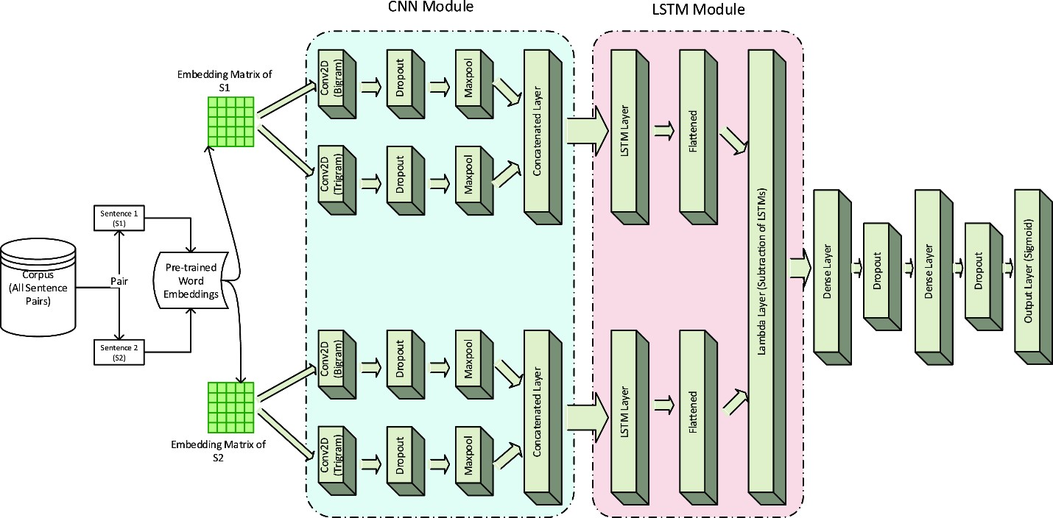
Figure 1 Hybrid Architecture using DNN Approach

2.1.3 Urdu Sentential Paraphrases (USP) Corpus and Paraphrase Detection Techniques
Paraphrase detection systems classify the sentences of the text into paraphrased or non-paraphrased on whether they give the same interpretation. Even though immense work has been done in the English language, such kind of significant research gaps in South Asian languages, including Urdu, are there. This work bridges that gap by making the large-scale manually annotated benchmark dataset-USP Corpus with 4,900 sentences of both paraphrased (2,941) and non-paraphrased sentences (1,959), collected from Urdu newspapers. This work also discusses the different techniques for paraphrase detection, such as Word Embedding (WE), Sentence Transformers (ST), and feature-fusion approaches with N-grams as baseline. Their experimental results prove that feature-fusion techniques combining the proposed ST with baseline N-gram features yield the best results at F1 = 0.855 [5]. Their Architecture:
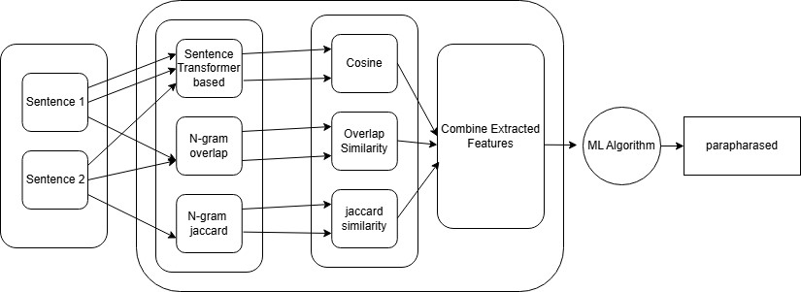
Figure 2 USP Architecture

2.1.4 Urdu Short Text Reuse Detection and Corpus Development
Text reuse is the act of taking over text, either word-to-word or word-to-many-words. This article proposes the Urdu Short Text Reuse Corpus (USTRC), which has 2,684 short text pairs labelled manually as verbatim (496), paraphrased (1,329), and independently written (859). The corpus was tested in binary class and multiclass classification with the help of various state-of-the-art algorithms. Results teach that character n-gram overlaps with the J48 classifier do well for Urdu text reuse detection [6].
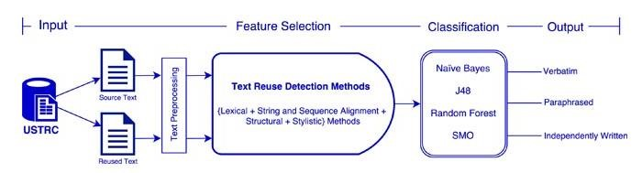
Figure 3 Short Text Reuse Detection Architecture

2.1.5 Architecture Comparison
Table 1 Comparison of Architectures
Study | Corpus | Categories | Methodology | Key Findings | Architecture
COUNTER  Corpus | Urdu Text  Reuse  Detection | Partially  Derived,  Wholly  Derived, NonDerived | Annotated dataset for text reuse  detection | Helps Urdu NLP research, a crucial resource for text  reuse tasks | -
Novel DNN Approaches for Urdu  Paraphrase  Detection | Urdu  Paraphrase  Corpus (3,147 pairs) | Paraphrased,  nonparaphrased | Semi-automatic pipeline, DNN  approaches  (WENGO, D-  TRAPPD) | D-TRAPPD outperforms  WENGO and state-  of-the-art methods | WENGO  , D-TRAPPD
USP  Corpus  Paraphrase  Detection  Techniques | Urdu  Sentential  Paraphrases (4,900 sentences) | Paraphrased,  nonparaphrased | Feature-fusion techniques combining ST and  N-grams | Best performance with feature-fusion techniques | ST + N-gram features
Urdu Short  Text Reuse  Detection  & Corpus | Urdu Short  Text Reuse  Corpus (2,684 pairs) | Verbatim,  Paraphrased,  Independently  Written | Character n-gram overlap integrated with the J48 decision tree  classifier | Character n-gram overlap with J48 classifier yields good results | J48 classifier, Character  n-gram overlap

2.2 Stakeholders list

2.2.1 System Admin
The user who manages and look after the operation, security, and maintenance of the paraphrase detection tool.

2.2.2 End-Users
Individuals who use the application for Urdu text reuse detection, including students, teachers, writers, and organizations.
- Student/Teacher
- Writer/Author
- Organization (which are getting API from us)

2.3 Requirements elicitation

2.3.1 FR-01 Login
Table 2 FR-01 Login
ID | Description
FR01-01 | The system shall allow authorized users to log into their accounts for access.
FR01-02 | The authorized user shall input their email and password on the login page.
FR01-03 | The system shall validate the authorized user's email and password against the database records.
FR01-04 | The system shall display an error message if login fails; otherwise, it shall log in the user and redirect to the home page.
FR01-05 | The system shall log all login attempts, including timestamps and IP addresses.

2.3.2 FR-02 Create Account
Table 3 FR-02 Create Account
ID | Description
FR02-01 | The system shall allow users to access the account creation page from login interface if user is not logged in.
FR02-02 | The system shall provide input fields for the user's name, phone number, email, password, and date of birth.
FR02-03 | The system shall validate that the phone number is in a valid format and does not already exist in the system.
FR02-04 | The system shall validate that the email address is in a proper format and is not already registered.
FR02-05 | The system shall ensure passwords are at least 8 characters long and include uppercase and lowercase letters, digits, and special characters
FR02-06 | The system should output clear error messages when input fields are invalid or incomplete.
FR02-07 | The system will send a verification email to the user's email address once the account is successfully created.
FR02-08 | The system shall log all account creation attempts, including timestamps and IP addresses.

2.3.3 FR-03 Forgot Password
Table 4 FR-03 Forgot Password
ID | Description
FR03-01 | The system will allow users to initiate a password reset process by choosing the "Forgot Password" option on the login interface.
FR03-02 | The system shall prompt users to input their registered email address to request a password reset.
FR03-03 | The system will generate and send a One-Time Password (OTP) to the user's email address when requested.
FR03-04 | The system shall prompt users to enter the received OTP for verification.
FR03-05 | The system shall verify the entered OTP against the one sent to the user's email address.
FR03-06 | After successful OTP verification, the system will enable a user to set a new password and confirm it by providing it twice.
FR03-07 | The system shall validate that the new password is different from the old password.
FR03-08 | The system shall allow users to resend the OTP after a 60-second cooldown period to prevent recalls.

2.3.4 FR-04 Change Password
Table 5 FR-04 Change Password
ID | Description
FR04-01 | The system shall allow users only to access the change password feature if they are logged onto the system.
FR04-02 | The system shall require users to verify their current password before allowing them to set a new password.
FR04-03 | The system shall provide input fields for the new password and confirm password during the password change process.
FR04-04 | The system shall ensure that the new password is different from the current (old) password.
FR04-05 | The system shall require the new passwords to meet the complexity criteria, such as being at least 8 characters long and containing uppercase letters, lowercase letters, digits, and special characters.
FR04-06 | The system shall display appropriate error messages if the current password is not correct or if the new password is not according to the complexity requirements.
FR04-07 | The system shall remove all the session of user on password change
FR04-08 | The system shall log all password change attempts, including timestamps and user identifiers.

2.3.5 FR-05 Profile Management
Table 6 FR-05 Profile Management
ID | Description
FR05-01 | The system will enable a user to view his/her profile information such as name, email, phone number, and profile picture.
FR05-02 | The system shall allow users to update their phone number.
FR05-03 | The system shall allow users to change their profile picture by uploading a new image.
FR05-04 | The system shall notify users via email upon successful changes to their profile information.
FR05-05 | The system shall log all profile management activities, including updates and changes, with timestamps and user identifiers.
FR05-06 | The system shall enforce authentication, allowing users to manage their profiles only when they are logged in.

2.3.6 FR-06 API Services
Table 7 FR-06 API Services
ID | Description
FR06 | The system shall provide API services to other platforms (e.g., blog websites, teachers) to identify text reuse.

2.3.7 FR-07 Rate Limiting and Throttling
Table 8 FR-07 Rate Limiting and Throttling
ID | Description
FR07 | The system shall implement rate limiting that restricts the number of API calls per user within a specified time frame.

2.3.8 FR-08 Authorization for API
Table 9 FR-08 Authorization for API
ID | Description
FR08 | The system shall require API users to authenticate using provided API keys.

2.3.9 FR-09 API Logging
Table 10 FR-09 API Logging
ID | Description
FR09 | The system shall log all API requests, responses, and user activities, ensuring traceability for each request made by the user.

2.3.10 FR-10 User History
Table 11 FR-10 User History
ID | Description
FR10 | The system shall track and save user history, including API calls and actions performed via the API.

2.3.11 FR-11 API Key
Table 12 FR-11 API Key
ID | Description
FR11-01 | The system shall allow the users to generate or regenerate their API keys for security purposes.
FR11-02 | The system shall allow the users to create multiple API keys for different applications or teams, with shared quotas.
FR11-03 | The system shall allow the users to download their API keys in CSV or PDF format for backup and documentation purposes.

2.3.12 FR-12 API Monitoring
Table 13 FR-12 API Monitoring
ID | Description
FR12-01 | The system shall provide users with detailed usage analytics, including total API calls, remaining quota, accessible through their dashboard, displaying current consumption relative to their package quota.
FR12-02 | The system shall automatically suspend API service for users who exceed their quota notifying them by using email.

2.3.13 FR-13 Text Reuse Detection
Table 14 FR-13 Text Reuse Detection
ID | Description
FR13-01 | The system shall allow users to input two separate Urdu paragraphs for comparison.
FR13-02 | The system shall process the two texts to identify reused content using proposed AI Models (e.g., Sentence Transformer).
FR13-03 | The system shall calculate the percentage of content reused between the two texts.
FR13-04 | The system shall classify the degree of text reuse into predefined categories (e.g., PD, WD, ND).
FR13-05 | The system shall allow users to upload images containing text or use a mobile device's camera to capture images, or upload images directly for OCR extraction.
FR13-06 | The system shall display the extracted text to the user for review and allow editing before proceeding to text reuse detection.
FR13-07 | The system shall allow users to upload two or more documents for text reuse detection.
FR13-08 | The system shall generate a comprehensive report detailing the findings of the documentbased text reuse detection, including reuse percentages and sources. allow users to download

2.3.14 FR-14 Plagiarism Detection
Table 15 FR-14 Plagiarism Detection
ID | Description
FR14-01 | The system shall allow users to upload files containing text for plagiarism checking.
FR14-02 | The system shall process the entered or extracted text to identify potential plagiarism by comparing it against online sources using search engines and databases.
FR14-03 | The system shall calculate the percentage of text that matches external sources to determine the level of plagiarism.
FR14-04 | The system shall identify and retrieve the URLs or sources from where the content is potentially copied.
FR14-05 | The system shall generate a comprehensive plagiarism report that includes the percentage of matched content and the corresponding source URLs.
FR14-06 | The system shall provide an option for users to download the plagiarism report in formats such as PDF

2.3.15 FR-15 Contact
Table 16 FR-15 Contact
ID | Description
FR15-01 | The system shall allow the users to create and submit queries or complaints via a contact form.
FR15-02 | The system shall allow the users to select a message category (e.g., billing, technical support, general) for their query.
FR15-03 | The system shall allow the users to view their submitted queries/complaints and the corresponding admin responses.
FR15-04 | The system shall allow the users to track the status of their queries (e.g., pending, responded, resolved).
FR15-05 | The system shall send email notifications to users whenever the status of their contact form query is updated.

2.3.16 FR-16 Notifications
Table 17 FR-16 Notifications
ID | Description
FR16-01 | The system shall notify users about important events, actions and task such as exceeding their API Limit, account creation, Completion of task via email.
FR16-02 | The system shall allow admins to send notifications to users.

2.3.17 FR-17 Admin Dashboard
Table 18 FR-17 Admin Dashboard
ID | Description
FR17 | The system shall provide an admin dashboard accessible only to admin users. Users must log in the dashboard, which shows details (e.g., total users, API usage, recent activities, Logs).

2.3.18 FR-18 System Management
Table 19 FR-18 System Management
ID | Description
FR18 | The system shall allow admins, to view, create, update, system users, complains, queries and other task accessible through admin dashboard.

2.3.19 FR-19 Report Generation
Table 20 FR-19 Report Generation
ID | Description
FR19-01 | The system shall allow admins to generate various. Reports may be filtered by date range, user, or activity type. Reports shall be exportable in common formats (e.g., CSV, PDF).
FR19-02 | The system shall generate detailed reports for API usage, including the most-used endpoints and peak usage times.

2.3.20 FR-20 Analytics
Table 21 FR-20 Analytics
ID | Description
FR20-01 | The system shall provide users with usage analytics, including token usage, remaining quota, and document history.
FR20-02 | The system shall provide admins with insights, user activity, and service usage.

2.3.21 NFR-01 Performance
Table 22 NFR-01 Performance
ID | Description
NFR01-01 | The system shall respond to user interactions (e.g., login, account creation, API requests) within 10 seconds under normal operating conditions.
NFR01-02 | The system must be able to accommodate 25 concurrent users without affecting its performance.
NFR01-03 | The system shall ensure that API responses have a maximum latency of 15 seconds to maintain real-time interactions.

2.3.22 NFR-02 Scalability
Table 23 NFR-02 Scalability
ID | Description
NFR02-01 | The system architecture shall have ability to scale to accommodate increased load and user base growth.
NFR02-02 | The system shall automatically allocate and deallocate resources based on real-time demand to optimize performance and cost.

2.3.23 NFR-03 Usability
Table 24 NFR-03 Usability
ID | Description
NFR03-01 | The system shall provide an perceptive and user-friendly interface that minimize the new learning for new users.

2.3.24 NFR-04 Availability
Table 25 NFR-04 Availability
ID | Description
NFR04-01 | The system shall maintain an uptime of 99%, ensuring high availability for users.
NFR04-02 | The system shall report failure to admin that results in minimize downtime and ensure continuous service availability.

2.3.25 NFR-05 Security
Table 26 NFR-05 Security
ID | Description
NFR05-01 | The system should implement robust authentication methods and role-based access control to guarantee authorized access.
NFR05-02 | All sensitive data, including user passwords and API keys, shall be encrypted.
NFR05-03 | The system shall maintain comprehensive logs for all operations (e.g., login attempts, password changes, API usage) with secure storage.
NFR05-04 | The system shall be safeguarded against common security vulnerabilities like SQL injection, Cross-Site Scripting (XSS), and Cross-Site Request Forgery (CSRF).

2.3.26 NFR-06 Maintenance
Table 27 NFR-06 Maintenance
ID | Description
NFR06-01 | The system shall follow a modular architecture to facilitate easier updates, maintenance, and scalability.
NFR06-02 | Detailed documentation for users and developers shall be available, in the form of API documentation and system architecture diagrams.
NFR06-03 | The system’s codebase shall follow industry-standard coding practices and be subject to regular code reviews to ensure high quality and maintainability.

2.3.27 NFR-07 Robustness
Table 28 NFR-07 Robustness
ID | Description
NFR07-01 | The system shall be designed to handle failures gracefully, with automatic failover mechanisms in place to maintain service continuity.
NFR07-02 | The system shall implement comprehensive error handling strategies to manage unexpected issues without compromising user experience or data integrity.

2.3.28 NFR-08 Backup and Recovery
Table 29 NFR-08 Backup and Recovery
ID | Description
NFR08-01 | The system shall perform backups(monthly) of all critical data.
NFR08-02 | The system shall have a disaster recovery plan that guarantees service restoration within 4 hours after a major failure.
NFR08-03 | The system shall regularly test data recovery processes to ensure reliability and effectiveness in restoring data after a loss event.

2.3.29 NFR-09 Monitoring & logging
Table 30 NFR-09 Monitoring & logging
ID | Description
NFR09-01 | The system shall log all the action performed by adding time stamp and user id(if user is logged in).
NFR09-02 | The system shall check security of failed login attempts or unauthorized access should be properly logged and checked.

2.3.30 NFR-10 Interoperability
Table 31 NFR-10 Interoperability
ID | Description
NFR10-01 | The system must ensure that all web pages, UI components, and functionality are displayed and work correctly across these browsers.
NFR10-02 | The application must be responsive and provide a consistent experience across all major mobile and tablet devices

2.4 Requirements traceability matric (RTM)
Table 32 Requirement Traceability Matrix
Require ment ID | Module | Requirement  Description | Module | Implementati on | Test  Case  ID | Test  Status
FR-01 | Authentication | Login  functionality for users | Auth  Module | Login API | TC01 | Passed
FR-02 | Authentication | Create new user accounts | Auth  Module | Create  Account API | TC02 | Passed
FR-03 | Authentication | Forgot Password feature | Auth  Module | Forgot  Password API | TC03 | Passed
FR-04 | Authentication | Change  Password functionality | Auth  Module | Change  Password API | TC04 | Passed
FR-05 | Profile  Management | Manage user  profiles | Profile  Module | Update Profile  API | TC05 | Passed
FR-06 | API Services | Provide various  API services | API  Services  Module | API Services Implementatio  n | TC06 | Passed
FR-07 | API Services | Implement rate limiting and throttling for  APIs | API  Services  Module | Rate Limiting & Throttling | TC07 | Passed
FR-08 | API Services | Authorization mechanisms for  APIs | API  Services  Module | API  Authorization | TC08 | Passed
FR-09 | API Services | Logging for all API interactions | API  Services  Module | API Logging Implementatio  n | TC09 | Passed
FR-10 | User Management | Track and display user  history | User  Managem | User History  API | TC10 | Passed

ent
Module
FR-11 | API Services | Manage API  keys for users | API  Services  Module | API Key  Management  API | TC11 | Passed
FR-12 | API Services | Monitor API performance and usage | API  Services  Module | API  Monitoring  API | TC12 | Passed
FR-13 | Text Analysis | Detect text reuse within documents | Text  Analysis  Module | Text Reuse  Detection  Module | TC13 | Passed
FR-14 | Plagiarism  Detection | Detect plagiarism in user submissions | Plagiaris m Module | Plagiarism  Detection  Module | TC14 | Passed
FR-15 | Communication | Provide a contact form for user queries | Communi  cation Module | Contact Form Implementatio  n | TC15 | Passed
FR-16 | Notifications | Send  notifications to users | Notificati ons  Module | Notifications  Service | TC16 | Passed
FR-17 | Admin Dashboard | Provide an  admin dashboard for system management | Admin  Module | Admin  Dashboard Implementatio  n | TC17 | Passed
FR-18 | System  Management | Manage system settings and  configurations | System Managem  ent  Module | System  Management  API | TC18 | Passed
FR-19 | Reporting | Generate various system reports | Reporting  Module | Report  Generation  API | TC19 | Passed
FR-20 | Analytics | Provide analytics and | Analytics Module | Analytics API | TC20 | Passed
 |  | insights based on system data

2.5 Use case descriptions

2.5.1 Login
Table 33 UC-01 Login
Use case ID 01 Use case Name: Login
Priority High
Actors: End-User (Student/Teacher, Writer/Author, Organization), Admin
Use Case Summary | Allows all registered users, including admins, to log into the system by providing valid email and password credentials. If a user fails to log in after multiple attempts, the system suggests using the forgot password feature.
Pre-condition: | - No user is currently logged into the system.  - User must have a registered account with a valid email and password.
Normal Flow of Events |  |  | Alternative Path
1.User navigates to the login page. |  |  | 1a. If user is logged in already, then system redirect to home page.
2. User input their email and password in the input fields respectively.
3. User submits the login form by pressing submit button.
4. System validates the email format and process for credentials verification against the database. |  |  | 4a In case the user forgets its password, he/she can click the "Forgot Password" link to start the forgot password step.
5. The system authenticates the user if the given credentials are valid, then shows a success message and redirects to the homepage. |  |  | 5a. If credentials are invalid, the system displays an error message indicating login failure and highlighting the error fields with appropriate message .
6. System logs the successful login attempt with a timestamp and IP address.
Exceptions / Alerts
None
Post Conditions
Step# |  |  | Description
1- Successful Login |  |  | User (including admins) is authenticated, logged into the system, and redirected to the home page.
2- Failed Login |  |  | User gets an error message and is not allowed to leave the login page. If there are several failed attempts, then the user is asked to reset the password.
Use Case Cross References
Includes |  | Validate Input Data, logging table
Extends |  | Display Error Message, Forgot Password

2.5.2 Create Account
Table 34 UC-02 Create Account
Use case ID 02 Use case Name: Create Account
Priority High
Actors: End-User (Student/Teacher, Writer/Author, Organization)
Use Case Summary | Enables new users to create an account by giving necessary personal information, validate input, verify email using, and ensuring that the email and phone number are unique in the system.
Pre-condition: | - User is not currently signed in into the system.  - User does not have an existing account associated with the provided email or phone number.
Normal Flow of Events |  | Alternative Path

1. User accesses the account creation page from the login interface or from home.
2. User inputs their name, email, password, date of birth, phone number, and selects user type. |  | 2a. If email or phone number already exists, system displays an error message indicating duplication by highlighting the specific input field with red border.
3. System validates the input fields for correct format email and phone number.
4. If email and phone number are valid and unique, system generates a 6-digit OTP and sends it to user's given email address.
5. User will get the OTP via email.
6. User inputs the received OTP in the verification field.
7. System validates the entered OTP.
8. If OTP is valid, the system creates user account and redirects user to the login page. |  | 8a. If OTP is invalid, system outputs an error message and allows user to retry.
9. User can also request new OTP after 60 seconds.
9. System logs the account creation attempt with timestamp and IP address.
Exceptions / Alerts
- If the email fails to send, system notifies the user and prompts to retry the account creation process.
- If the user requests to resend the OTP, system sends a new OTP after a 60-second cooldown period.
Post Conditions
Step# |  | Description
1- Successful Account Creation |  | User's account is created, and user is redirected to login page.
2- Failed Account Creation |  | User receives appropriate error messages and remains on the account creation page to correct inputs or retry OTP verification.
Use Case Cross References
Includes | Send Email, OTP Verification
Extends | Resend OTP

2.5.3 Forgot Password
Table 35 UC-03 Forgot Password
Use case ID 03 Use case Name: Forgot Password
Priority Medium
Actors: End-User (Student/Teacher, Writer/Author, Organization), System
Use Case Summary | Allows registered users who are not currently logged in to reset their password by verifying their identity through a One-Time Password (OTP) sent to their registered email address.
Pre-condition: | - User is currently not logged into the system.  - User must have a registered account with a valid email address in the system.
Normal Flow of Events |  | Alternative Path
1. The user selects the "Forgot Password" option on the login screen.
2. User inputs their registered email address.
3. System validates the email format and checks if it exists in the database.

4. If the email is correct and exists, system will generate a 6-digit OTP.
5. System sends the OTP code to the user's registered email address.
6. User receives the OTP via email.
7. User inputs the received OTP into the verification field.
8. System verifies the entered OTP against the one sent to the email.
9. Once the OTP is verified, the system asks the user to input a new password and enter it again for confirmation.
10. The System verify the new password for complexity and ensures it is different from the old password.
11. System updates the user's password in the database.
12. System logs the password reset attempt with timestamp and IP address.
13. The system successfully redirects the user to the login page with a success message.
Exceptions / Alerts
User can request new OTP after 60 seconds of generation of old OTP.
Post Conditions
Step# |  | Description
Successful Password Reset |  | The user's password is updated successfully in the system, and the user is sent to the login page.
Failed Password Reset |  | User receives appropriate error messages and remains on the password reset page to correct inputs or retry OTP verification.
Use Case Cross References
Includes | OTP Generation and Sending, Password Validation
Extends | Resend OTP

2.5.4 Change Password
Table 36 UC-04 Change Password
Use case ID 04 Use case Name: Change Password
Priority Medium
Actors: End-User (Student/Teacher, Writer/Author, Organization), System
Use Case Summary | Allows authenticated users to change their current password by verifying their existing password and ensuring the new password meets complexity requirements and is different from the old password.
Pre-condition: | - The user must be logged into the system.  - The user must know their current password.
Normal Flow of Events |  |  | Alternative Path
1. User navigates to the profile to change password and select change password.
2. The user input their current password.
3. User input the new password and confirm password.
4. System verifies the current password. |  |  | 4a. If the user enter the an invalid current password system delivers a message of error.
5. System validates the new password for complexity and ensures it is different from the old password. |  |  | 5a. If the new password doesn’t meet the complexity requirements, the system outputs an appropriate error message and highlight the input field.
6. System will update the password in the database.
7. System logs the password change attempt with timestamp and user identifier.
8. System removes all active user sessions.
9. System notifies the user of the successful password change.
Exceptions / Alerts
None
Post Conditions
Step# |  |  | Description
Successful Password Change |  |  | User's password is updated, all sessions are terminated, and the user is notified.
Failed Password Change |  |  | User remains on the change password page with error messages prompting corrective actions.
Use Case Cross References
Includes |  | Password Complexity Enforcement, Session Termination
Extends |  | Password History Check

2.5.5 Profile Management
Table 37 UC-05 Profile Management
Use case ID 05 Use case Name: Profile Management
Priority Medium
Actors: End-User (Student/Teacher, Writer/Author, Organization), System

Use Case Summary | Enables users to view and update their profile information, including personal details and profile picture, while ensuring that changes are authenticated and logged.
Pre-condition: | - User must be logged into the system.  - User has an existing profile with updatable fields.
Normal Flow of Events |  |  | Alternative Path
1. The user proceeds to the profile management section.
2. The system outputs the current profile information.
3. User click on to update button to update information. (e.g., phone number, profile picture).
4. User inputs the new information. |  |  | 4a. If the current password is incorrect, system displays an error message.
5. System validates the input fields. |  |  | 5a. If the input data is invalid, system displays appropriate error messages.
6. If validation passes, system updates the profile in the database. |  |  | 6a. If the user cancels the update, system retains the existing profile information.
7. System sends a notification email about the successful update.
8. System logs the profile management activity with timestamp and user identifier.
Exceptions / Alerts
None
Post Conditions
Step# |  |  | Description
Successful Update |  |  | User's profile information is updated, and a notification is sent.
Failed Update |  |  | User remains on the change password page with error messages prompting corrective actions.
Use Case Cross References
Includes |  | Email Notification, Input Validation
Extends |  | Upload Profile picture

2.5.6 API Services
Table 38 UC-06 API Services
Use case ID 06 Use case Name: API Services
Priority Low
Actors: API Users, System
Use Case Summary | Provides API services to external platforms, enabling them to identify text reuse and plagiarism in Urdu documents by sending requests and receiving processed results.
Pre-condition: | - External platform must have a valid API key.  - External platform must comply with rate limiting policies.  - User has access to the API documentation.
Normal Flow of Events |  |  | Alternative Path
1. External platform sends a request to the API with the necessary data (e.g., text documents).
2. System authenticates the API key. |  |  | 2a. If the API key is invalid, system returns an authentication error.
3. System processes the request using AI models to detect text reuse.
4. System returns the results to the external platform. |  |  | 4a. If the request exceeds rate limits, system throttles the request and returns a rate limit exceeded error.
5. System logs the API request and response with timestamp and user identifier.
6. If validation passes, system updates the profile in the database.
7. System sends a notification email about the successful update.
8. System logs the profile management activity with timestamp and user identifier.
Exceptions / Alerts
If the request data is malformed, system returns a validation error.
Post Conditions
Step# |  |  | Description
Successful Request |  |  | External platform receives processed results indicating text reuse and plagiarism detection.
Failed Request |  |  | External platform receives appropriate error messages indicating the reason for failure.
Use Case Cross References
Includes |  | Authorization for API, API Logging
Extends |  | Rate Limiting and Throttling

2.5.7 Rate Limiting for API
Table 39 UC-07 Rate Limiting for API
Use case ID 07 Use case Name: Rate Limiting for API
Priority Medium
Actors: API Users, System
Use Case Summary | Implement the rate limiting to restrain the number of API calls from a single user within the specified time frame to restrict abuse and ensure fair utilization of the API resources.
Pre-condition: | - API user must have a valid API key.  - API user is making requests to the API services.
Normal Flow of Events |  |  | Alternative Path
1. API user sends a request to the API.
2. System checks the number of requests made by the user in the current time frame. |  |  | 2a. If the user is nearing the rate limit, system may send a warning notification.
3. If the user is within the limit, system processes the request.
4. If the user exceeds the limit, system throttles the request and returns a rate limit exceeded error. |  |  | 4a. If the user requests to exceed the rate limit (if permitted), system evaluates and grants access based on predefined policies.
5. System logs the rate limiting event with timestamp and user identifier.
Exceptions / Alerts
None
Post Conditions
Step# |  |  | Description
Within Limit |  |  | API request is processed successfully.
Exceeded Limit |  |  | API request is throttled, and the user receives a rate limit exceeded error message.
Use Case Cross References
Includes |  | Logging Rate Limits, Notification of Nearing Limits
Extends |  | Dynamic Rate Limiting

2.5.8 Authorization for API
Table 40 UC-08 Authorization for API
Use case ID 08 Use case Name: Authorization for API
Priority Medium
Actors: API Users, System
Use Case Summary | Requires API users to authenticate using provided API keys to securely access API services, confirming that access is available only to authorized users can utilize the API functionalities.
Pre-condition: | - API user must possess a valid API key.  - API user is making a request to the API services.
Normal Flow of Events |  |  | Alternative Path
1. API user includes their API key in the request headers or parameters.
2. System retrieves and verifies the API key.
3. If the API key is valid, system grants access to the requested API service. |  |  | 3a. If the API key is invalid or expired, system denies access and returns an authentication error.
4. System processes the request and returns the appropriate response to the API user. |  |  | 4a. If the API key has insufficient permissions for the requested service, system returns an authorization error.
5. System logs the authorization attempt with timestamp and user identifier.
Exceptions / Alerts
If the API key is missing from the request, system returns an authentication error.
Post Conditions
Step# |  |  | Description
Authorized Access |  |  | API user gains access to the requested service.
Unauthorized Access |  |  | API user is denied access and receives an error message indicating the reason for denial.
Use Case Cross References
Includes |  | API Logging, Permission Checks
Extends |  | API Key Revocation

2.5.9 API Logging
Table 41 UC-09 API Logging
Use case ID 09 Use case Name: API Logging
Priority Medium
Actors: API Users, System, Admin
Use Case Summary | Logs all API requests, responses, and user activities to ensure traceability, accountability, and security for each interaction with the API services.
Pre-condition: | - API users must have access to the API services.  - System must have logging capabilities enabled.
Normal Flow of Events |  |  | Alternative Path
1. API user sends a request to the API.
2. System processes the request and generates a response. |  |  | 2a. If logging fails (e.g., due to storage issues), system alerts the admin and retries logging.
3. System logs the request details, including timestamp, API key, request parameters, and response status. |  |  | 3a. If sensitive information is included in the logs, system ensures data masking or encryption to protect user privacy.
4. System stores the log securely to prevent tampering.
5. Admin can access and review the logs through the admin dashboard.
Exceptions / Alerts
If the logging service is unavailable, system queues the logs and attempts to log them once the service is restored.
Post Conditions
Step# |  |  | Description
API Integration |  |  | All API interactions are recorded and stored for auditing and monitoring purposes.
Admin Access |  |  | Admins have access to detailed logs for analysis and troubleshooting.
Use Case Cross References
Includes |  | Log Retrieval, Secure Storage of Logs
Extends |  | Log Analysis

2.5.10 User History
Table 42 UC-10 User History
Use case ID 10 Use case Name: User History
Priority Medium
Actors: End-User (Student/Teacher, Writer/Author, Organization), System
Use Case Summary | Tracks and saves user history, including API calls and actions performed via the API, allowing users to review their past activities and providing admins with insights for monitoring and analysis.
Pre-condition: | - User must be authenticated and logged into the system.  - System must have tracking capabilities enabled.
Normal Flow of Events |  |  | Alternative Path
1. User performs an action or makes an API call.
2. System records the action details, including timestamp, action type, and parameters.
3. System stores the history in the user's profile.
4. User can access their history through their dashboard. |  |  | 4a. If the user requests to clear their history, system deletes the relevant records after confirmation.  4b. If the user has extensive history, system provides filtering and search options for easier navigation.
5. System logs the history tracking event.
Exceptions / Alerts
If the system fails to record an action, it notifies the user and retries logging the action.
Post Conditions
Step# |  |  | Description
Successful Tracking |  |  | User's actions and API calls are recorded and accessible for review.
Failed Tracking |  |  | User is informed of the unsuccessful tracking attempt and can retry or report the issue.
Use Case Cross References
Includes |  | Action Logging, History Retrieval
Extends |  | Advanced Analytics, Privacy Controls

2.5.11 API Key Management
Table 43 UC-11 API Key Management
Use case ID 11 Use case Name: API Key Management
Priority Medium
Actors: API Users, System

Use Case Summary | Allows users to generate, regenerate, and manage their API keys for secure access to API services, including the ability to create multiple keys for different applications or teams and download them for backup and documentation.
Pre-condition: | - User must be logged into the system.  - User has the necessary permissions to manage API keys.
Normal Flow of Events |  |  | Alternative Path
1. User navigates to the API key management section.
2. User chooses to generate a new API key.
3. System generates a unique API key.
4. User can create multiple API keys for different applications or teams. |  |  | 3a. If the user attempts to generate more API keys than allowed, system outputs an error message.  4b. If the user requests to regenerate an existing API key, system invalidates the old key and generates a new one.
5. User can download their API keys in CSV or PDF format for backup and documentation purposes.
6. System logs the API key generation/regeneration event with timestamp and user identifier.
Exceptions / Alerts
- If the download fails, the system outputs the user and prompts to retry.
- If the API key generation service is unavailable, system alerts the user and suggests alternative actions.
Post Conditions
Step# |  |  | Description
Successful API Key Management |  |  | User successfully generates, regenerates, and downloads API keys.
Failed API Key Management |  |  | User receives error messages and can retry the actions as necessary.
Use Case Cross References
Includes |  | API Logging, Permission Checks
Extends |  | API Key Revocation, Usage Quotas

2.5.12 API Monitoring
Table 44 UC-12 API Monitoring
Use case ID 12 Use case Name: API Monitoring
Priority Medium
Actors: Admin , API Users
Use Case Summary | Provides users with detailed usage analytics, including total API calls and remaining quota, and allows admins to monitor API usage, identify peak usage times, and manage API services based on usage patterns.
Pre-condition: | - User must have an active account with API access.  - Admin must have access to monitoring tools and dashboards.  - Admin and User must be login.
Normal Flow of Events |  |  | Alternative Path
1. User accesses the API monitoring dashboard.
2. System displays usage analytics, including total API calls, remaining quota.
3. Admin accesses the dashboard and select user to monitor.
4. System displays detailed API usage statistics, including the most-used endpoints and peak usage times. |  |  | 3a. If the user has exceeded their quota but requests an extension, admin can review and adjust quotas as necessary.
5. Admin reviews the analytics to identify trends and potential issues.
6. If a user exceeds their quota, system automatically suspends their API service and sends an email notification.
7. System logs all monitoring activities with timestamps and user identifiers.
Exceptions / Alerts
If the monitoring service fails, system alerts the admin and attempts to restore monitoring capabilities.
Post Conditions
Step# |  |  | Description
User Analytics Accessed |  |  | Users can view their API usage statistics.
Admin Insights |  |  | Admins have access to comprehensive analytics for monitoring and managing API services.
Quota Enforcement |  |  | Users exceeding their quotas are notified and restricted from further API access until resolved.
Use Case Cross References
Includes |  | Email Notification for Quota Exceeding, Logging Monitoring Activities
Extends |  | Automated Alerts, Customize Dashboards

2.5.13 Reuse Detection
Table 45 UC-13 Reuse Detection
Use case ID 13 Use case Name: Reuse Detection
Priority High
Actors: End-User (Student/Teacher, Writer/Author, Organization), System,

Use Case Summary | Enables users to detect text reuse in Urdu by inputting paragraphs manually or uploading documents/images, processing the texts using AI models to identify reused content, and generating comprehensive reports.
Pre-condition: | - User must be logged into the system.  - User has access to the reuse detection tool.  - System has the necessary AI models and OCR capabilities integrated.
Normal Flow of Events |  |  | Alternative Path
1. User navigates to the reuse detection tool.
2. User inputs two separate Urdu paragraphs manually or uploads images/documents containing text. |  |  | 2a. If the uploaded documents are in unsupported formats, system prompts the user to upload compatible formats.
3. If images are uploaded, system performs OCR to extract text. |  |  | 3a. If OCR fails to extract text from images, system notifies the user and suggests uploading clearer images.
4. System displays the extracted text for user review and allows editing.
5. User initiates the text reuse detection process.
6. System processes the texts using AI models (e.g., Sentence Transformer) to identify reused content.
7. System calculates the percentage of content reused between the two texts.
8. System classifies the reuse into predefined categories (PD, WD, ND).
9. System generates a comprehensive report detailing the findings, including reuse percentages and sources.
10. User can download the report in desired formats (e.g., PDF).
11. System logs the reuse detection activity with timestamp and user identifier.
Exceptions / Alerts
If the AI model fails to process the texts, system will output an error message and logs the failure for troubleshooting.
Post Conditions
Step# |  |  | Description
Successful Detection |  |  | User receives a detailed report on text reuse, including percentages and sources, and can download the report.
Failed Detection |  |  | User is informed of the failure and prompted to retry or correct inputs.
Use Case Cross References
Includes |  | OCR Processing, Report Generation
Extends |  | Multi-Document Detection, Editing Extracted Text

2.5.14 Plagiarism Detection
Table 46 UC-14 Plagiarism Detection
Use case ID 14 Use case Name: Plagiarism Detection
Priority High
Actors: End-User (Student/Teacher, Writer/Author, Organization), System,
Use Case Summary | Allows users to upload text files for plagiarism by comparing the content against online sources using search engines and databases, calculating the percentage of matched content, identifying source URLs, and generating downloadable reports.
Pre-condition: | - User must be signed in into the system.  - User has access to the plagiarism detection tool.  - System has access to online search engines and databases for comparison.

Normal Flow of Events |  | Alternative Path
1. User navigates to the plagiarism detection tool.
2. User uploads a text file containing Urdu content. |  | 2a. If the format of uploaded files is unsupported, system prompts the user to upload a compatible format.
3. System extracts the text from the uploaded file.
4. System processes the extracted text by comparing it against online sources using search engines and databases. |  | 4a. If no matches are found, system informs the user that no plagiarism was detected.
5. System calculates the percentage of text that matches external sources to determine the level of plagiarism.
6. System identifies and retrieves the URLs or sources from where the content is potentially copied.
7. System generates a comprehensive plagiarism report that includes the percentage of matched content and corresponding source URLs.
8. User can download the plagiarism report in formats such as PDF.
9. System logs the plagiarism detection activity with timestamp and user identifier.
Exceptions / Alerts
If the comparison process fails because of network issues, system notifies the user and logs the failure for troubleshooting.
Post Conditions
Step# |  | Description
Successful Detection |  | User receives a plagiarism report indicating matched content percentages and source URLs, and can download the report.
Failed Detection |  | User is informed of the failure and prompted to retry or correct inputs.
Use Case Cross References
Includes | Text Extraction, Report Generation
Extends | Source URL, Bulk Upload

2.5.15 Contact From

Table 47 UC-15 Contact From
Use case ID 15 Use case Name: Contact Form
Priority Low
Actors: Unregistered User, End-User (Student/Teacher, Writer/Author, Organization), System, Admin
Use Case Summary | Enables users to create and submit queries or complaints via a contact form, categorize their messages, view submitted queries and admin responses, track the status of their queries, and receive email notifications upon status updates.
Pre-condition: | - User must be logged into the system (optional based on design).  - User has access to the contact form tool.
Normal Flow of Events |  | Alternative Path
1. User navigates to the contact form.
2. User fills in the query or complaint details.
3. User selects a message category (e.g., billing, technical support, general). |  | 3a. If the user does not select a message category, system prompts the user to select one.
4. User submits the form. |  | 4a. If the user attempts to submit an incomplete form, system displays appropriate error messages.

5. System sends the query to the admin.
6. Admin reviews and responds to the query.
7. User can view their submitted queries and corresponding admin responses.
8. User can track the status of their queries (e.g., pending, responded, resolved).
9. System sends email notifications to users whenever the status of their contact form query is updated.
10. System logs the contact form activities with timestamps and user identifiers.
Exceptions / Alerts
- If the system fails to send the query to the admin, it notifies the user and logs the failure for troubleshooting.
- • If the admin is unavailable to respond immediately, system updates the query status accordingly.
Post Conditions
Step# |  | Description
Successful Submission |  | User's query is submitted, responded to by admin, and the status is updated and tracked.
Failed Submission |  | User receives error messages and remains on the contact form page to correct inputs or retry submission.
Use Case Cross References
Includes | Email Notifications, Status Tracking
Extends | Message Categorization, Admin Response Management

2.5.16 Notifications
Table 48 UC-16 Notifications
Use case ID 16 Use case Name: Notifications
Priority Low
Actors: End-User (Student/Teacher, Writer/Author, Organization), System, Admin
Use Case Summary | Sends notifications to users about important events, actions, and tasks (e.g., exceeding API limits, account creation, task completion) via email, and allows admins to send custom notifications to users.
Pre-condition: | - The user must be registered in the system.  - The admin must have permissions to send notifications.
Normal Flow of Events |  |  | Alternative Path
1. System identifies an important event or action (e.g., user exceeds API limit, account creation, task completion).
2. System generates a notification message. |  |  | 2a. If the user has opted out of certain notifications, system respects user preferences and does not send those notifications.
3. System sends an email notification to the user. |  |  | 3a. If the email fails to send, system retries and notifies the admin of the failure.
4. Admin can access the notification feature in the admin dashboard.
5. Admin creates and sends custom notifications to selected users.
6. Users receive and can view the notifications.
7. System logs all notification activities with timestamps and user identifiers.
Exceptions / Alerts
If the notification content is invalid or contains prohibited information, system rejects the notification and alerts the admin.
Post Conditions
Step# |  |  | Description
Successful Notification |  |  | Users receive timely and relevant notifications about important events and actions.
Failed Notification |  |  | Users are informed of the notification failure, and admins are alerted for troubleshooting.
Use Case Cross References
Includes |  | Email Sending, Notification Logging
Extends |  | Custom Admin Notifications, User Preferences Management

2.5.17 Admin Dashboard
Table 49 UC-17 Admin Dashboard
Use case ID 17 Use case Name: Admin Dashboard
Priority Medium
Actors: Admin, System
Use Case Summary | Provides admins with a centralized dashboard to monitor system metrics, user activities, API usage, recent activities, and access logs, enabling efficient management and oversight of the application.
Pre-condition: | - Admin must be logged into the system with appropriate administrative privileges.  - System must have dashboard capabilities enabled and populated with relevant data.
Normal Flow of Events |  | Alternative Path
1. Admin logs into the system.
2. Admin navigates to the admin dashboard section.

3. System displays various metrics such as total users, API usage statistics, recent user activities, and access logs. |  | 3a. If the admin requests specific data not displayed on the dashboard, system provides options to customize the dashboard or access detailed reports.  3b. If the dashboard fails to load data, system notifies the admin and logs the failure for troubleshooting.
4. Admin interacts with dashboard widgets to drill down into specific metrics or data points.
5. Admin can perform administrative tasks directly from the dashboard (e.g., managing users, viewing logs, generating reports).
6. System updates the dashboard in real-time as new data becomes available.
7. System logs all admin dashboard accesses and actions for security and auditing purposes.
Exceptions / Alerts
If the admin lacks necessary permissions for certain dashboard functionalities, system restricts access and displays an appropriate message.
Post Conditions
Step# |  | Description
Successful Dashboard Access |  | Admin has comprehensive visibility into system metrics and can perform necessary administrative tasks.
Failed Dashboard Access |  | Admin is informed of access issues and can attempt to resolve them or seek assistance.
Use Case Cross References
Includes | Real-Time Data Display, Log Management
Extends | Customizable Widgets, Data Exporting

2.5.18 System Management
Table 50 UC-18 System Management
Use case ID 18 Use case Name: System Management
Priority Medium
Actors: Admin, System
Use Case Summary | Allows admins to manage system users, handle complaints and queries, and perform other administrative tasks through the admin dashboard, ensuring smooth operation, security, and maintenance of the paraphrase detection tool.
Pre-condition: | - Admin must be logged into the system with appropriate administrative privileges.  - System must have user and task management capabilities enabled.
Normal Flow of Events |  |  | Alternative Path
1. Admin accesses the system management section from the admin dashboard.
2. Admin can view the list of system users, including their details and statuses.
3. Admin can create new user accounts or update existing ones. |  |  | 3a. If the admin encounters an issue while managing users or tasks, system provides troubleshooting options or error notifications.
4. Admin can delete or deactivate user accounts as necessary.
5. Admin can view and manage complaints and queries submitted by users.
6. Admin can assign, prioritize, and respond to user queries and complaints.
7. Admin can perform other administrative tasks such as configuring system settings, managing API keys, and monitoring system health. |  |  | 7a. If the admin attempts to perform an action without the necessary permissions, system displays an error message.
8. System logs all system management activities with timestamps and admin identifiers.
Exceptions / Alerts
If the system fails to update user information or handle a complaint, system notifies the admin and logs the failure for troubleshooting.
Post Conditions
Step# |  |  | Description
Successful System Management |  |  | Admin effectively manages users, complaints, queries, and system settings.
Failed System Management |  |  | Admin receives error messages and can retry or seek assistance to resolve issues.
Use Case Cross References
Includes |  | User Management, Complaint and Query Management
Extends |  | Bulk User Operations, Automated Task Assignments

2.5.19 Report Generation
Table 51 UC-19 Report Generation
Use case ID 19 Use case Name: Report Generation
Priority Medium
Actors: Admin, System
Use Case Summary | Enables admins to generate various reports filtered by date range, user, or activity type, and export them in common formats (e.g., CSV, PDF). Additionally, generates detailed reports for API usage, including the most-used endpoints and peak usage times.
Pre-condition: | - Admin must be logged into the system with appropriate administrative privileges.  - System must have reporting capabilities enabled and access to relevant data sources.

Normal Flow of Events |  | Alternative Path
1. The admin proceeds to the report generation section in the admin dashboard.
2. The admin selects the type of report to generate (e.g., user activity, API usage). |  | 2a. If the admin requests a report type that requires additional permissions, system prompts for necessary access.
3. Admin applies desired filters such as date range, specific users, or activity types. |  | 3a. If the selected filters return no data, system notifies the admin and suggests adjusting the filters.
4. The system retrieves, and the compiles relevant data based on the selected criteria.
5. The system will generate the report in the mentioned format (e.g., CSV, PDF).
6. Admin reviews the generated report.
7. Admin exports or downloads the report for external use.
8. System logs the report generation activity with timestamp and admin identifier.
Exceptions / Alerts
If the report generation process fails due to data retrieval issues, system notifies the admin and logs the failure for troubleshooting.
Post Conditions
Step# |  | Description
Successful Report Generation |  | Admin receives the generated report in the desired format and can use it for analysis, record-keeping, or decision-making.
Failed Report Generation |  | Admin is informed of the failure and can adjust filters or seek assistance.
Use Case Cross References
Includes | Data Filtering, Report Exporting
Extends | Automated Report Scheduling, Custom Report Templates

2.5.20 Analytics
Table 52 UC-20 Analytics
Use case ID 20 Use case Name: Analytics
Priority Medium
Actors: Admin, System
Use Case Summary | Provides Admin with usage analytics, including token usage, remaining quota, and offers insights into user activity and service usage to inform system improvements and decision-making.
Pre-condition: | 1. Admin must be logged into the system.
Normal Flow of Events |  |  | Alternative Path
1. Admin navigates to the analytics section. |  |  | 1a. If the user requests analytics data without being admin permissions, system restricts access and notifies the user.
2. Admins Selects Analytics report type.
3. System retrieves and displays usage analytics, including token usage, remaining quota, and document history |  |  | 3a. If the selected filters return no data, system notifies the admin and suggests adjusting the filters.
4. Admin can apply filters.
5. System can generate custom analytics reports based on specific metrics or criteria.
6. System allows exporting of analytics data in formatted document for further analysis. |  |  | 6a. This Document can also be mailed.
7. System logs all analytics access and actions with timestamps and user identifiers.
Exceptions / Alerts
If the report generation process fails due to data retrieval issues, system notifies the admin and logs the failure for troubleshooting.
Post Conditions
Admins can export analytics data for external analysis.
Use Case Cross References
Includes |  | Usage Tracking, Data Visualization
Extends |  | Real-Time Email Alerts

2.6 Use case design

2.6.1 Login
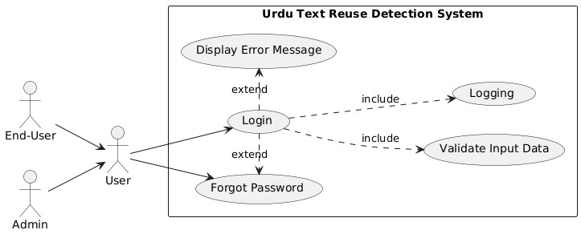
Figure 4 Login Use Case Diagram

2.6.2 Create Account
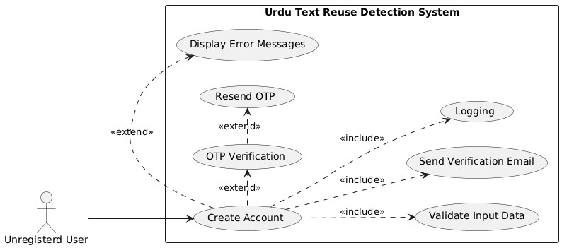
Figure 5 Create Account Use Case

2.6.3 Forget Password
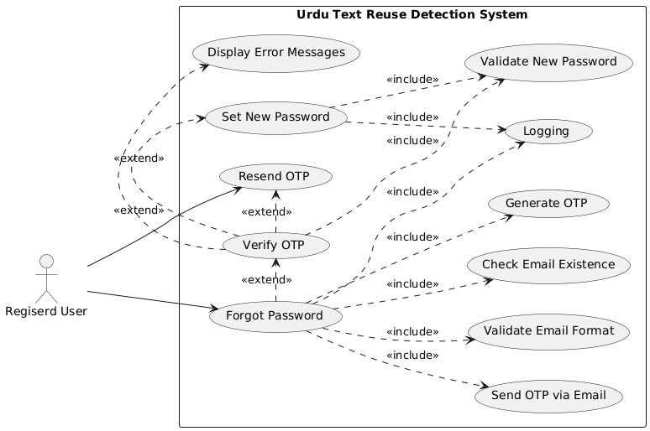
Figure 6 Forget Password Use Case Diagram

2.6.4 Change Password
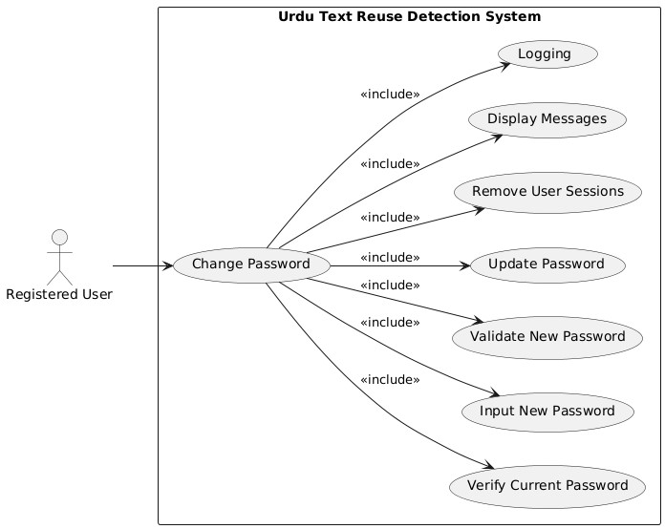
Figure 7 Change Password Use Case Diagram

2.6.5 Update Profile
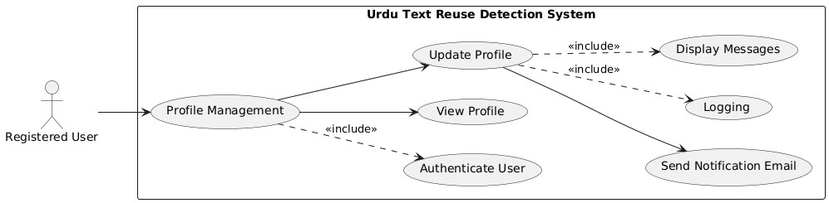
Figure 8 Update Profile Use Case Diagram

2.6.6 API Services
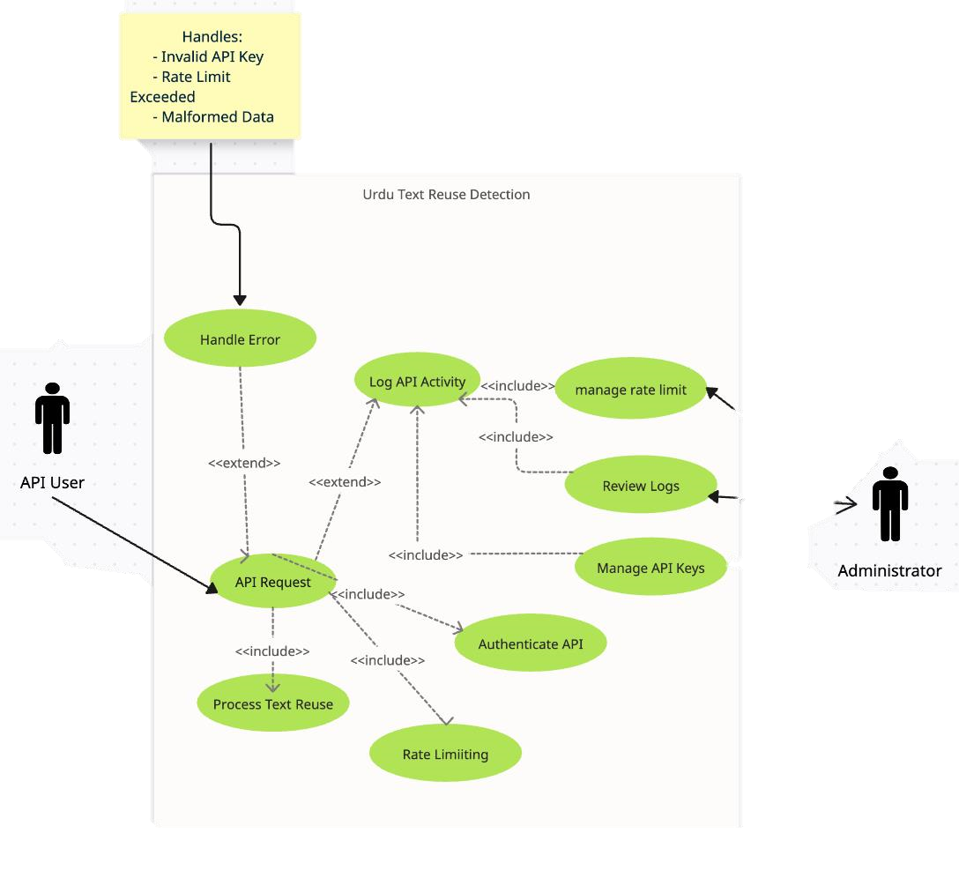
Figure 9 API Services Use Case Diagram

2.6.7 Rate Limiting for API
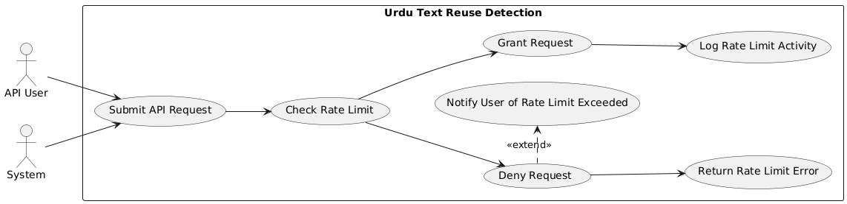
Figure 10 Rate Limiting for API Use Case Diagram

2.6.8 Authorization for API
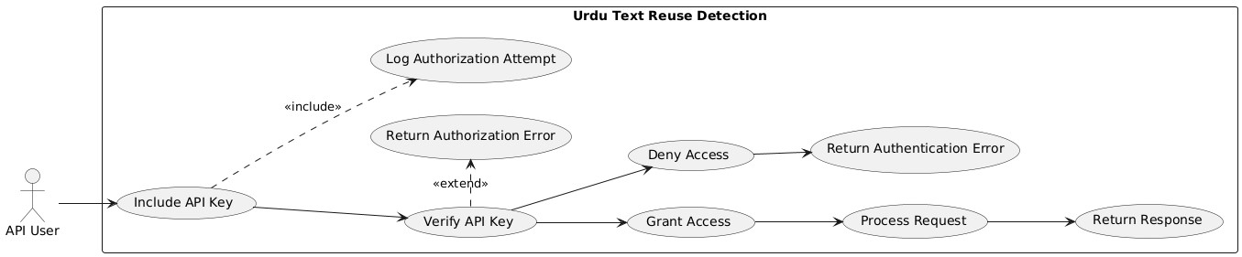
Figure 11 API Authorization Use Case Diagram

2.6.9 API logging
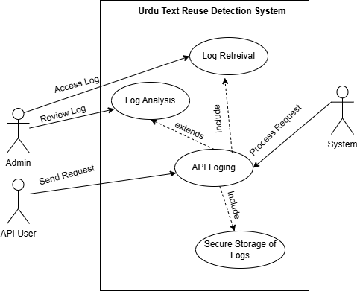
Figure 12 API logging Use Case Diagram

2.6.10 User history
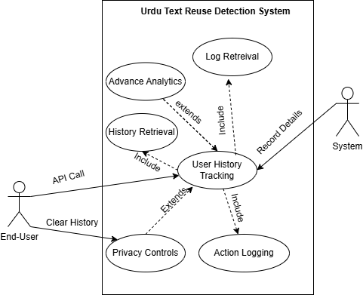
Figure 13 User History Use case Diagram

2.6.11 API key management
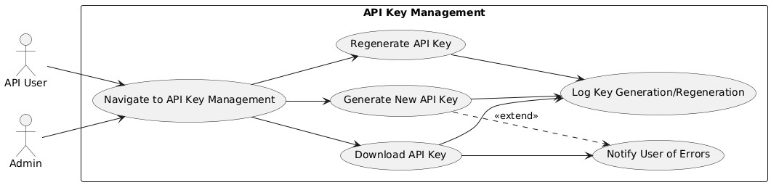
Figure 14 API key management Use case Diagram

2.6.12 API Monitoring
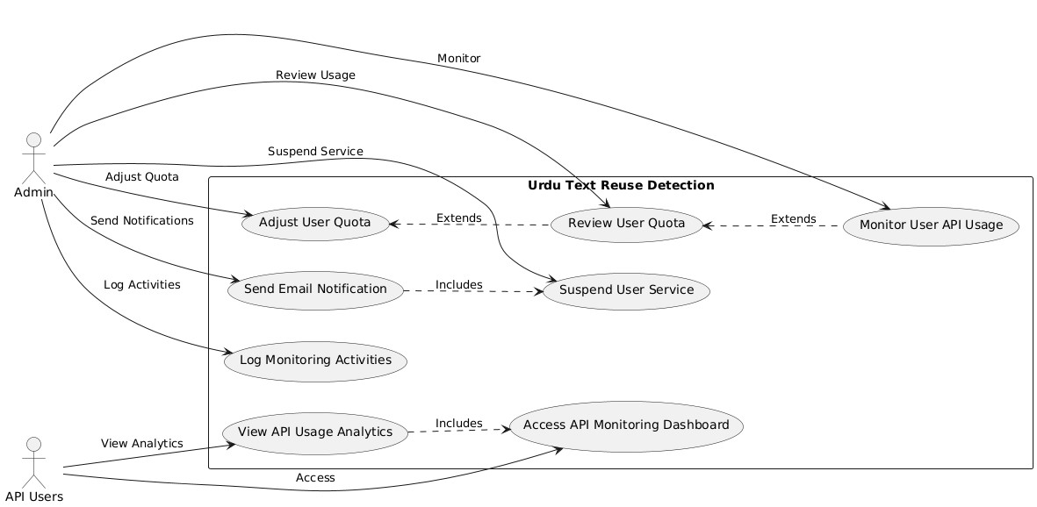
Figure 15 API Monitoring Use Case Diagram

2.6.13 Text Reuse Detection
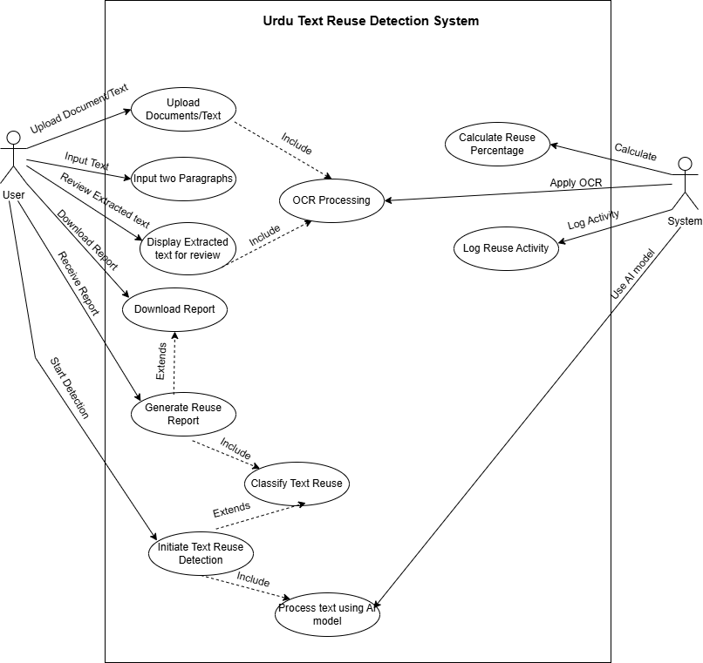
Figure 16 Text Reuse Detection Use Case Diagram

2.6.14 Plagiarism Detection
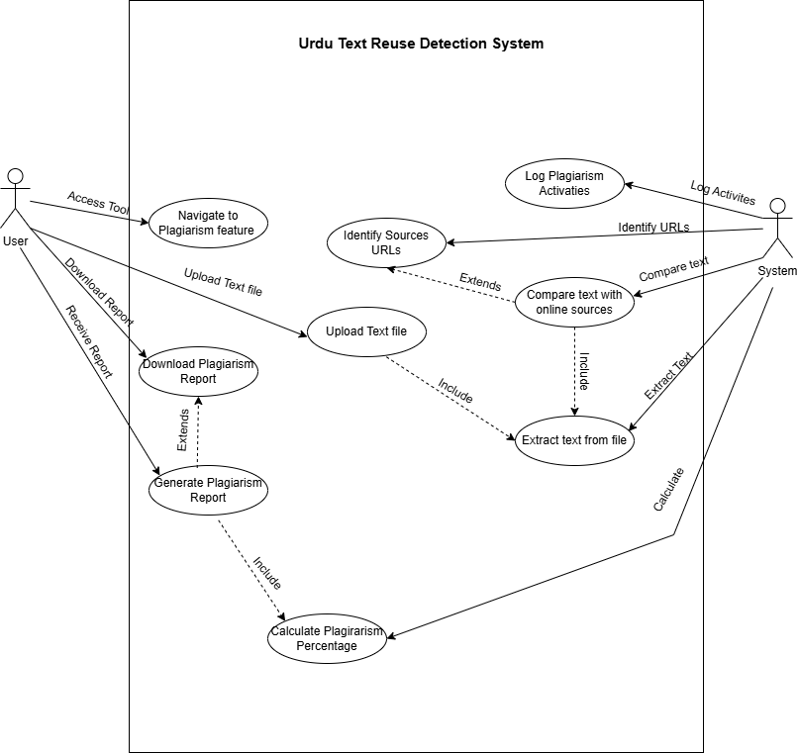
Figure 17 Plagiarism Detection Use case Diagram

2.6.15 Contact
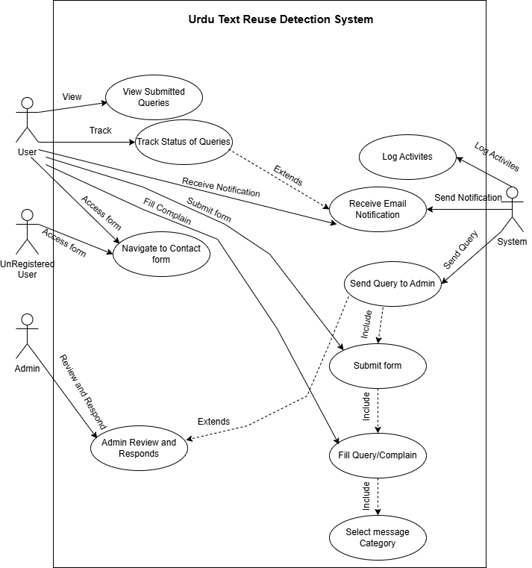
Figure 18 Contact Use Case Diagram

2.6.16 Notifications
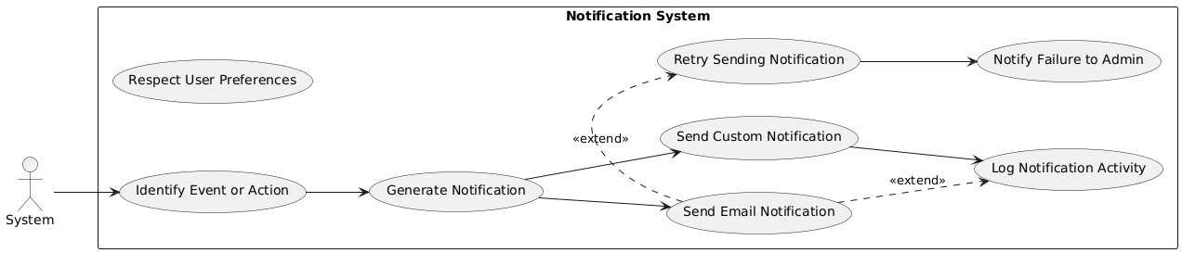
Figure 19 Notifications Use Case Diagram

2.6.17 Admin Dashboard
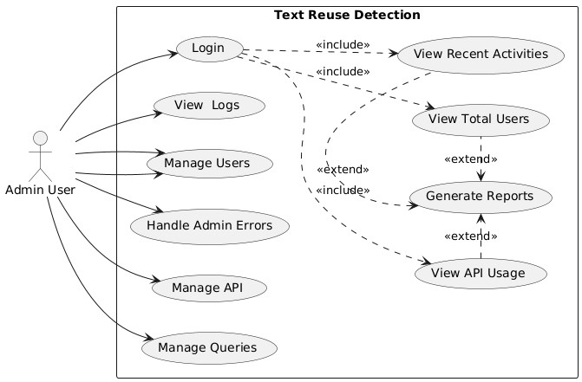
Figure 20 Admin Dashboard Use Case Diagram

2.6.18 System Management
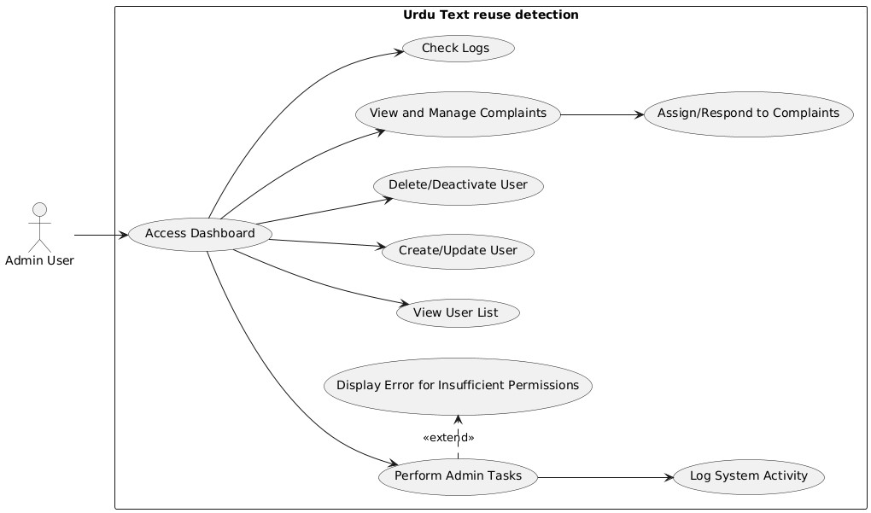
Figure 21 System Management Use Case Diagram

2.6.19 Report Generation
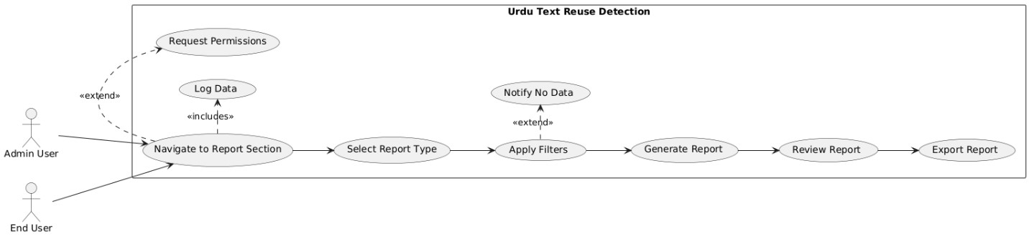
Figure 22 Report Generation Use Case Diagram

2.6.20 Analytics
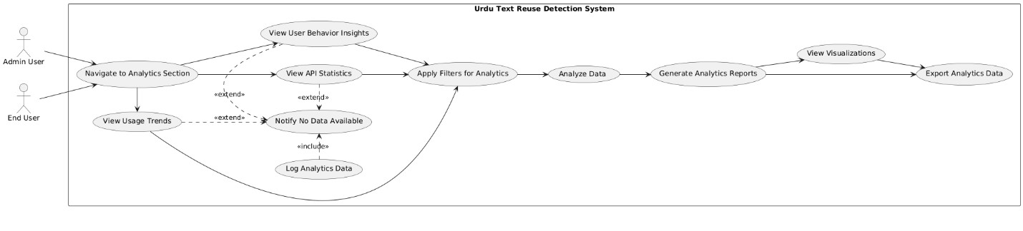
Figure 23 Analytics Use Case Diagram

2.7 Software development life cycle model
We Choose Agile SDLC model for this project because of its flexibility, adaptability, and iterative process due to the experimental nature of Urdu text reuse detection system. Agile allows use for incremental development, enables us to refine our model and application features in manageable sprints. Additionally, Agile is particularly suitable for AI and machine learning related projects, because it enables experimentation with various algorithms and architectures. Unlike traditional SDLC models like Waterfall, Agile gives the flexibility to address the challenges of text reuse detection’s experimentation on of low-resource languages like Urdu, making it the suitable choice for delivering a user-friendly system.
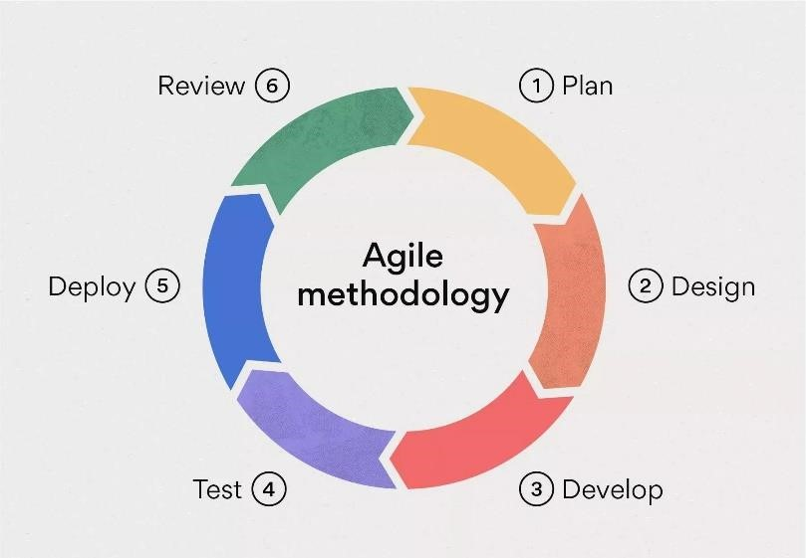
Figure 24 Agile Diagram

Chapter # 03

System Design

3 System Design

3.1 Work breakdown structure (WBS)
The following is the Work break down structure of this final year project:
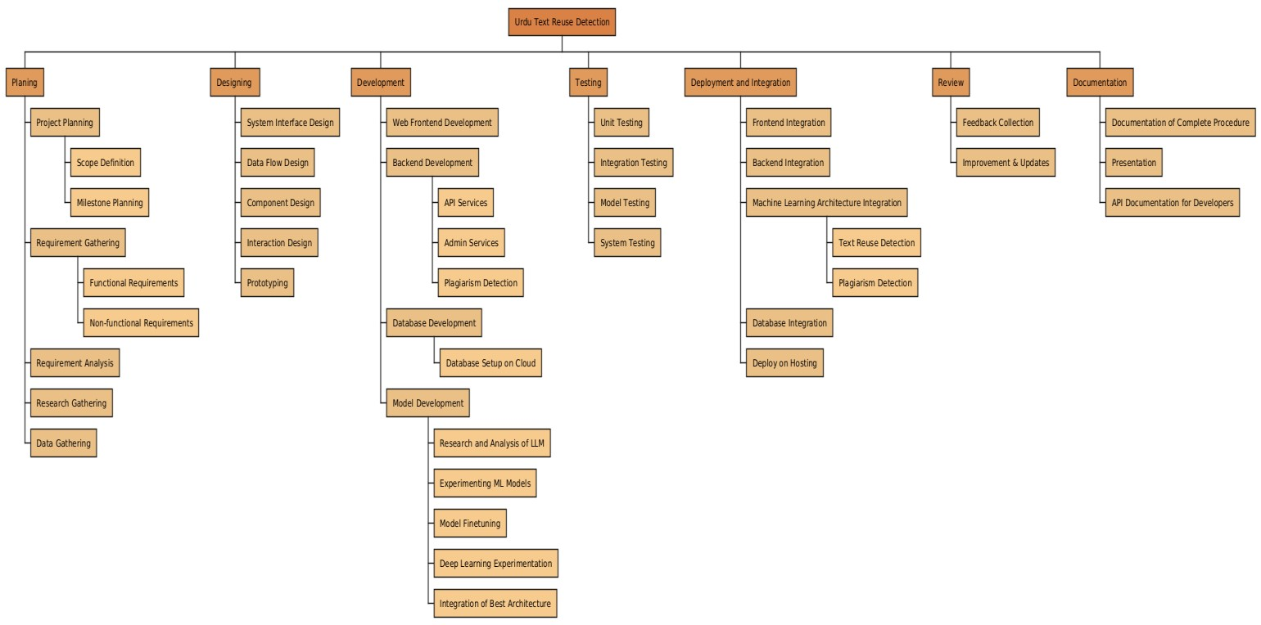
Figure 25 Work Break Down Structure

3.2 Activity diagram
The following are the activity diagram of each user functional requirement of our final year project:

3.2.1 Login
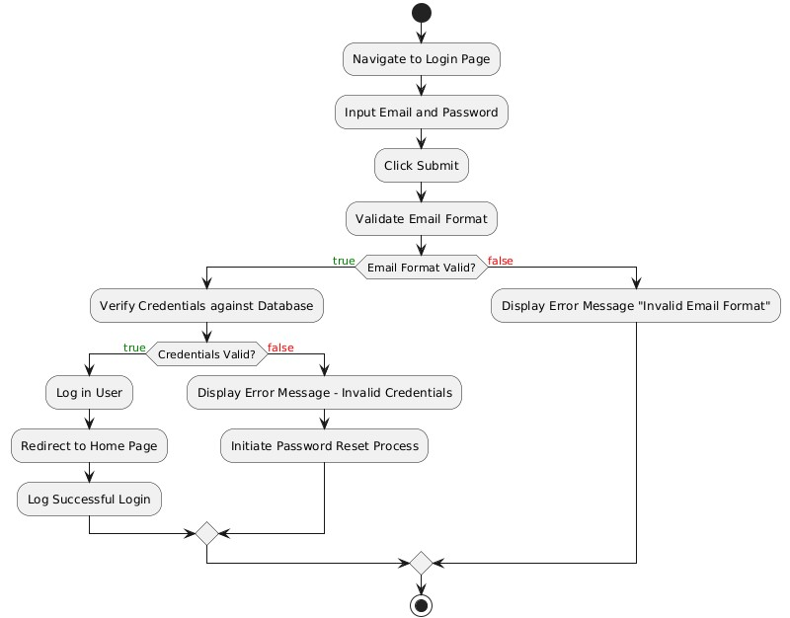
Figure 26 Login Activity Diagram

3.2.2 Create Account
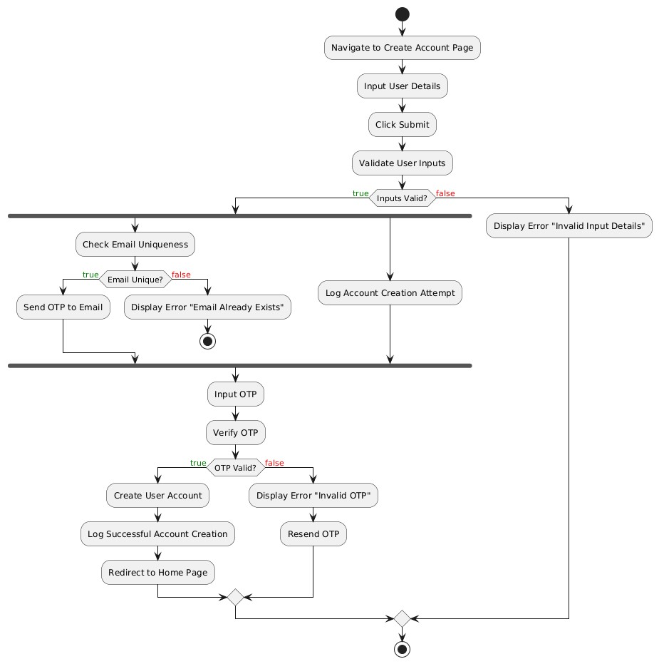
Figure 27 Create Account Activity Diagram

3.2.3 Forgot Password
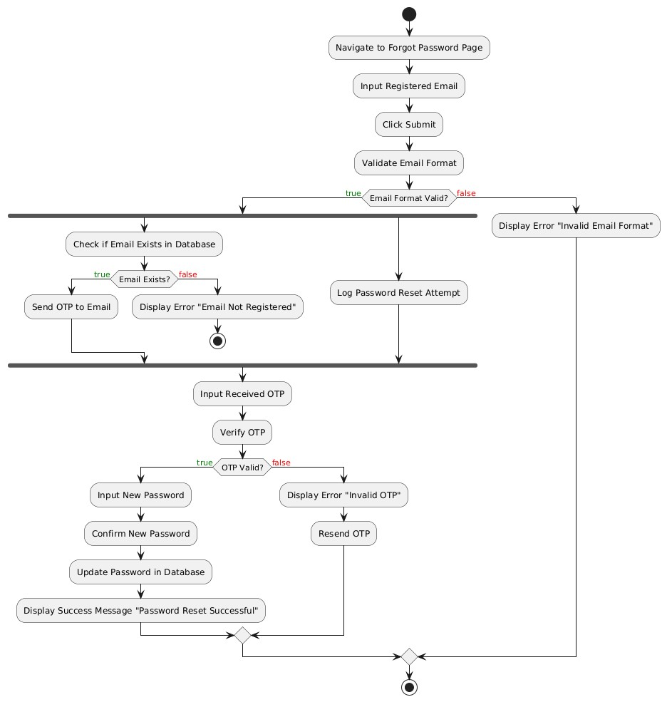
Figure 28 Forgot Password Activity Diagram

3.2.4 Change Password
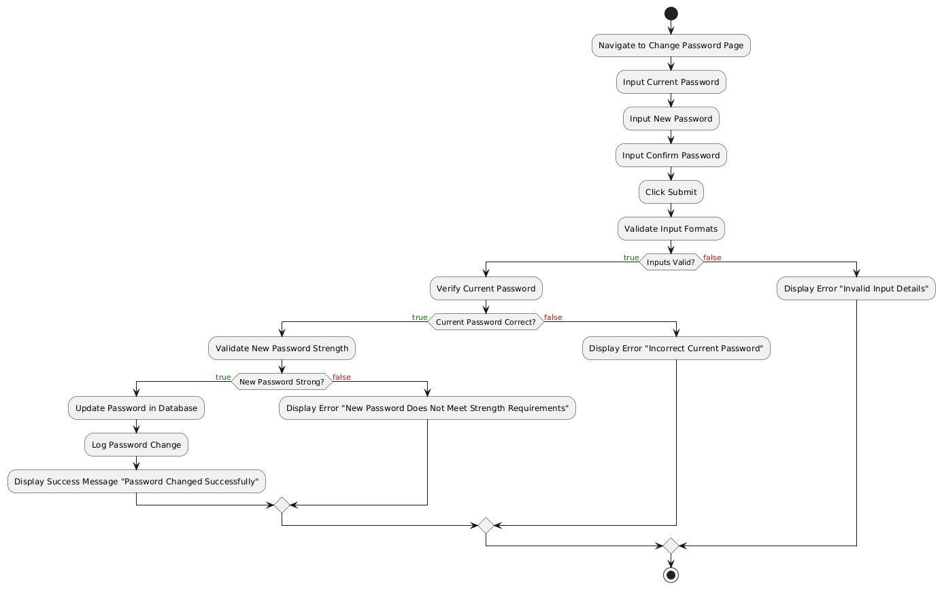
Figure 29 Change Password Activity Diagram

3.2.5 Edit Profile
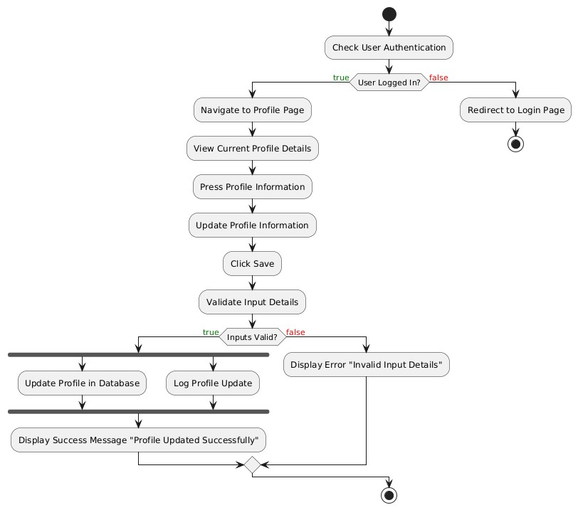
Figure 30 Edit Profile Activity Diagram

3.2.6 API services
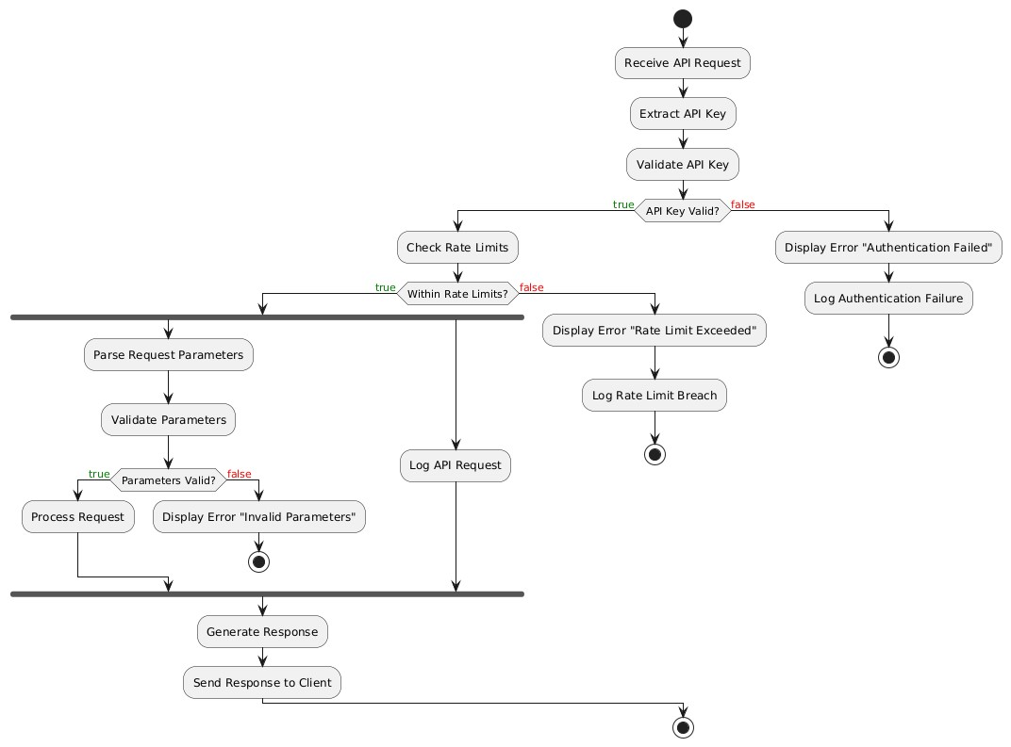
Figure 31 API Services Activity Diagram

3.2.7 Rate Limiting for API
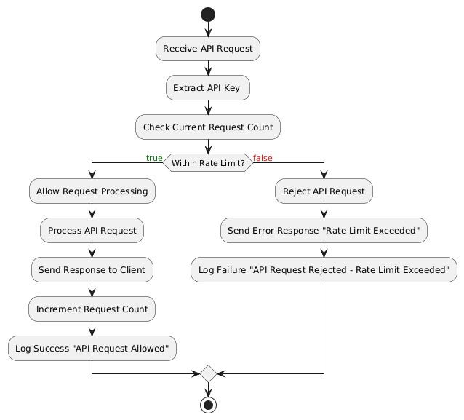
Figure 32 API Rate Limiting Activity Diagram

3.2.8 Authorization for API
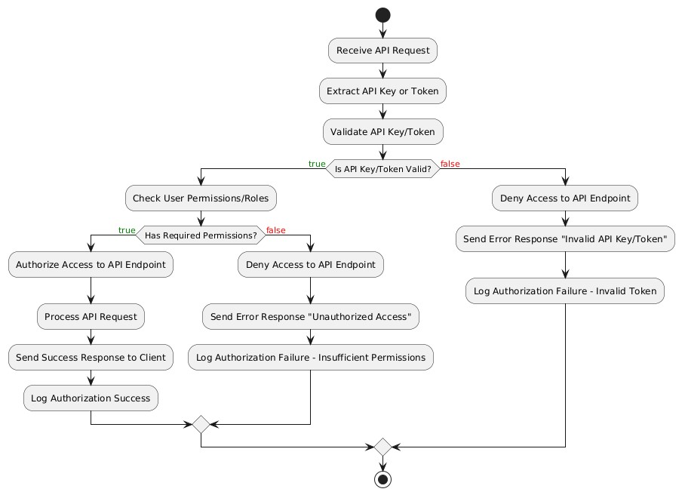
Figure 33 API Authorization Activity Diagram

3.2.9 API logging
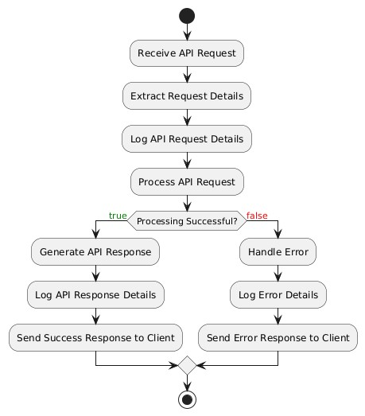
Figure 34 API logging Activity Diagram

3.2.10 User History
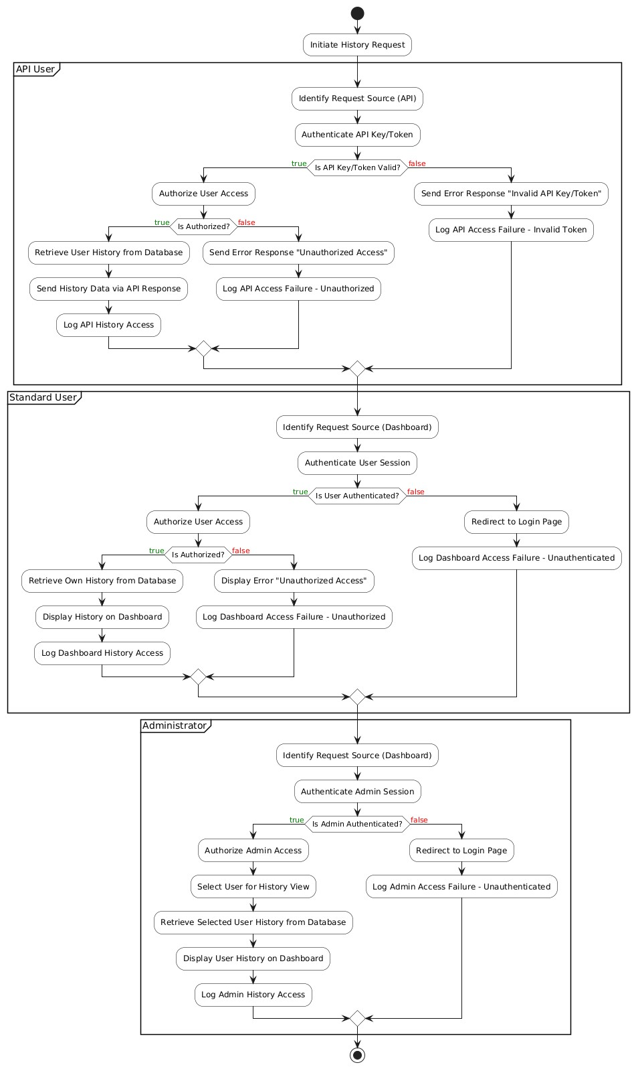
Figure 35 User history Activity Diagram

3.2.11 API Key management
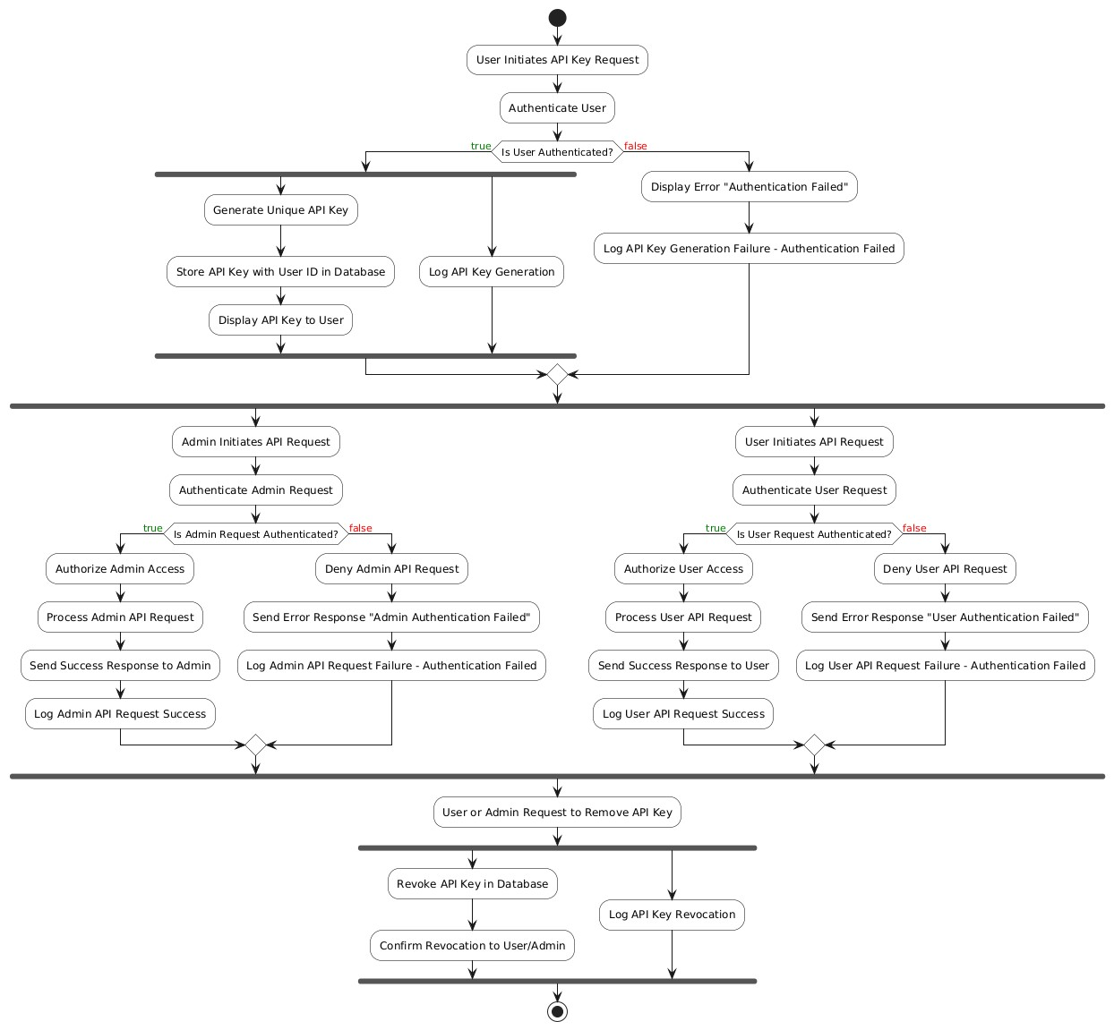
Figure 36 API key Management Activity Diagram

3.2.12 API monitoring
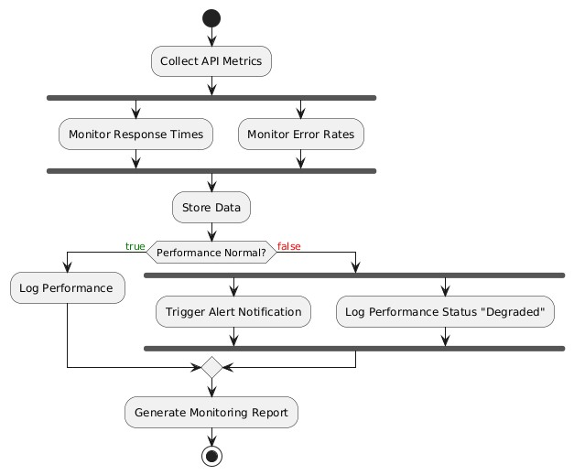
Figure 37 API monitoring Activity Diagram

3.2.13 Text Reuse Detection
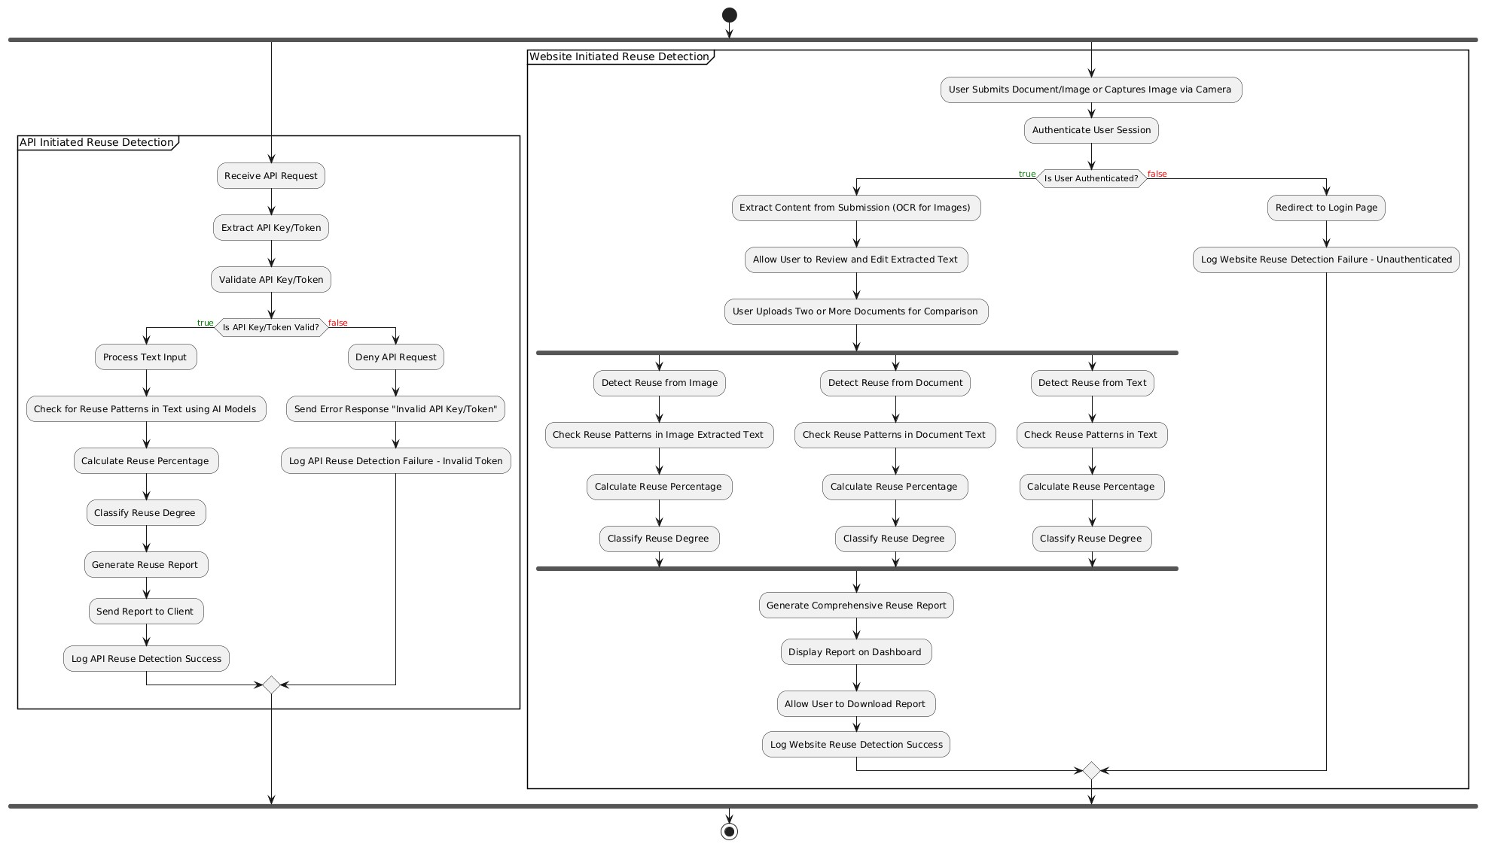
Figure 38 Text Reuse Detection Activity Diagram

3.2.14 Plagiarism Detection
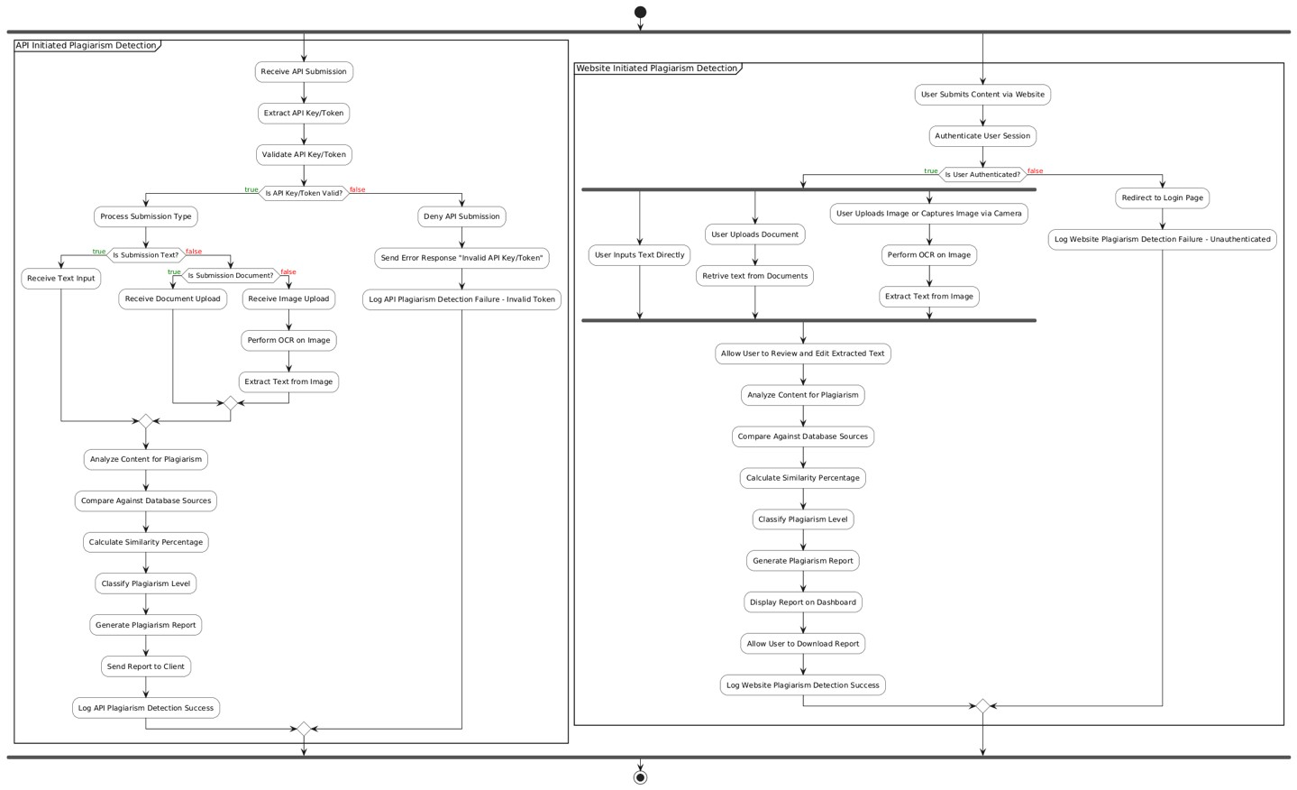
Figure 39 Plagiarism Detection Activity Diagram

3.2.15 Contact
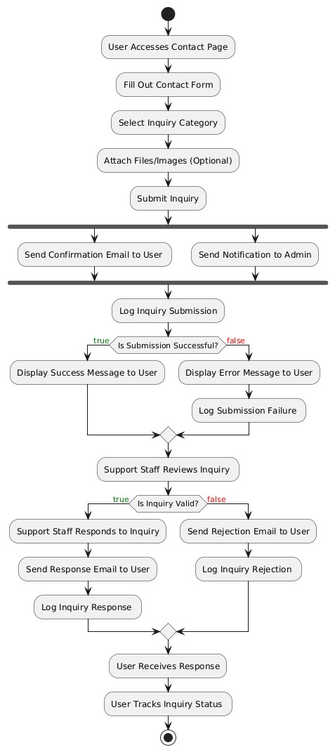
Figure 40 Contact Activity Diagram

3.2.16 Notification
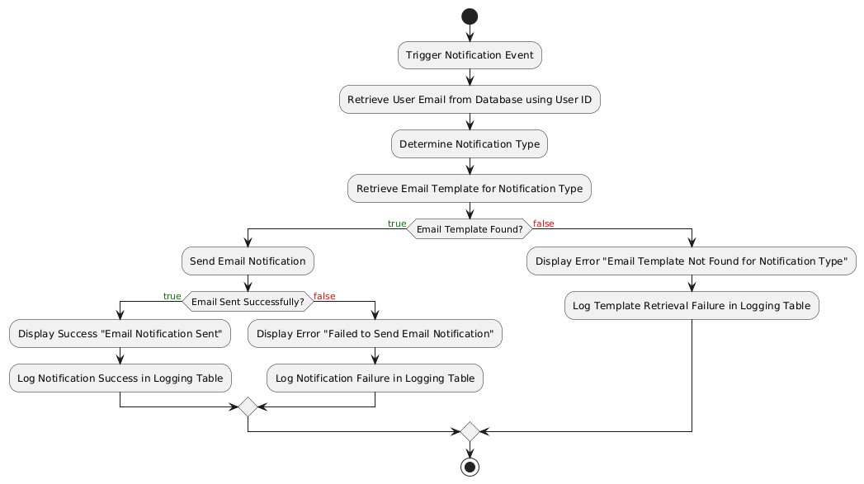
Figure 41 Notifications Activity Diagram

3.2.17 Admin Dashboard
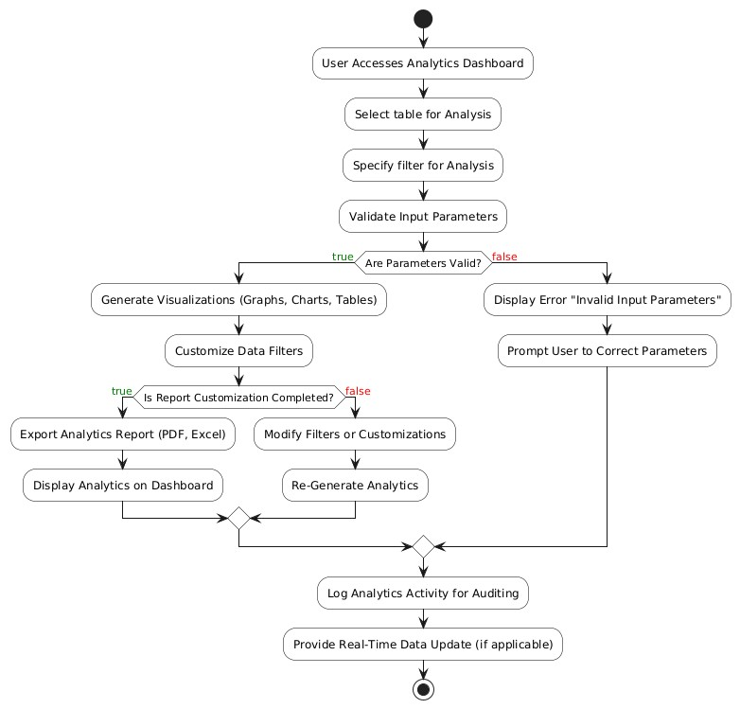
Figure 42 Admin Dashboard Activity Diagram

3.2.18 System Management
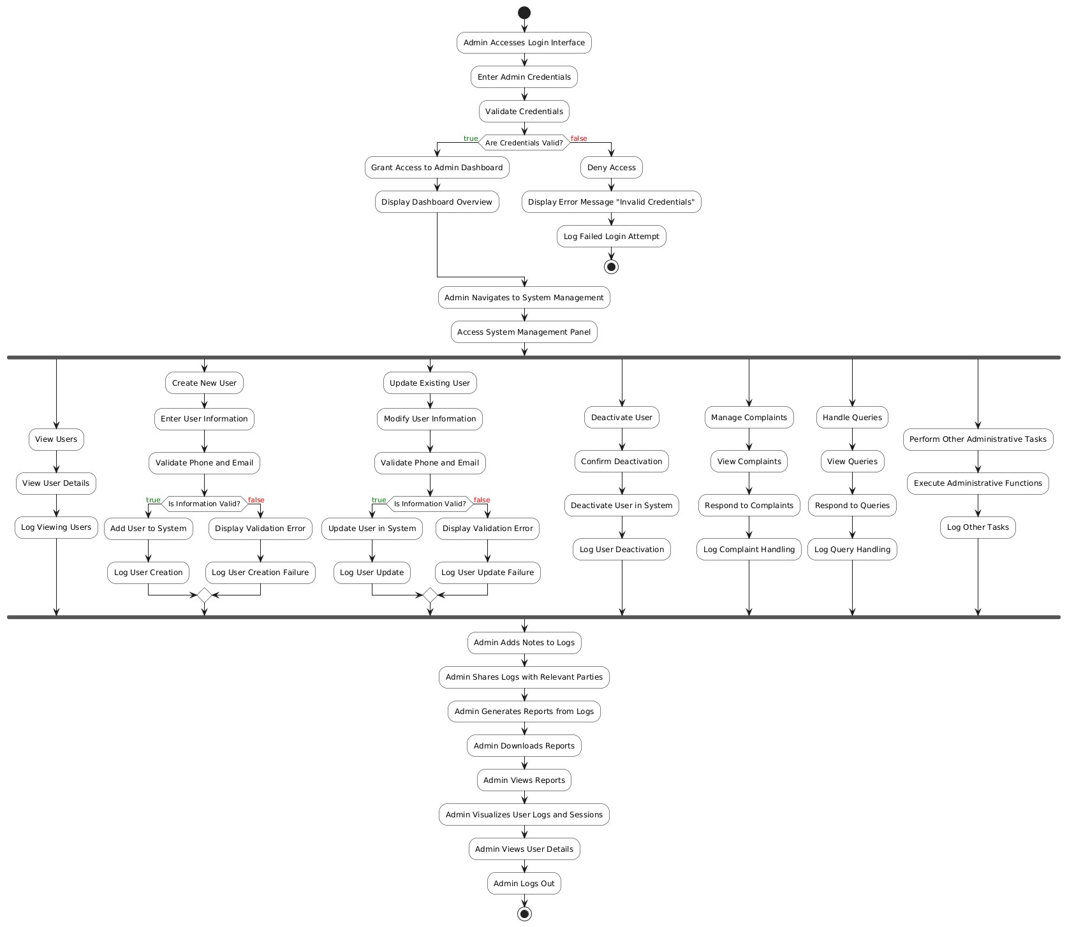
Figure 43 System Management Activity Diagram

3.2.19 Report Generation
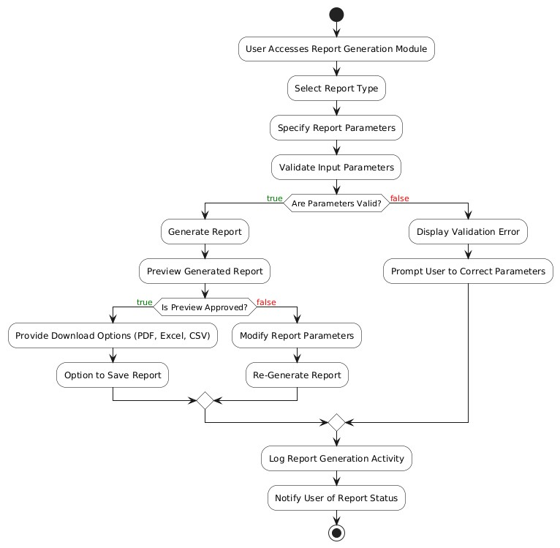
Figure 44 Report Generation Activity Diagram

3.2.20 Analytics
Figure 45 Analytics Activity Diagram

3.3 Sequence diagram

3.3.1 Login
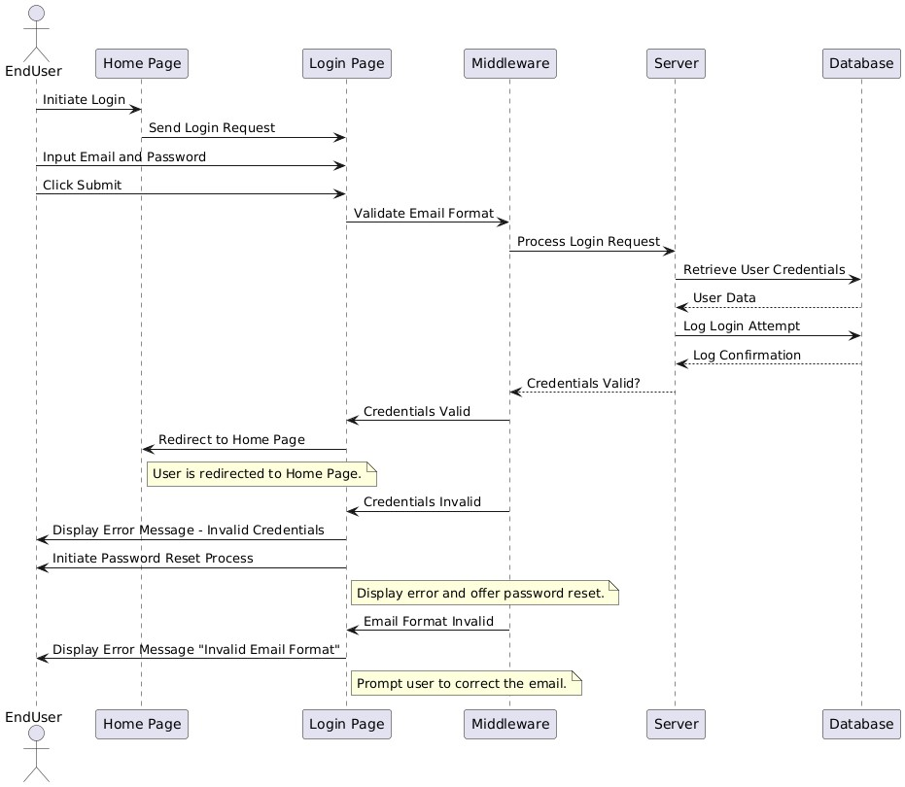
Figure 46 Login Sequence Diagram

3.3.2 Create Account
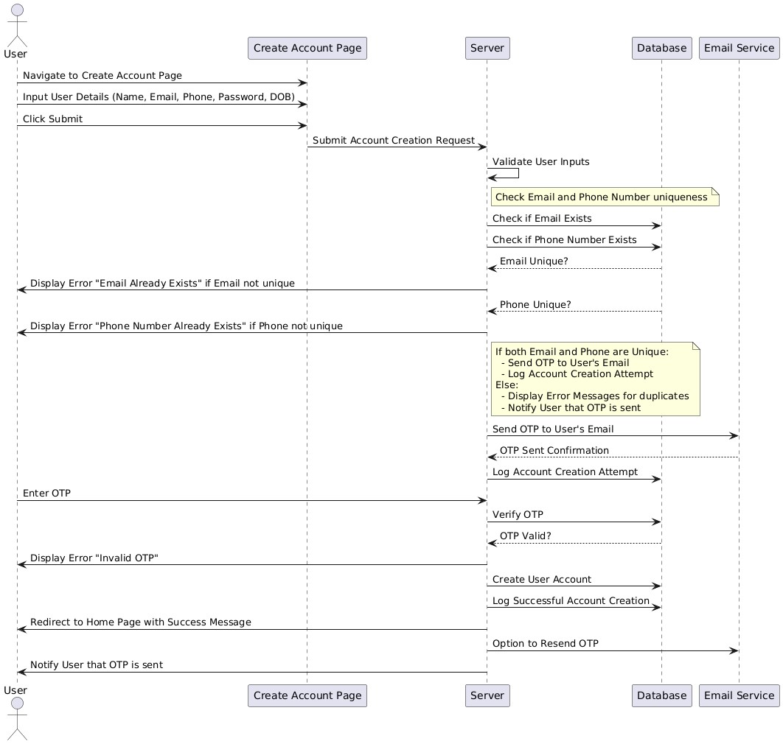
Figure 47 Create Account Sequence Diagram

3.3.3 Forgot Password
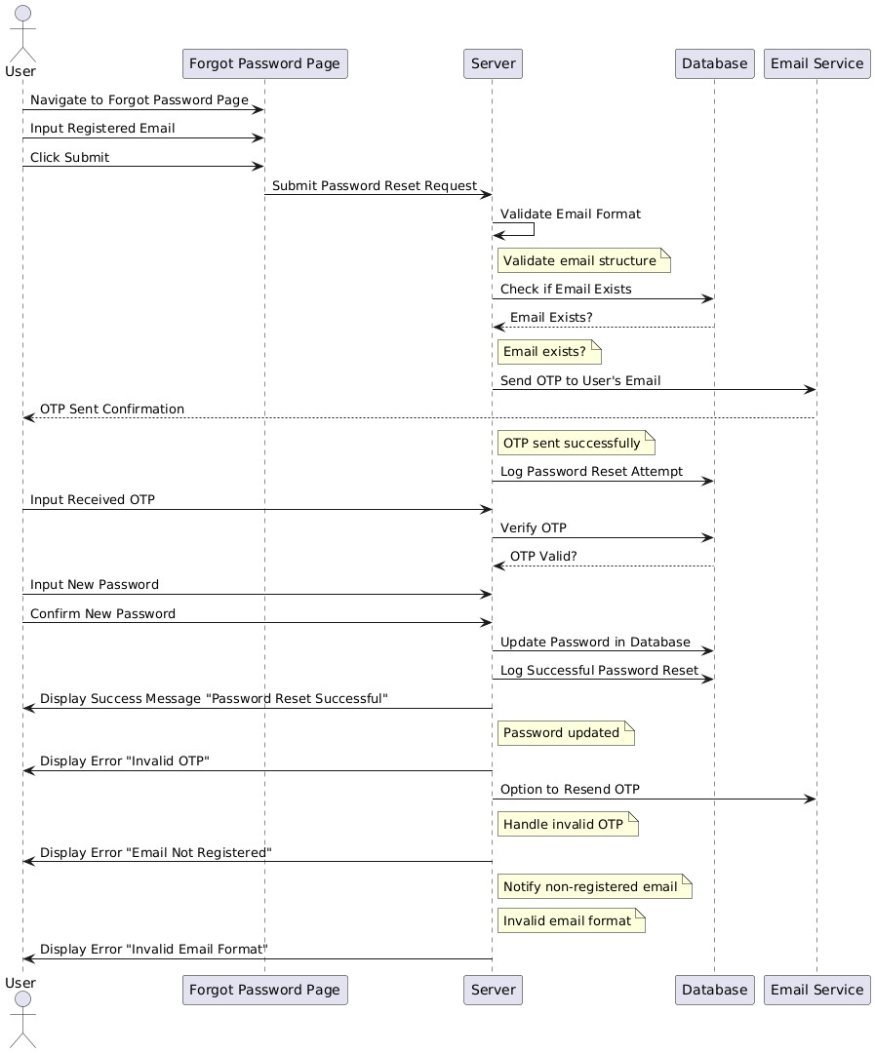
Figure 48 Forgot Password Sequence Diagram

3.3.4 Change Password
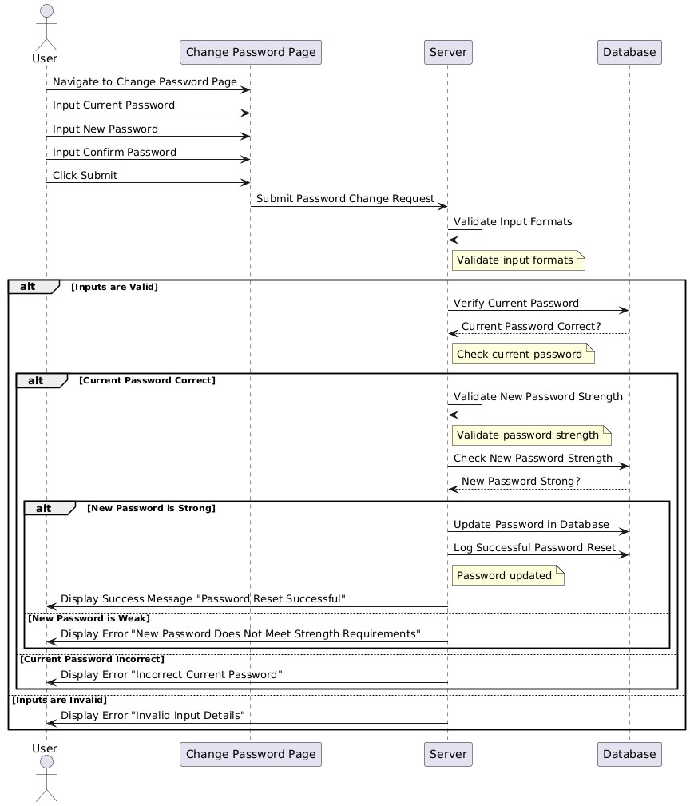
Figure 49 Change Password Sequence Diagram

2.1.1. Edit Profile
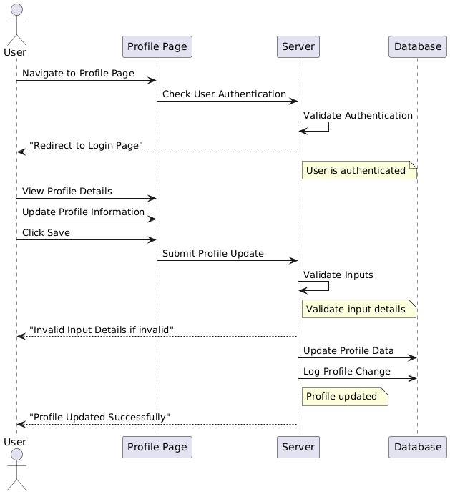
Figure 50 Update Profile Sequence Diagram

3.3.5 API services
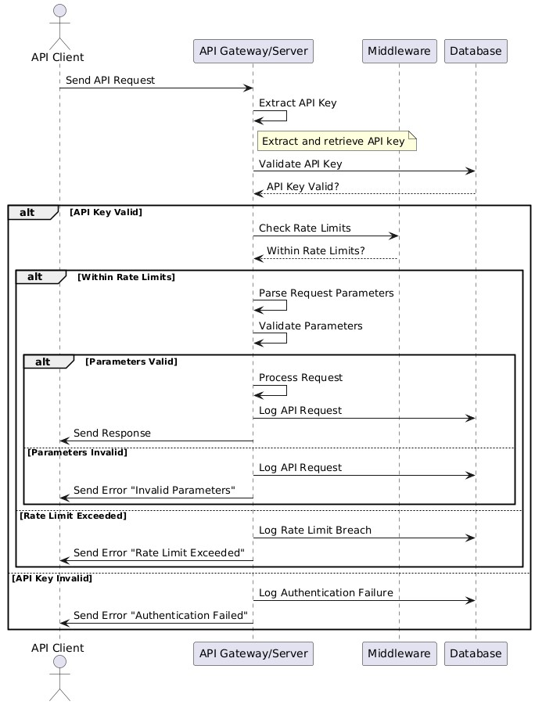
Figure 51 API Services Sequence Diagram

3.3.6 Rate Limiting for API
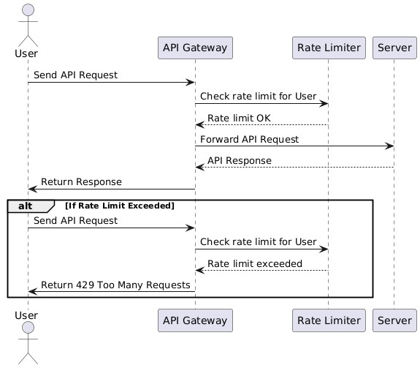
Figure 52 Rate Limiting Sequence Diagram

3.3.7 Authorization for API
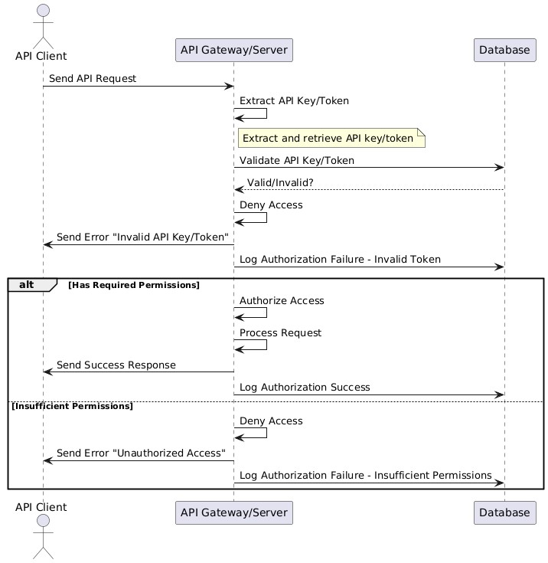
Figure 53 Authorization Sequence Diagram

3.3.8 API logging
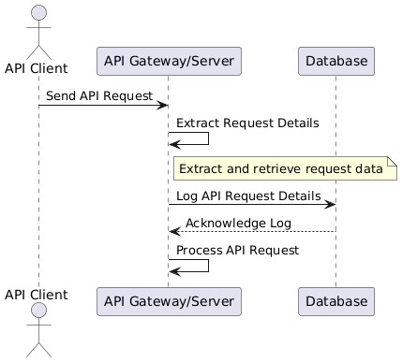
Figure 54 API logging Sequence Diagram

3.3.9 User History
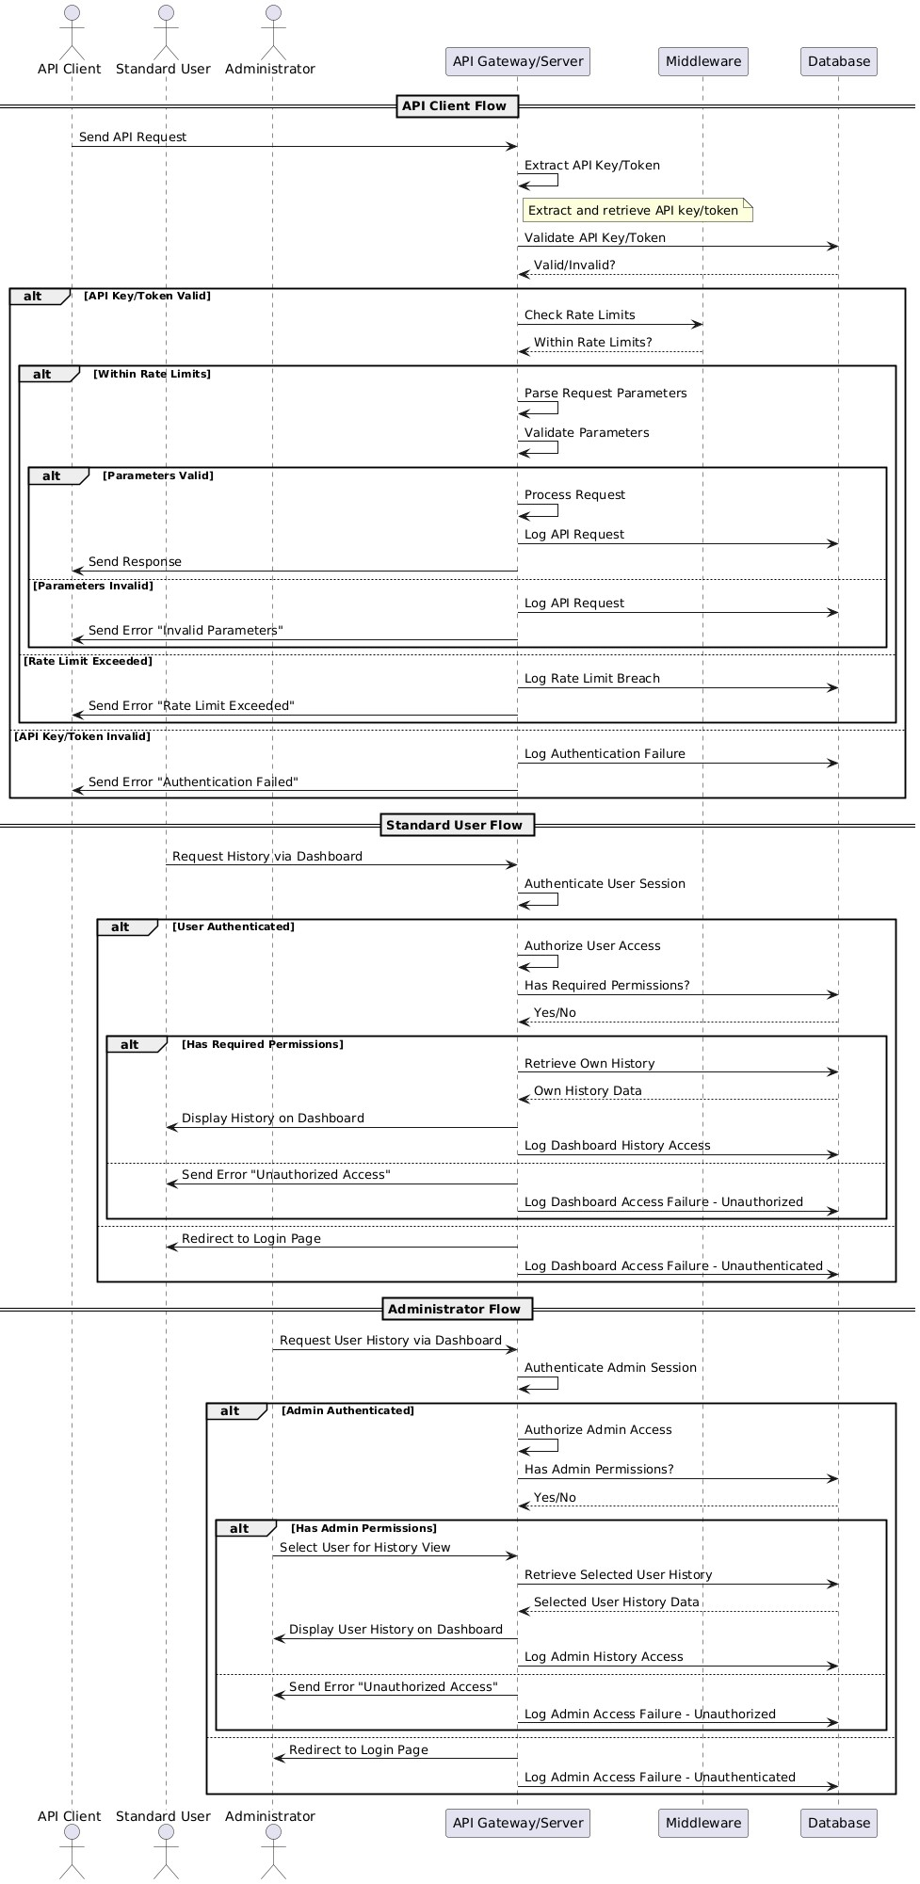
Figure 55 User History Sequence Diagram

3.3.10 API Key management
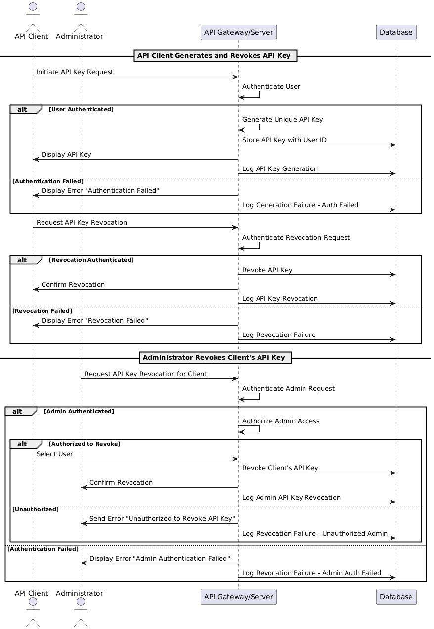
Figure 56 API Key Management Sequence Diagram

3.3.11 API monitoring
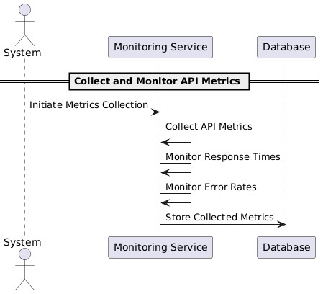
Figure 57 API Monitoring Sequence Diagram

3.3.12 Text Reuse Detection
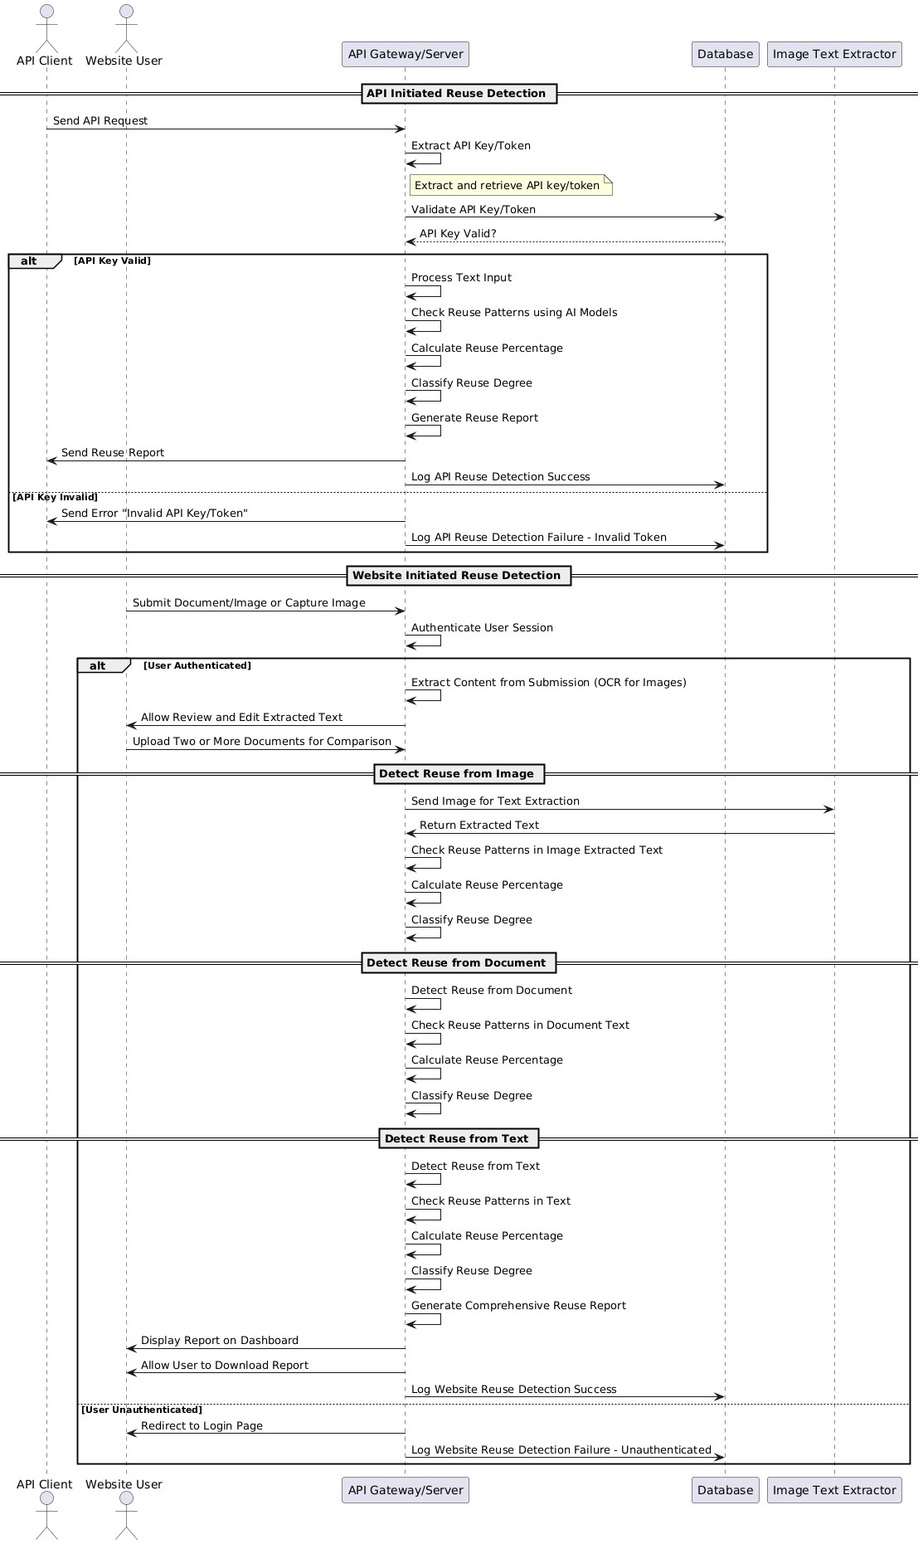
Figure 58 Text Reuse Detection Sequence Diagram

2.1.2. Plagiarism Detection
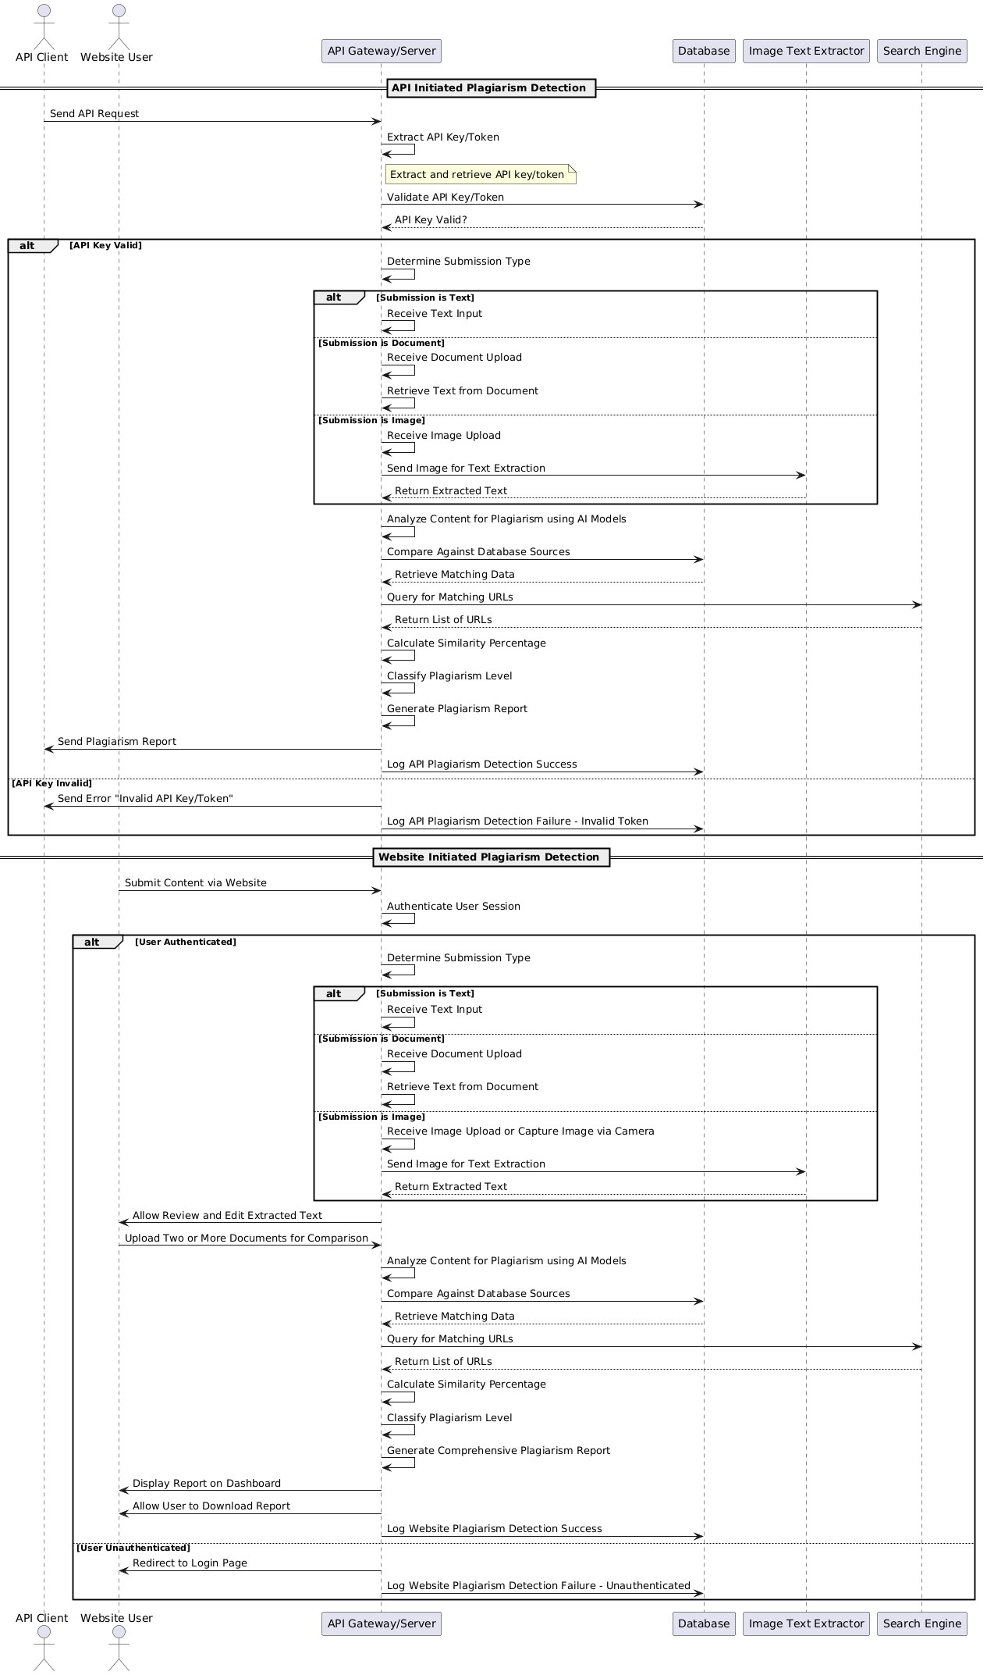
Figure 59 Plagiarism Detection Sequence Diagram

3.3.13 Contact
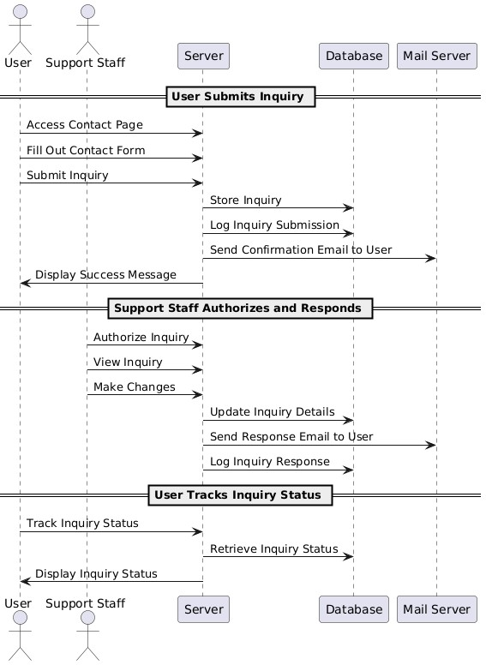
Figure 60 Contact Sequence Diagram

3.3.14 Notification
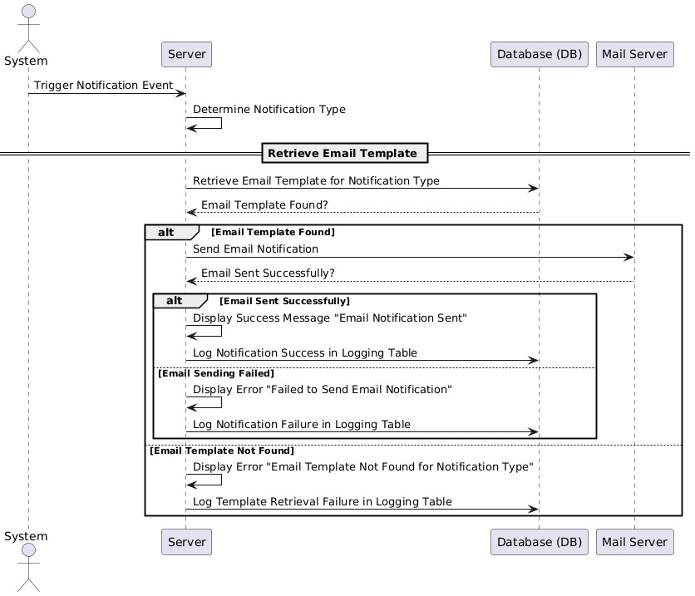
Figure 61 Notification Sequence Diagram

3.3.15 Admin Dashboard
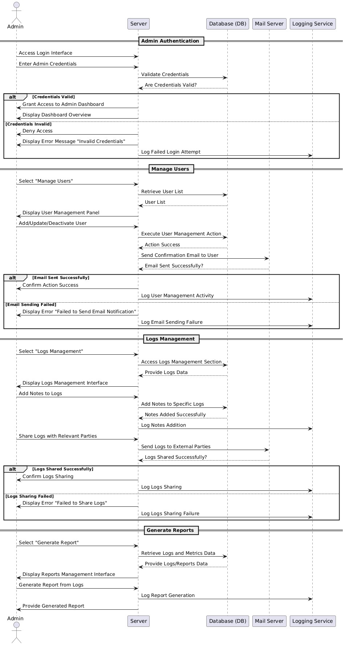
Figure 62 Admin Dashboard Sequence Diagram

3.3.16 System Management
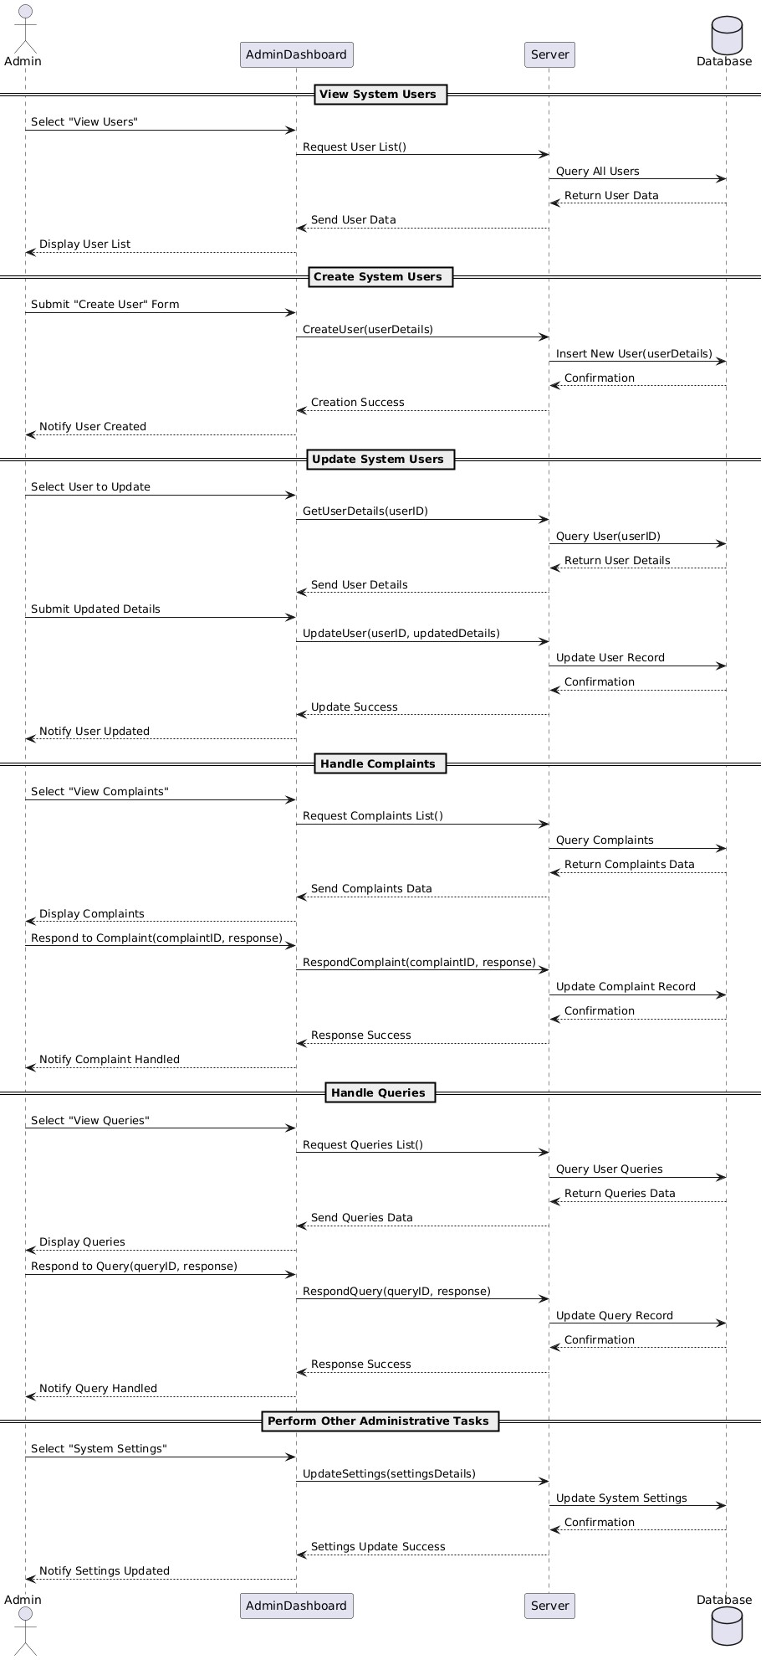
Figure 63 System Management Sequence Diagram

3.3.17 Report Generation
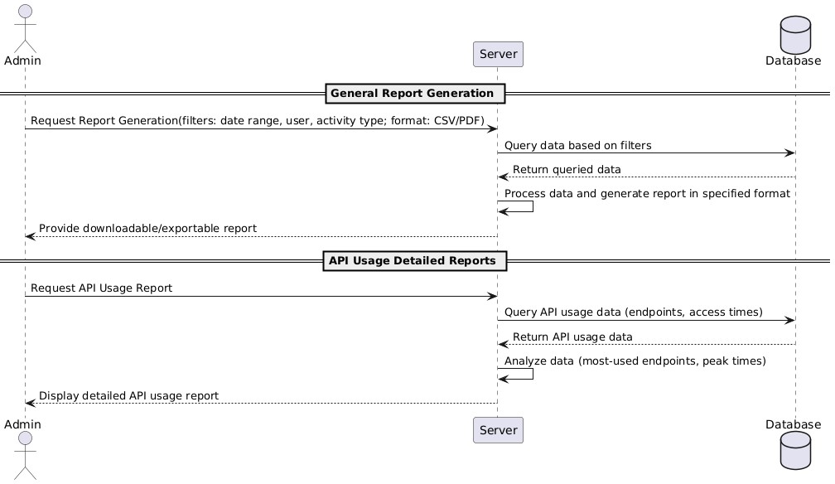
Figure 64 Report Generation Sequence Diagram

3.3.18 Analytics
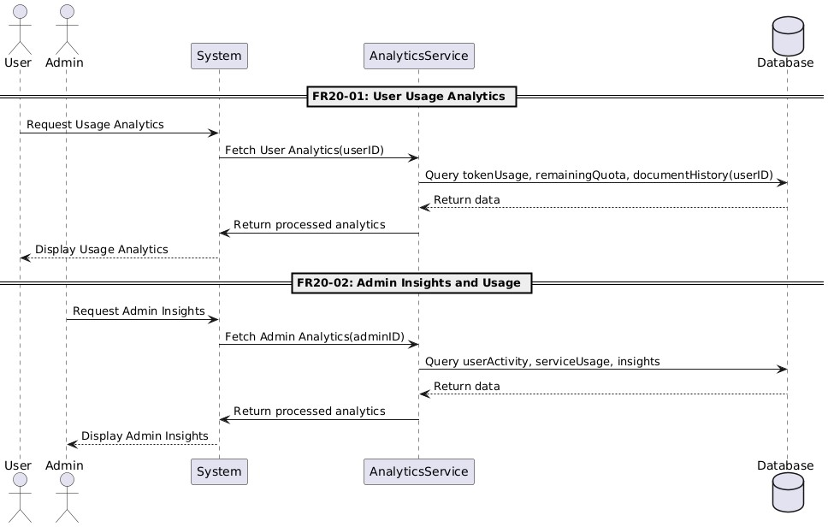
Figure 65 Analytics Sequence Diagram

3.4 Software architecture
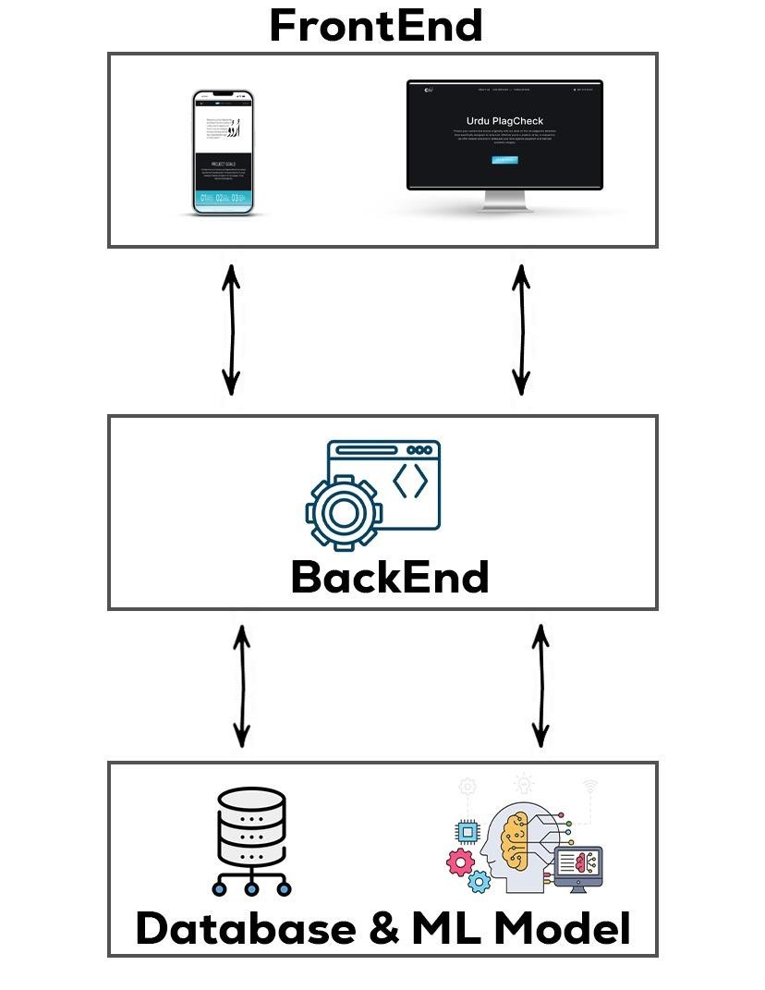
Figure 66 Software Architecture Diagram

3.5 Model
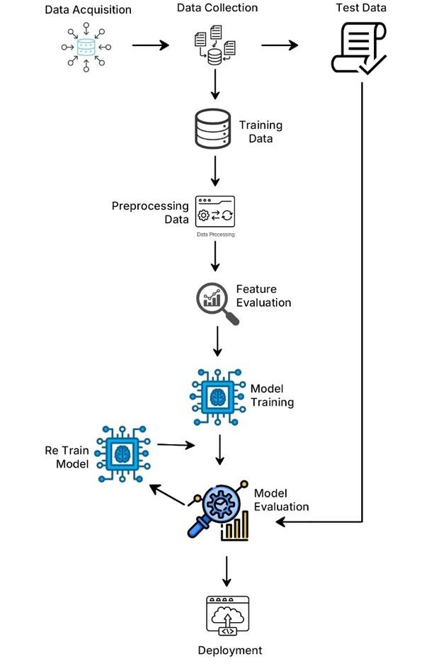
Figure 67 Machine Learning Model Process

3.6 Class diagram
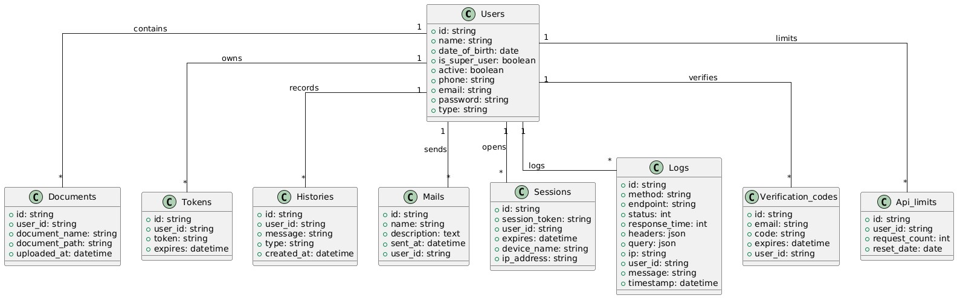
Figure 68 Class Diagram

3.7 Database diagram
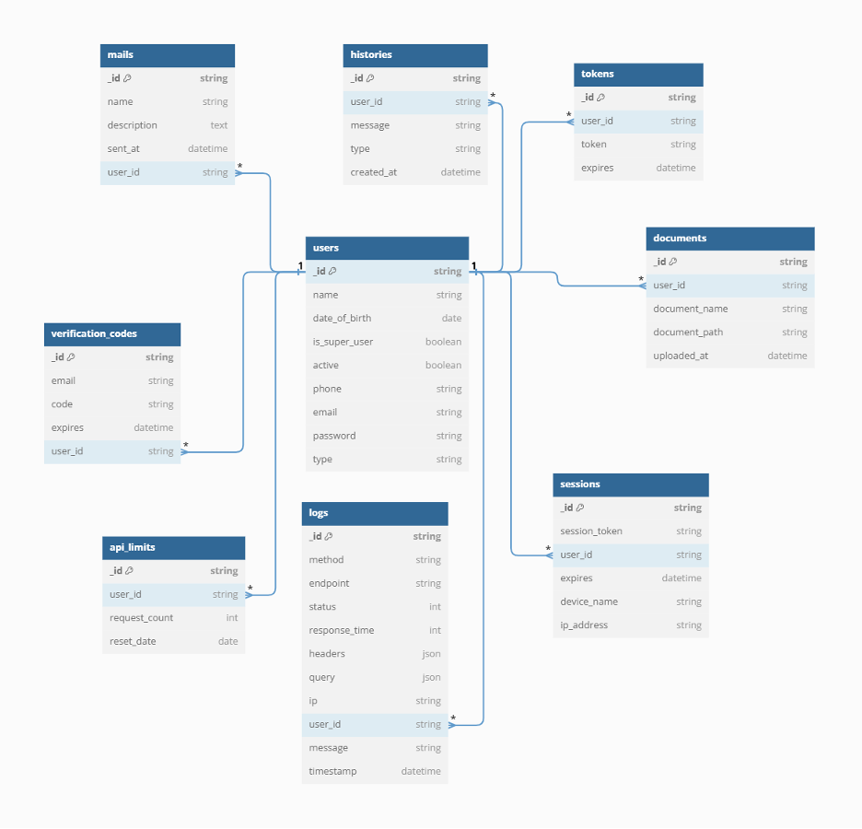
Figure 69 Database Diagram

3.8 Network diagram (Gantt chart)
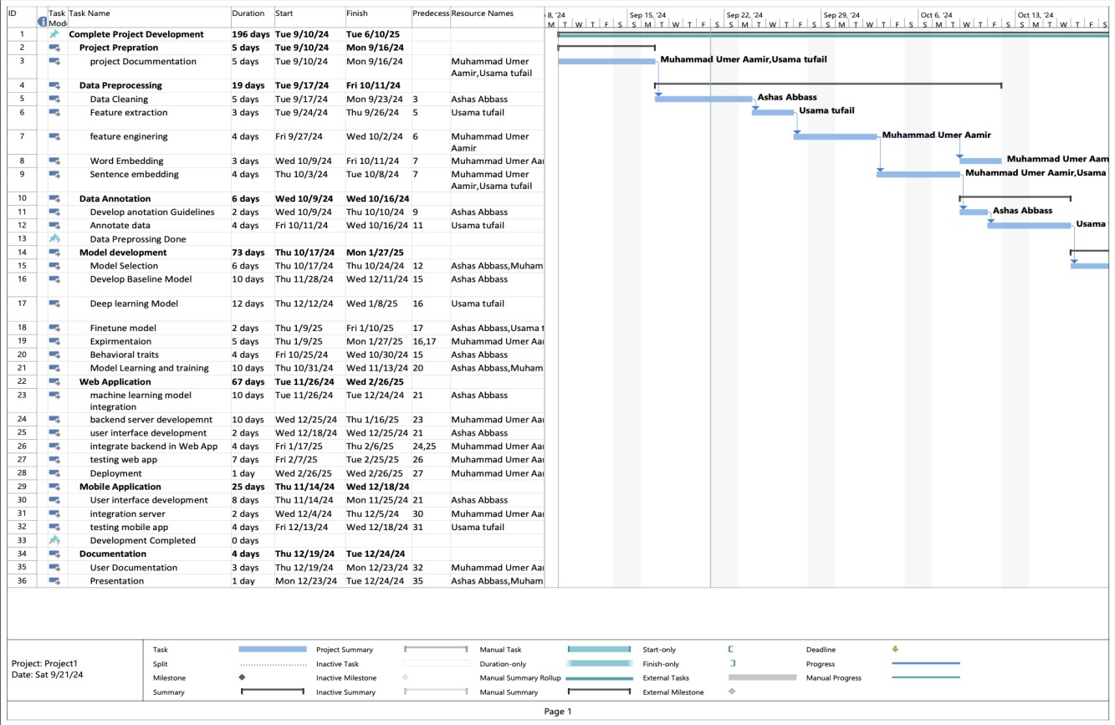
Figure 70 Network diagram (Gantt chart)

3.9 Collaboration Diagram

3.9.1 Login
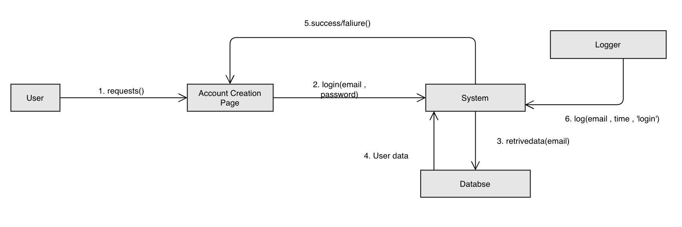
Figure 71 Login Collaboration Diagram

3.9.2 Create Account
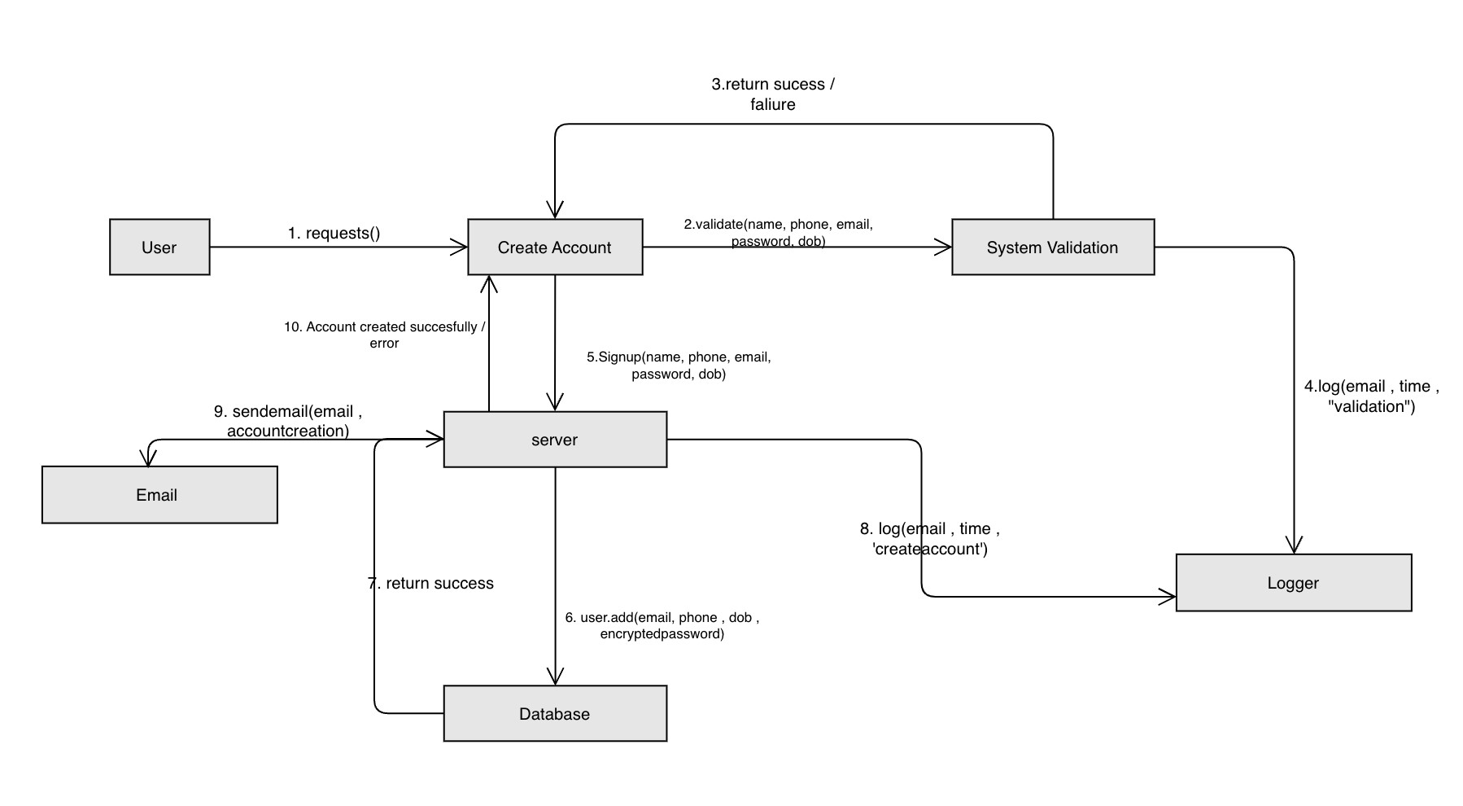
Figure 72 Create Account Collaboration Diagram

3.9.3 Forgot Password
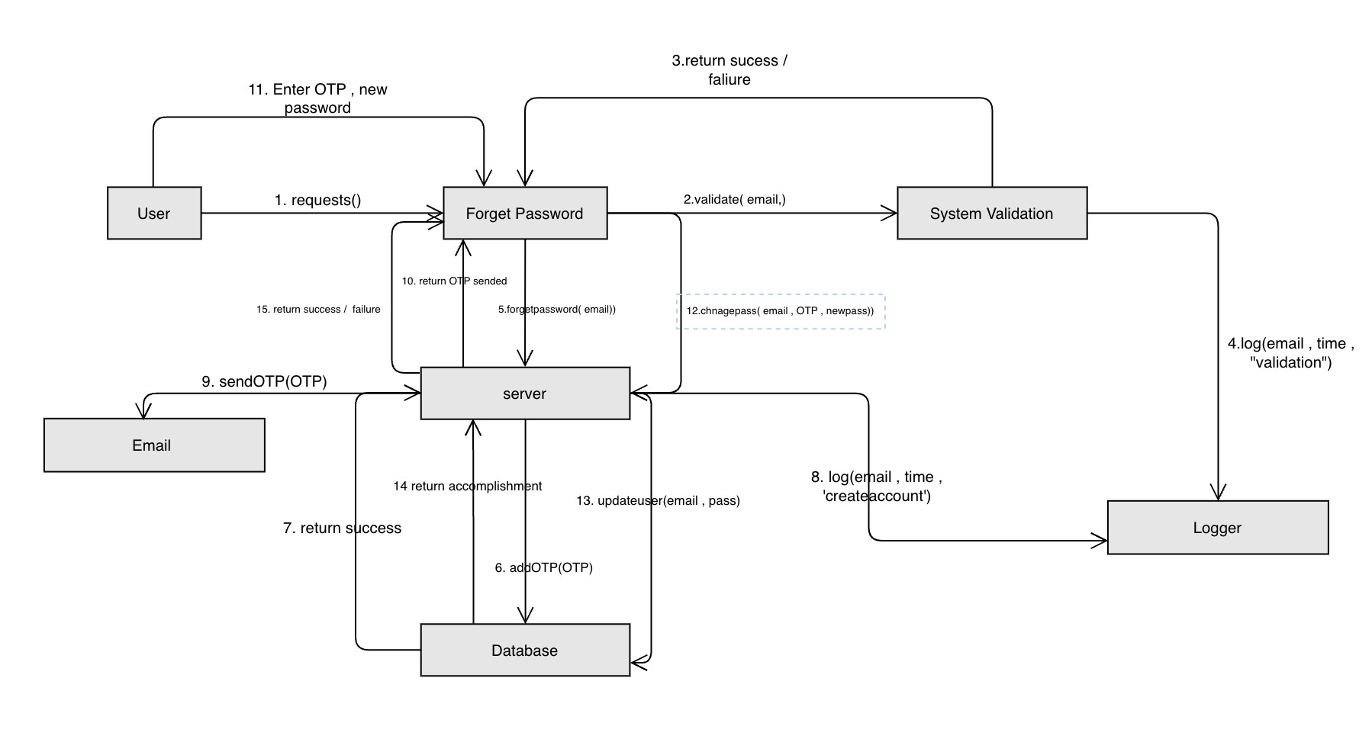
Figure 73 Forgot Password Collaboration Diagram

3.9.4 Change Password
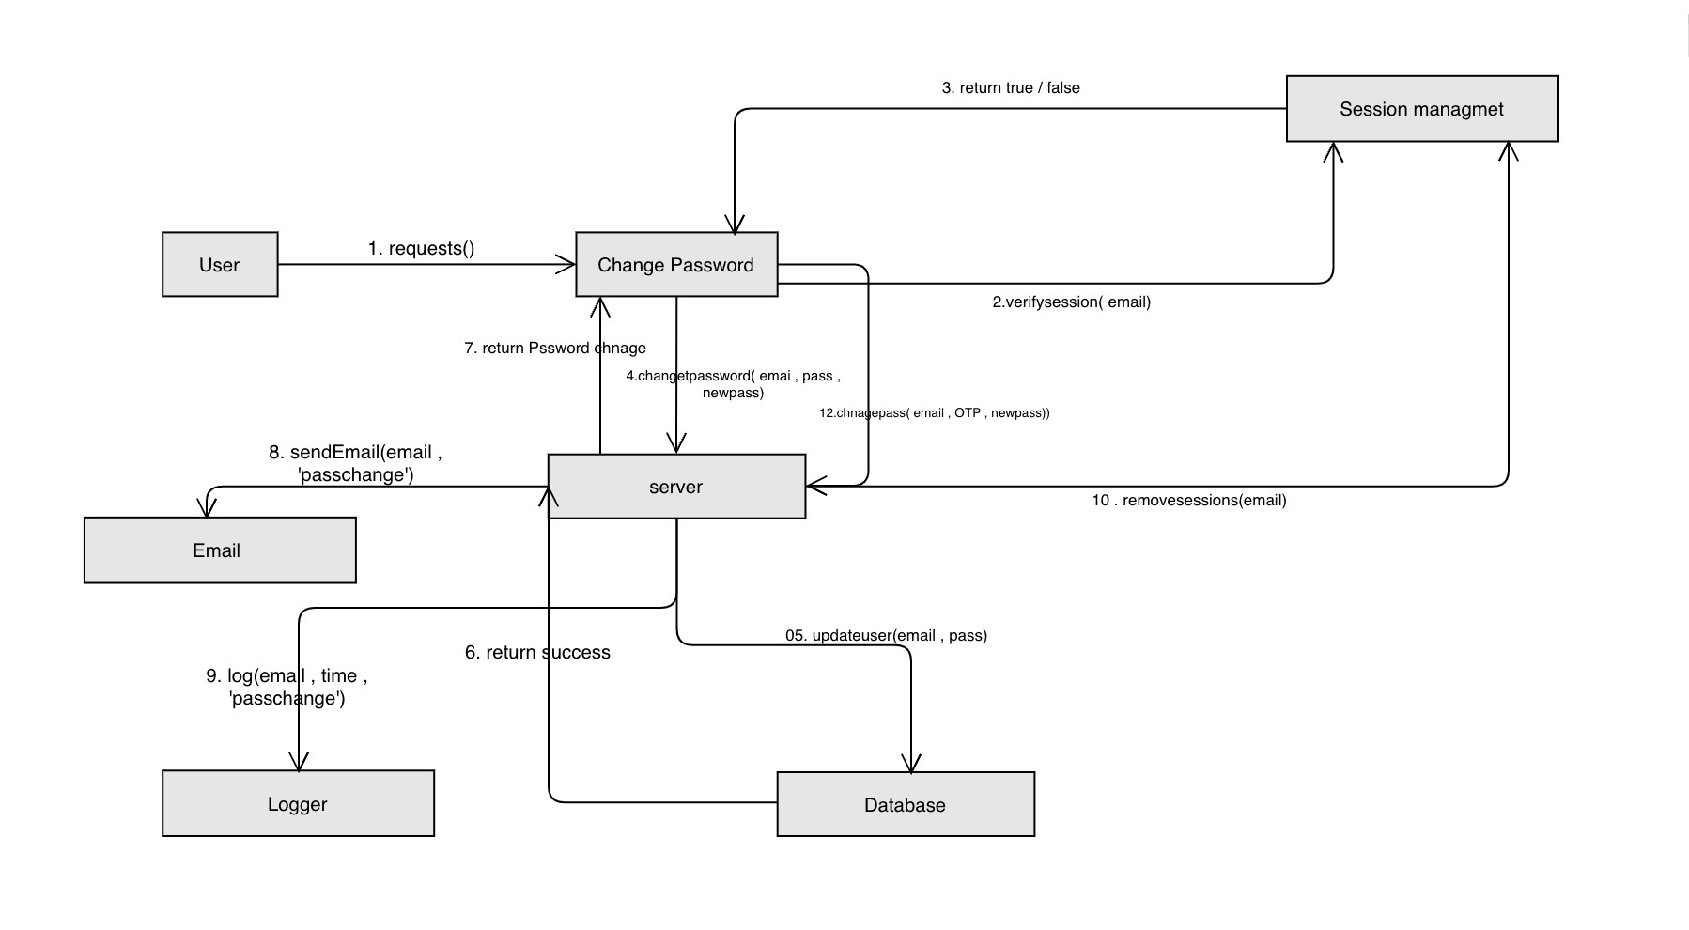
Figure 74 Change Password Collaboration Diagram

3.9.5 Edit Profile
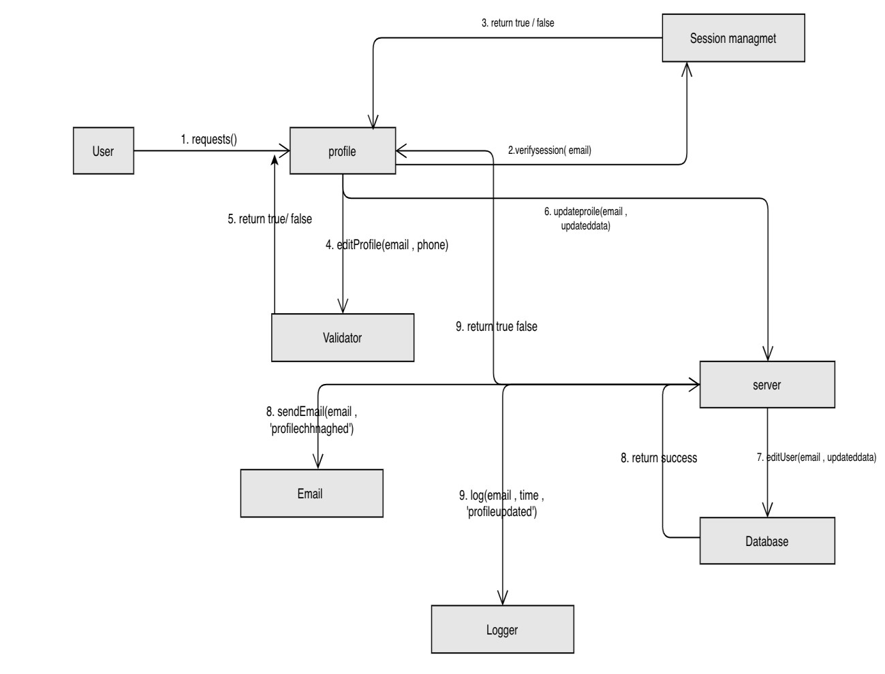
Figure 75 Edit Profile Collaboration Diagram

3.9.6 API services
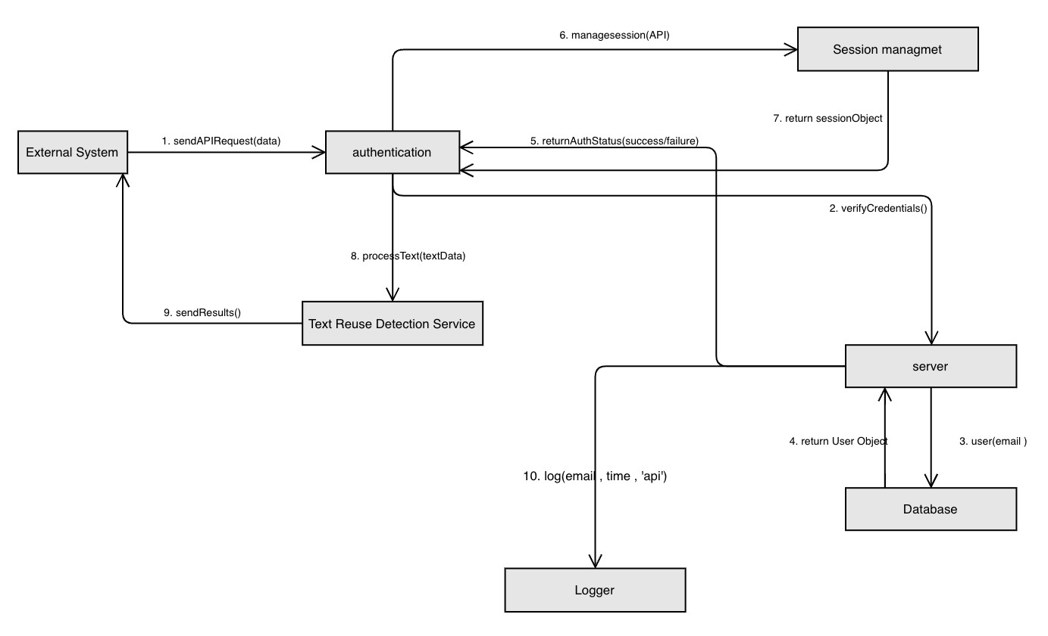
Figure 76 API services Collaboration Diagram

3.9.7 Rate Limiting for API
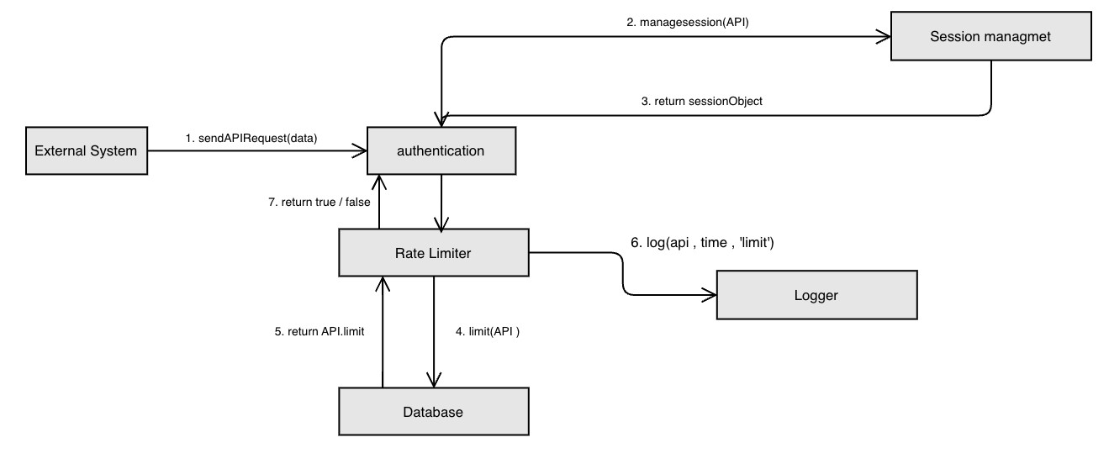
Figure 77 Rate Limiting for API Collaboration Diagram

3.9.8 Authorization for API
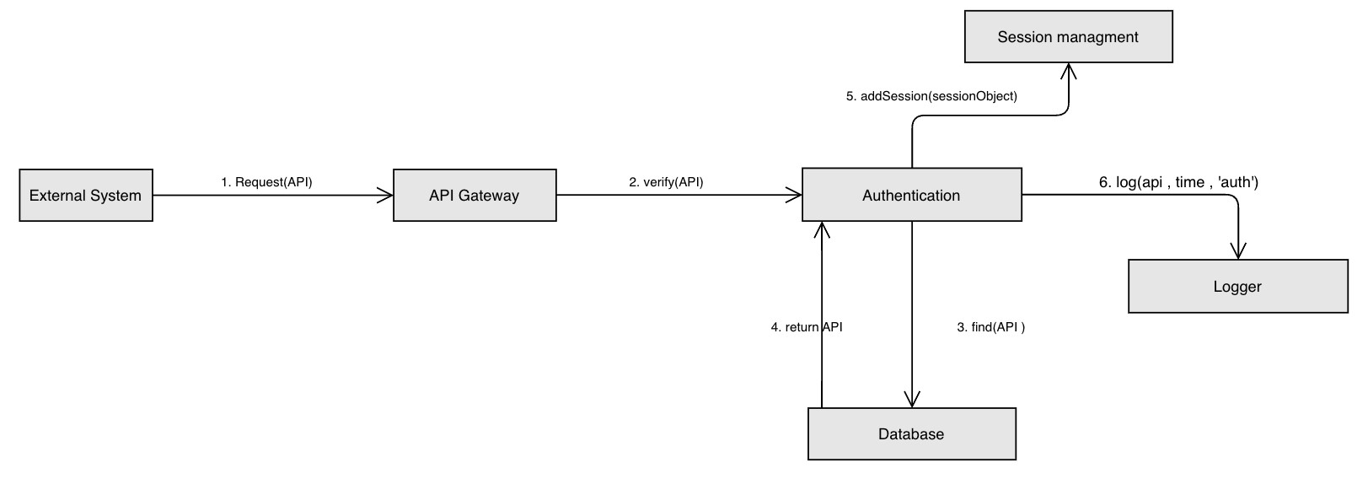
Figure 78 Authorization for API Collaboration Diagram

3.9.9 API logging
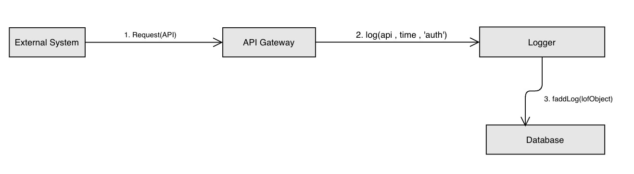
Figure 79 API logging Collaboration Diagram

3.9.10 User History
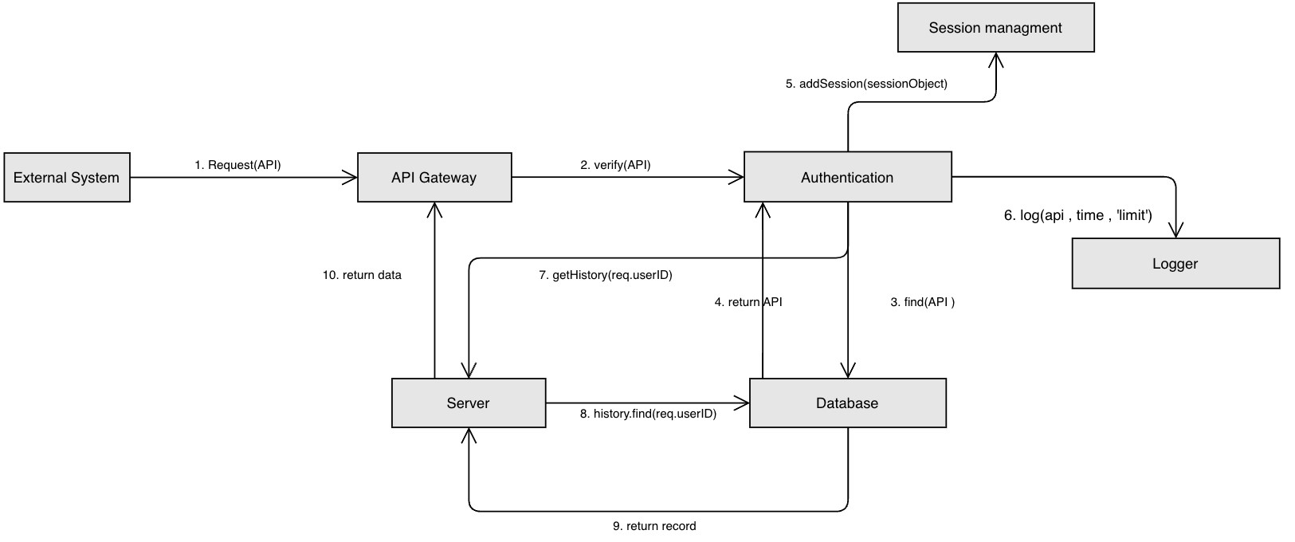
Figure 80 User History Collaboration Diagram

3.9.11 API Key management
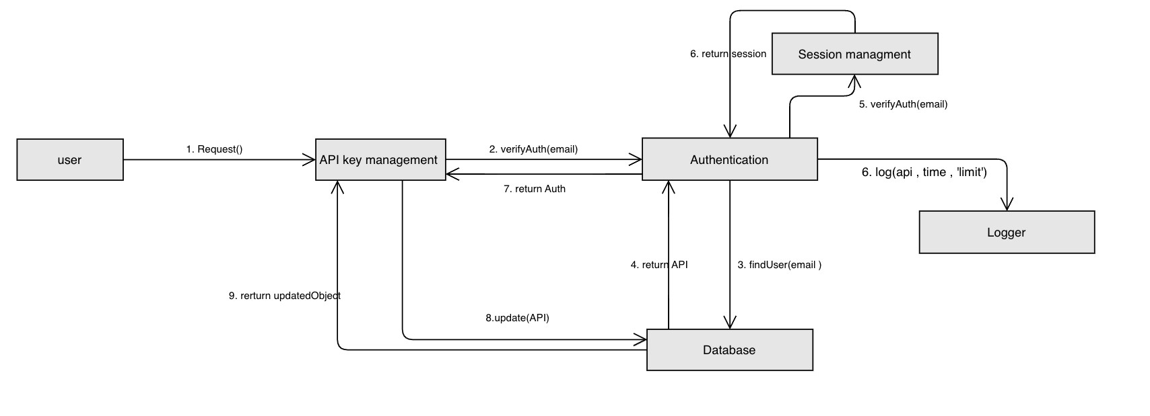
Figure 81 API Key management Collaboration Diagram

3.9.12 API monitoring
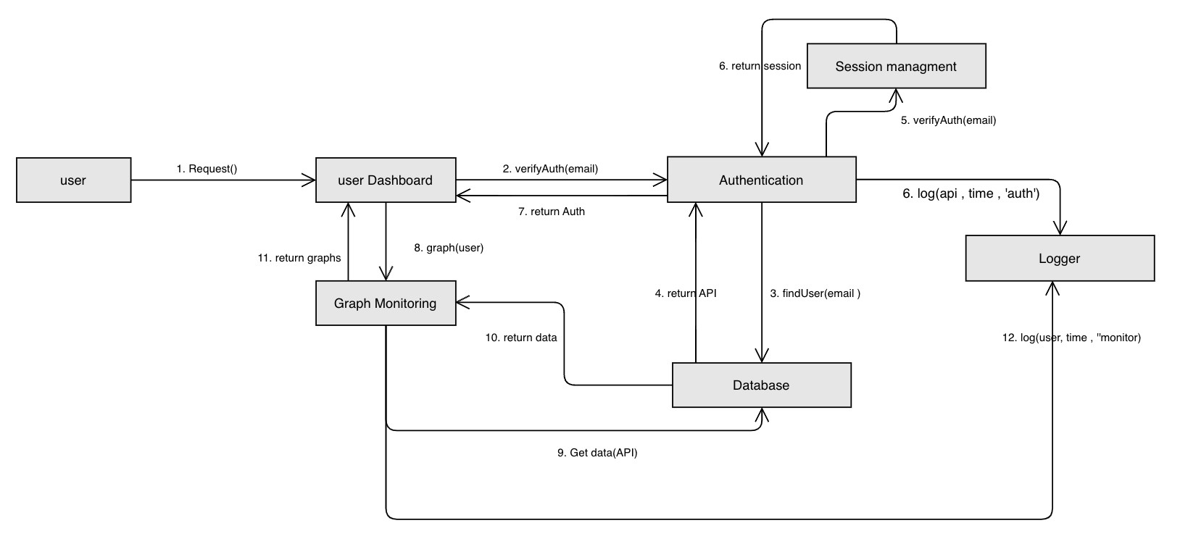
Figure 82 API monitoring Collaboration Diagram

3.9.13 Text Reuse Detection
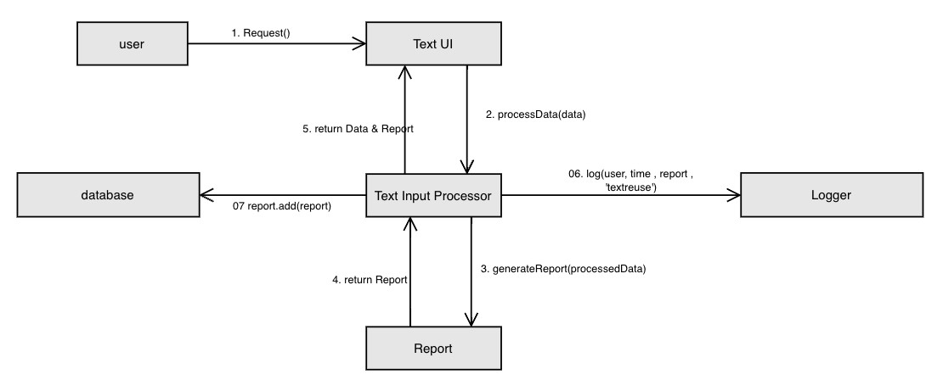
Figure 83 Text Reuse Detection Collaboration Diagram

3.9.14 Plagiarism Detection
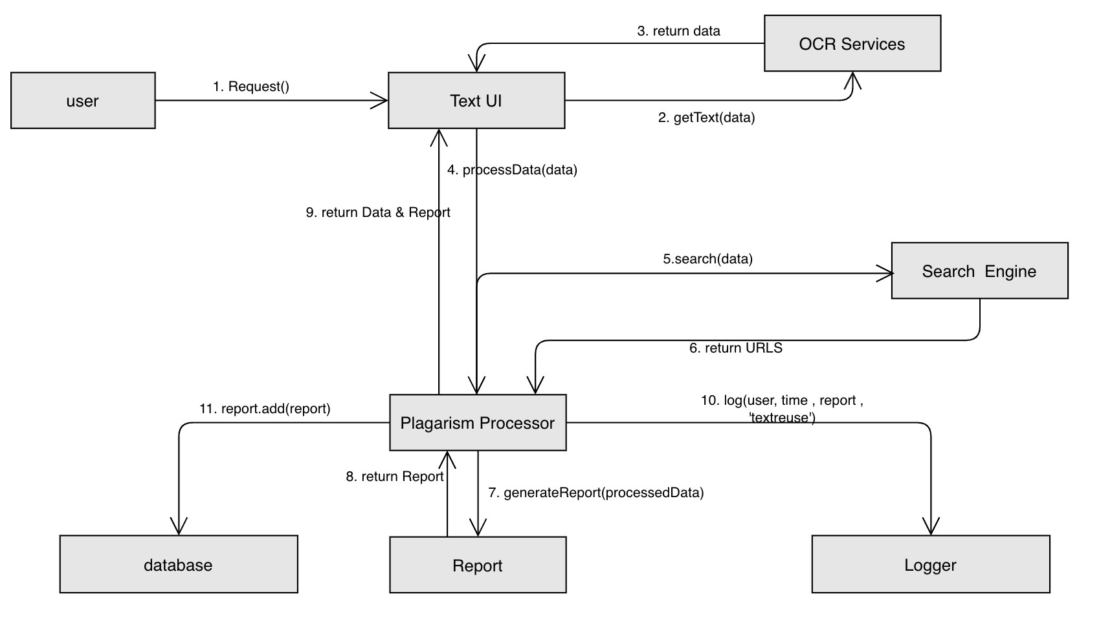
Figure 84 Plagiarism Detection Collaboration Diagram

3.9.15 Contact
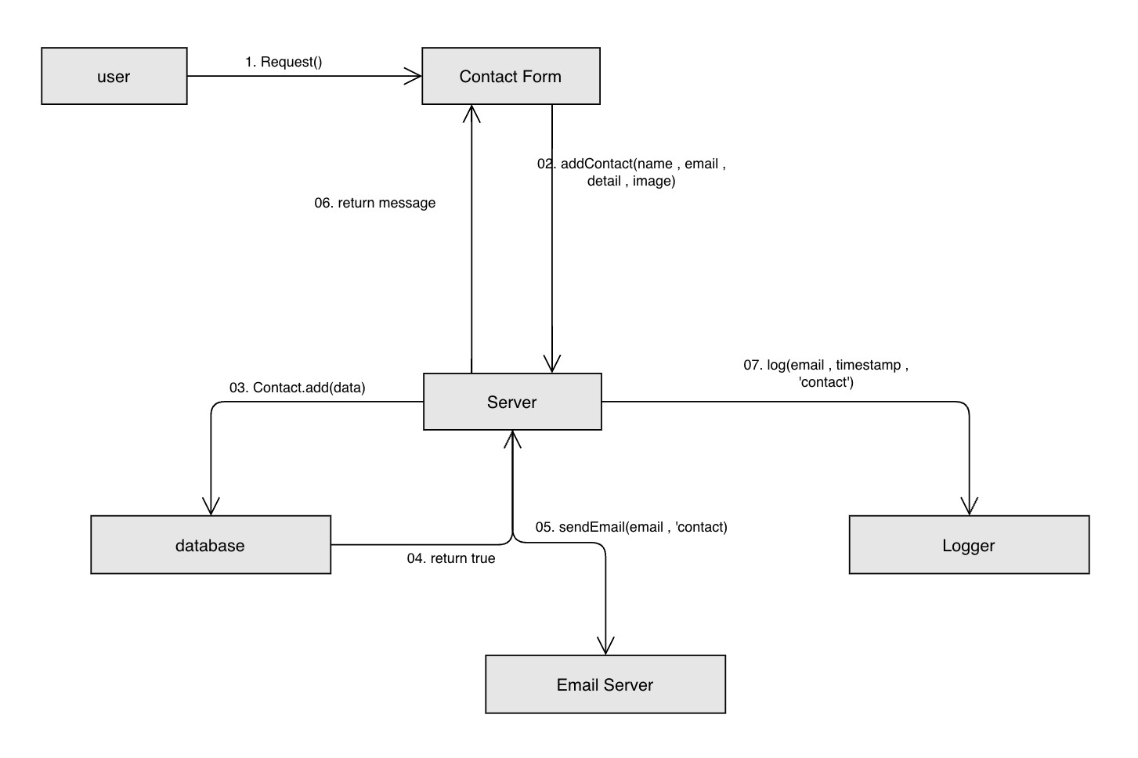
Figure 85 Contact Collaboration Diagram

3.9.16 Notification
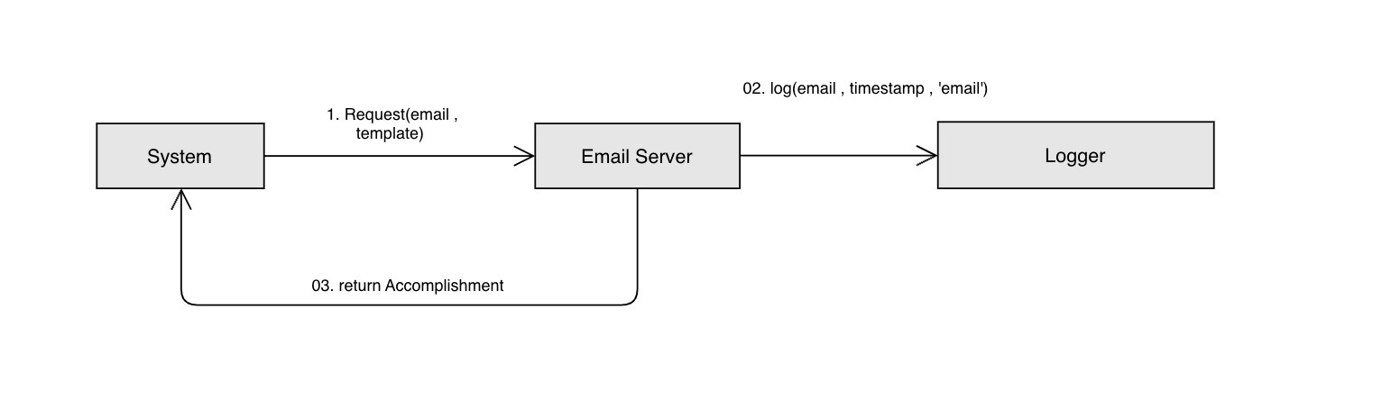
Figure 86 Notification Collaboration Diagram

3.9.17 Admin Dashboard
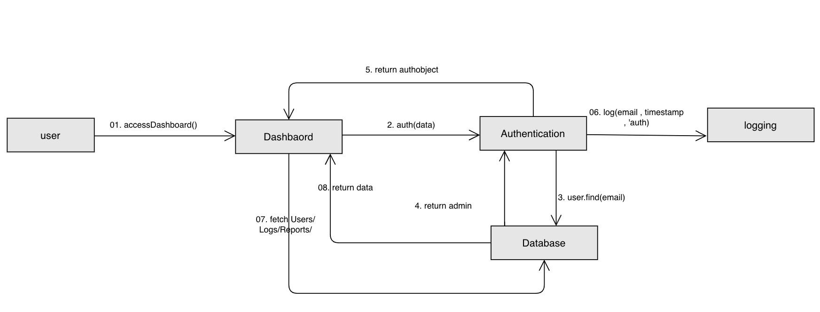
Figure 87 Admin Dashboard Collaboration Diagram

3.9.18 System Management
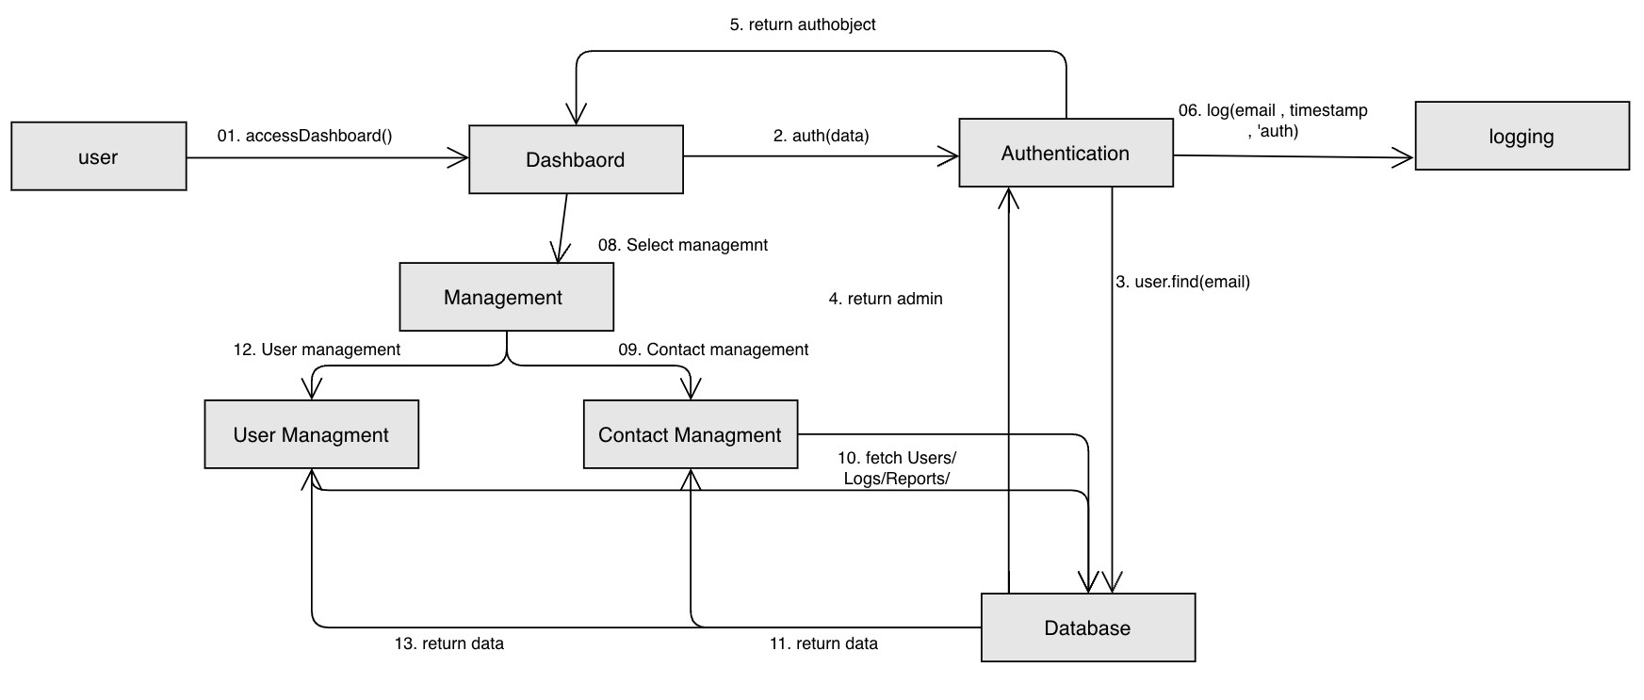
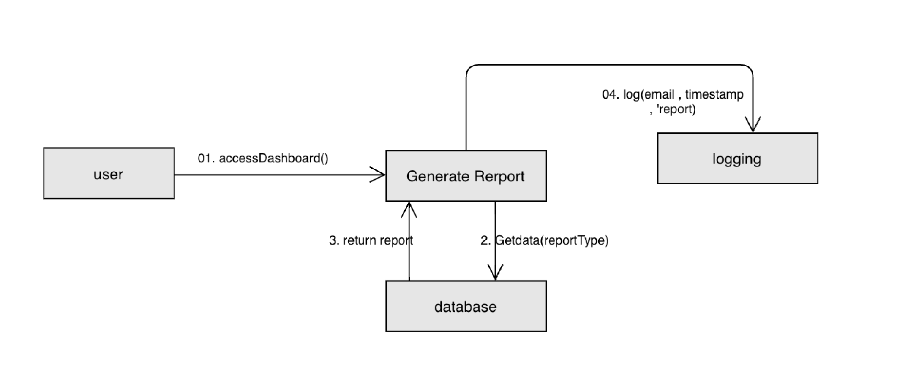
Figure 88 System Management Collaboration Diagram

3.9.19 Report Generation
Figure 89 Report Generation Collaboration Diagram

3.9.20 Analytics
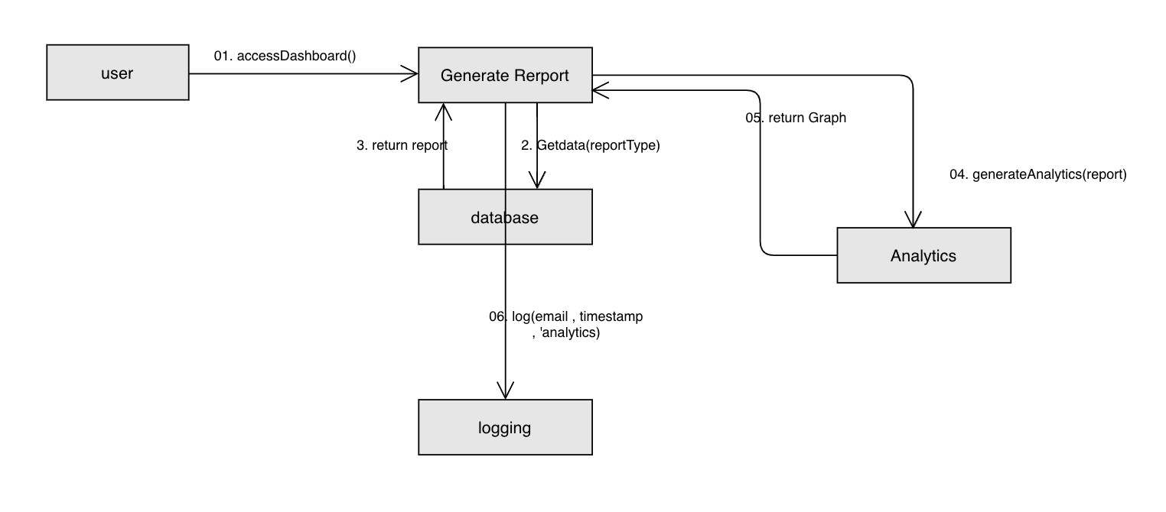
Figure 90 Analytic Collaboration Diagram

Chapter # 04

System Testing

4 System Testing

4.1 Test cases
The following are the test cases both valid and invalid for our final year project:

4.1.1 Login
Table 53 Test Case 01 Login
Field | TC01-01 (Valid Login Test) | TC01-02 (Invalid Login Test)
Test Case ID | TC01-01 | TC01-02
Test Case  Name | Valid Login Test | Invalid Login Test
Description | Test the functionality of logging in with valid credentials. | Test the system behaviour when logging in with invalid credentials.
Pre-  Conditions | - The user have a valid registered account with a valid email and password.  - No user is currently logged into the system. | - The user does not enter valid email and/or password.  - No user is currently logged into the system.
Steps | 1. Navigate to the login page. 2. Enter a valid email (e.g., user@example.com) and valid password.  3. Press the submit button. | - Go to the login page.  - Enter an wrong email format (for example rand#example.in) or incorrect password.  - Press the submit button.
Expected  Results | - System validates the email format and credentials.  - Displays a success notification.  - Logs the attempt (timestamp, IP).  - Redirects the user to the system home page. | - The system validates the email format and flags errors (e.g., "Invalid email format").  - Displays an error message.  - Highlights invalid fields.  - User remains on the same login page.
Post-  Conditions | The user is sign in into the system. | The user is not sign in into the system. If multiple failures occur, the system suggests using the "Forgot Password" feature.

4.1.2 Create Account
Table 54 Test Case 02 Create Account
Field | TC02-01 (Valid Account Creation  Test) |  | TC02-02 (Invalid Account Creation Test)
Test Case ID | TC02-01 |  | TC02-02
Test Case  Name | Valid Account Creation Test |  | Invalid Account Creation Test
Description | Test the functionality of creating an account with valid inputs and a successfully verified OTP. |  | Test the system behaviour when creating an account with invalid inputs (e.g., duplicate email) or incorrect OTP.
Pre-  Conditions | 1.  2.  3. | The user is not sign in into the system.  The user does not have an existing account with the email or phone number provided.  Email and phone number formats are correct. | 1. 2.  3. | The user is not sign in into the system. The input email is already registered with the system.  OTP entered by the user is incorrect or expired.
Steps | 1. 2.  3.  4. | Access the account creation page. Enter valid name, email, password, date of birth, phone number, and user type.  Submit the form.  Enter the correct OTP for verification. | 5. 6.  7.  8. | Access the account creation page.  Enter a duplicate email or invalid format phone number.  Submit the form.  Enter an incorrect or expired OTP for verification.
Expected  Results | 1. 2.  3.  4. | The system validates input fields. Generates and sends a 6-digit OTP to the user's email.  User enters the correct OTP. Accounts are created, and the user is redirected to the login page. |  | - System displays an error for duplicate email or invalid phone number and highlights the relevant field.  - Displays an error for incorrect OTP, allowing retries.
Post-  Conditions | The user account is successfully created and stored in the database. |  | The user remains on the account creation page and can correct inputs or retry OTP verification.

4.1.3 Forget Password
Table 55 Test Case 03 Forget Password
Field | TC03-01 (Valid Password Reset  Test) |  | TC03-02 (Invalid Password Reset Test)
Test Case  ID | TC03-01 |  | TC03-02
Test Case  Name | Valid Password Reset Test |  | Invalid Password Reset Test
Description | Test the functionality of resetting a password with valid email, correct OTP, and a valid new password. |  | Test the system behaviour when resetting a password with an invalid email, incorrect OTP, or a new password which is not according to the complexity requirements.
Pre-  Conditions | 1.  2. | The user is not logged into the system.  The email provided is registered in the system.  OTP is generated and sent to the registered email. | 1. 2.  3. | The user is not logged into the system. The email provided is not registered in the system or OTP entered is incorrect/expired.  New password is invalid.
Steps | 1.  2. 3. 4.  5. | Navigate to the "Forgot  Password" from the login page.  Enter a registered email.  Enter the correct OTP. Enter and confirm a valid new password.  Submit the form. | 1.  2.  3. 4.  5. | Navigate to the "Forgot Password" from the login page.  Enter an unregistered email or incorrect email format.  Enter an incorrect or expired OTP.  Enter an invalid new password.  Submit the form.
Expected  Results | 1.  2.  3.  4. | The system validates email and OTP.  System prompts for a new password.  User enters a valid, complex password.  Password is reset successfully, and user will be navigated to the login page. | 1.  2. | The system displays an error message for invalid email, incorrect OTP, or invalid new password.  User remains on the reset page and can correct inputs or retry OTP.
Post-  Conditions | The user's password field is updated in the database, and the user successfully redirected to the login page with a successful message. |  | The password reset fails. The user stays on the password reset page and can retry with corrected inputs.

4.1.4 Change Password
Table 56 Test Case 04 Change Password
Field | TC04-01 (Valid Password Change Test) |  | TC04-02 (Invalid Password Change  Test)
Test Case ID | TC04-01 |  | TC04-02
Test Case  Name | Valid Password Change Test |  | Invalid Password Change Test
Description | Test the functionality of changing the password with the correct current password and a valid, complex new password that is different from the old one. |  | Test the system behaviour when the current password is wrong, or the new password input by user doesn’t meet complexity requirements.
Pre-  Conditions | 1.  2. | The user is logged into the system.  The user knows their current password. | 1.  2. | The user is sign in into the system. The user enters an incorrect current password or a new password that does not meet complexity requirements.
Steps | 1.  2. 3.  4. | Redirect to the profile page and select "Change Password".  Enter the correct current user password.  Enter and confirm a valid new password.  Submit the form. | 1.  2.  3. | Redirect to the profile page and select "Change Password" option. Enter an wrong current password. Enter a weak or invalid new password.
 |  |  | 4. | Submit the form.
Expected  Results |  | - System validate and verify the current password of user.  - System will check the new password is according to the complexity requirements and is different from the old password.  Password is successfully updated, all sessions are terminated, and the user is notified of the successful change. |  | - The system will output an error message showing incorrect current password or invalid new password.  - User remains on the change password page to retry.
Post-  Conditions | The user's password is updated in the database, all active sessions are terminated, and the user is notified of the successful password change. |  | The password change fails. The user stays on the change password page and can retry with corrected inputs.

4.1.5 Edit Profile
Table 57 Test Case 05 Edit Profile
Field | TC05-01 (Valid Profile Update Test) |  | TC05-02 (Invalid Profile Update Test)
Test Case ID | TC05-01 |  | TC05-02
Test Case  Name | Valid Profile Update Test |  | Invalid Profile Update Test
Description | Test the functionality of updating the user's profile with valid information, including a valid phone number and profile picture. |  | Test the system behaviour when invalid information is provided, such as an incorrect phone number or invalid profile picture format.
Pre-  Conditions | 1.  2. | The user is sign in into the system. The user has an existing profile with updatable fields. | 1.  2. | The user is sign in into the system. The user attempts to update the profile with incorrect or invalid data (e.g., wrong phone number format, invalid image).
Steps |  | - Navigate to the profile management section.  - View the current profile information.  - Click on the update button.  - Input valid information (e.g., phone number, profile picture).  - Submit the changes. | 1.  2.  3.  4. | Navigate to the profile management section. View the current profile information.  Click on the update button. Input invalid data (e.g., incorrect phone number format, invalid image).
 |  |  | 5. | Submit the changes.
Expected  Results | 1. 2.  3. | System validates the input fields. Profile is successfully updated in the database.  A notification email is sent.  The activity is logged. | - Sys inv nu  - The | tem displays error messages for  alid inputs (e.g., incorrect phone  mber format, invalid image file).  user remains on the profile update  page to correct the data.
Post-  Conditions | The user's profile detail is successfully updated, and related notification is sent about the update. |  | The user's profile information is not updated, and error messages are displayed. The user remains on the profile update page to fix the issues.

4.1.6 API Services
Table 58 Test Case 06 API Services
Field | TC06-01 (Valid API Request Test) |  | TC06-02 (Invalid API Request Test)
Test Case ID | TC06-01 |  | TC06-02
Test Case  Name | Valid API Request Test |  | Invalid API Request Test
Description | Test the functionality of sending a valid API request with correct data and API key to process text reuse detection and plagiarism detection. |  | Test the system's behaviour when the API request is invalid due to incorrect API key or exceeding rate limits.
Pre-  Conditions |  | - The external platform has a valid API key.  - The external platform complies with rate limiting policies.  - The user has access to the API documentation. |  | - The external platform sends a request with an invalid API key or exceeds the rate limit for requests.  - The user does not comply with rate limiting policies.
Steps | 1.  2. 3.  4.  5. | External platform sends a request to the API with valid text data and API key. System authenticates the API key. System processes the request using AI models for text reuse detection.  System returns the results to the external platform.  System logs the API request and response. | 1.  2.  3.  4. | External platform sends a request to the API with an invalid API key or exceeds rate limits.  System detects invalid API key or rate limit issue.  System returns an authentication error or rate limit exceeded error. System logs the error and provides an appropriate error response.
Expected  Results | 1.  2. | System processes the text reuse detection request successfully and returns processed results.  The system logs the API request and response with a timestamp and user identifier. | 1.  2. | System returns an error message indicating the invalid API key or rate limit issue.  The system logs the error with a timestamp and user identifier.
Post-  Conditions | The external platform receives the processed results of the text reuse detection and plagiarism detection. |  | The external platform receives an error message explaining the reason for the failure, such as invalid API key or rate limit exceeded.

4.1.7 Rate Limit for API
Table 59 Test Case 07 Rate Limiting
Field | TC07-01 (Valid Rate Limit Test) |  | TC07-02 (Invalid Rate Limit Test)
Test Case ID | TC07-01 |  | TC07-02
Test Case  Name | Valid Rate Limit Test |  | Invalid Rate Limit Test
Description | Test the functionality of the rate limiting system by making API requests within the allowed rate limit. |  | exc | Test the system’s response when the rate limit is eeded and the system throttles the API request.
Pre-  Conditions | 1.  2. | API user has a valid API key. API user is within the rate limit for API requests. |  | - API user has a valid API key.  - API user exceeds the rate limit for API requests.
Steps | 1.  2.  3.  4. | API user sends a request to the API.  System checks the number of requests made by the user within the current time frame. System processes the request because it is within the rate limit.  System logs the event. | 1.  2.  3.  4. | API user sends a request to the API that exceeds the allowed rate limit.  System checks the number of requests made by the user and detects the limit has been exceeded.  System throttles the request and returns a rate limit exceeded error message.  System logs the event.
Expected  Results | System processes the API request successfully and logs the event with a timestamp and user identifier. |  | 1.  2. | System throttles the request and returns a "rate limit exceeded" error message. The system logs the error with a timestamp and user identifier.
Post-  Conditions | The API request is processed successfully, and the user is within the rate limit for future requests. |  | The API request is throttled, and the user is notified about exceeding the rate limit. The user is prevented from making additional requests within the time frame.

4.1.8 Authorization for API
Table 60 Test Case 08 Authorization
Field | TC08-01 (Valid Authorization Test) | TC08-02 (Invalid Authorization Test)
Test Case  ID | TC08-01 | TC08-02
Test Case  Name | Valid API Authorization | Invalid API Authorization
Description | Test the system’s handling of valid API keys and authorized access to API services. | Test the system’s response when the API key is missing, invalid, or expired, leading to unauthorized access.
Pre-  Conditions | - API user has a valid API key.  - API user includes the API key in the request header or parameters. | 1. API user has either an invalid or expired API key or is missing the API key in the request.
Steps | - API user includes the valid API key in the request.  - System retrieves and verifies the API key.  - System grants access to the requested service.  - System processes the request and returns a valid response.  - System logs the authorization attempt. | - API user omits the API key, or the key is invalid or expired.  - System retrieves and verifies the API key, detects the error.  - System denies access and returns an authentication error.  - System logs the failed authorization attempt.
Expected  Results | System grants access to the requested service, processes the request, and logs the successful authorization attempt with a timestamp and user identifier. | System denies access to the requested service, returns an authentication or authorization error message, and logs the failed attempt with a timestamp and user identifier.
Post-  Conditions | API user gains access to the requested service, and the authorization attempt is logged. | API user is denied access, and the error is logged. The system prevents further access until a valid API key is provided.

4.1.9 API logging
Table 61 Test Case 09 API logging
Field | TC09-01 (Valid API Logging Test) |  | TC09-02 (Invalid API Logging Test)
Test Case ID | TC09-01 |  | TC09-02
Test Case  Name | Valid API Logging |  | Invalid API Logging
Description | Test the system’s ability to log API requests, responses, and activities when the logging system is functioning correctly. |  | Test the system’s behaviour when the logging service is unavailable or encounters an issue (e.g., storage issues, system failure).
Pre-  Conditions | 1.  2. | API user has access to API services.  System has logging capabilities enabled. | 1. | API user has access to API services, but logging service is unavailable or encounters a failure.
Steps | 1.  2.  3. | API user sends a request to the API.  System processes the request and generates a response.  System logs the request details (timestamp, API key, request parameters, response status). | 1. 2.  3.  4. | API user sends a request to the API. System processes the request and generates a response.  Logging service is unavailable or fails (e.g., storage issue).  System alerts the admin and retries logging.
- System securely stores the log.
- Admin accesses the logs.
Expected  Results | The system logs the request, response, and relevant details securely. Admin can access the logs for review. |  | The system queues the logs or retries logging once the service is restored. Admin receives an alert, and logs are not immediately recorded.
Post-  Conditions | All API interactions are recorded and stored securely. Admin can access detailed logs for analysis. |  | Logs are queued for later processing, and admin is notified of the logging failure. The system attempts to log once the issue is resolved.

4.1.10 User History
Table 62 Test Case 10 User History
Field | TC10-01 (Valid User History Test) |  | TC10-02 (Invalid User History Test)
Test Case ID | TC10-01 |  | TC10-02
Test Case  Name | Valid User History Tracking |  | Invalid User History Tracking
Description | Test the system’s ability to track and store user history correctly, allowing the user to view their actions and API calls from their dashboard. |  | Test the system’s behaviour when it fails to record an action due to system error or insufficient permissions.
Pre-  Conditions | 1.  2. | User is authenticated and logged into the system.  System has tracking capabilities enabled. | 1.  2. | User is authenticated and logged into the system.  System tracking capabilities are enabled, but there is a failure in recording actions (e.g., system error).
Steps | 1.  2.  3.  4. | User performs an action or makes an API call.  System records the action details (timestamp, action type, parameters).  History is stored in the user's profile. User accesses their history via their dashboard. | 1.  2.  3. | User performs an action or makes an API call.  System fails to record the action due to a system error (e.g., storage issue).  System notifies the user about the failure.
Expected  Results | The action is logged successfully and stored in the user's history. User can access the history via their dashboard. |  | The system notifies the user of the failure to record the action and offers an option to retry or report the issue.
Post-  Conditions | User’s actions and API calls are successfully recorded and can be reviewed in the dashboard. |  | User is informed of the failure to record their action, and they can retry or report the issue to the admin.

4.1.11 API Key Management
Table 63: Test Case 11 API Key Management
Field | TC11-01 (Valid API Key Management  Test) |  | TC11-02 (Invalid API Key Management  Test)
Test Case  ID | TC11-01 |  | TC11-02
Test Case  Name | Valid API Key Management |  | Invalid API Key Management
Description | Test the system’s ability to allow a user to generate and manage API keys, including creating multiple keys, regenerating keys, and downloading them for backup. |  | Test the system’s behaviour when a user attempts to generate more API keys than allowed or when the API key generation service is unavailable.
Pre-  Conditions | 1.  2. | User is sign in into the system. User has the appropriate permissions to manage API keys. | 1.  2. | User is logged into the system. User attempts to generate more API keys than allowed, or the API key generation service is unavailable.
Steps | 1.  2.  3. 4. 5.  6. | User redirects to the API key management section.  User chooses to generate a new API key.  System generates a unique API key. User can create multiple API keys. User downloads the API key in CSV or PDF format.  System logs the API key management event. | 1.  2.  3. | User navigates to the API key management section.  User attempts to generate more API keys than allowed (or service is unavailable).  System displays an error message or alerts the user about the issue.
Expected  Results | System successfully generates and allows the user to download the API key. The event is logged. |  | System alerts the user with an error message (e.g., "API key limit exceeded" or "Service unavailable"). The user is given an option to retry or contact support.
Post-  Conditions | API key(s) generated, downloaded, and logged successfully. |  | User is informed of the failure and can retry the action as necessary.

4.1.12 API Monitoring
Table 64 Test Case 12 API Monitoring
Field | TC12-01 (Valid API Monitoring Test) |  | TC12-02 (Invalid API Monitoring Test)
Test Case  ID | TC12-01 |  | TC12-02
Test Case  Name | Valid API Monitoring and Quota  Enforcement |  | Invalid API Monitoring (Failure in Quota  Enforcement)
Description | 1. | Tests the system’s ability to provide valid API usage analytics and enforce quota limits correctly, including notifying the user and suspending their access if exceeded. | 2. | Tests the system’s behaviour when there is a failure in quota enforcement, such as the suspension of API services not occurring even if the quota is exceeded.
Pre-  Conditions | 1.  2. | User is logged in with an active account.  Admin is logged in with access to the monitoring dashboard. | 3.  4. | User is logged in with an active account.  Admin is logged in with access to the monitoring dashboard.
 |  |  | 5. | The system's monitoring service is functioning correctly.
Steps | 1.  2.  3.  4.  5. 6.  7. | User accesses the API monitoring dashboard.  System displays usage analytics, including total API calls and remaining quota.  Admin accesses the dashboard and selects the user to monitor.  System displays detailed API usage statistics.  Admin reviews the analytics. If the user exceeds the quota, the system suspends their access and sends an email notification.  System logs all monitoring activities. | 1.  2. 3.  4. | Admin accesses the dashboard and selects the user.  Admin reviews usage statistics. User exceeds the quota, but the system fails to suspend the service. The system does not send an email notification.
Expected  Results | 1. | The system displays accurate usage statistics and successfully enforces quota limits by suspending the user’s access and sending an email notification. | 1. | The system fails to suspend the user’s access after exceeding the quota and does not send an email notification, indicating a failure in quota enforcement.
Post-  Conditions | API usage statistics displayed correctly. User's access suspended if quota exceeded and email sent. Monitoring activities logged. |  | User's access is not suspended, and no email notification is sent despite exceeding the quota.

4.1.13 Text Reuse Detection
Table 65 Test Case 13 Text Reuse Detection
Field | TC13-01 (Valid Reuse Detection Test) |  | TC13-02 (Invalid Reuse Detection  Test)
Test Case  ID | TC13-01 |  | TC13-02
Test Case  Name | Valid Reuse Detection and Report  Generation |  | Invalid Reuse Detection (OCR Failure /  Unsupported File Format)
Description | Tests the system's ability to detect text reuse accurately from manually inputted text or uploaded documents/images, process it using AI models, and generate a report. |  | Tests the system’s behaviour when an uploaded image cannot be processed due to OCR failure or an unsupported file format, preventing reuse detection and report generation.
Pre-  Conditions | 1. 2.  3. | User is logged in.  User has access to the reuse detection tool.  System has necessary AI models and OCR capabilities. | 1. 2.  3. | User is logged in.  User has access to the reuse detection tool.  The uploaded file is in an unsupported format or the OCR fails to process the text.
Steps | 1.  2.  3.  4. 5. 6.  7. 8.  9. | User navigates to the reuse detection tool.  User inputs two Urdu paragraphs manually or uploads a valid document/image.  OCR processes the text from the image (if applicable).  System displays extracted text.  User initiates reuse detection. System processes texts using AI models.  System calculates the reuse percentage.  System generates a report.  User downloads the report. | 1.  2.  3.  4.  5. | User navigates to the reuse detection tool.  User uploads an unsupported file type (e.g., .docx, .jpg).  System prompts for a compatible format.  User uploads a clearer image, but OCR still fails to extract text.  The system shows an OCR failure notification and suggests uploading a clearer image.
Expected  Results | 1. | The system successfully processes the texts and generates a detailed report on reused content with percentages, categories, and sources. User can download the report. | 1. | The system fails to process the uploaded file or text, displays an error or warning message about unsupported file format or OCR failure, and provides suggestions for resolution.
Post-  Conditions | Reuse detection report is generated and available for download. |  | User is informed of the failure (either due to unsupported file format or OCR
 |  |  | failure) and is prompted to retry or correct the issue.

4.1.14 Plagiarism Detection
Table 66 Test Case 14 Plagiarism Detection
Field | TC14-01 (Valid Plagiarism Detection  Test) |  | TC14-02 (Invalid Plagiarism Detection  Test)
Test Case  ID | TC14-01 |  | TC14-02
Test Case  Name | Valid Plagiarism Detection and Report  Generation |  | Invalid Plagiarism Detection  (Unsupported File Format)
Description | Tests the system's ability to detect plagiarism from an uploaded text file containing Urdu content, process the text using online sources, and generate a report. |  | Tests the system’s behaviour when an unsupported file type is uploaded, preventing plagiarism detection and report generation.
Pre-  Conditions | 1. 2.  3. | User is logged in.  User has access to the plagiarism detection tool.  System has access to online search engines and databases for comparison. | 1. 2.  3. | User is logged in.  User has access to the plagiarism detection tool.  The uploaded file is in an unsupported format (e.g., .docx, .jpg).
Steps | 1.  2.  3.  4.  5.  6. 7.  8. | User navigates to the plagiarism detection tool.  User uploads a text file with Urdu content in a supported format. System extracts the text from the uploaded file.  System compares the extracted text with online sources.  System calculates the plagiarism percentage.  System identifies source URLs.  System generates a plagiarism report.  User downloads the report. | 1.  2.  3. | User navigates to the plagiarism detection tool.  User uploads an unsupported file format (e.g., .docx, .jpg).  System notify the user to upload a valid and accordant file.
Expected  Results | 1. | The system processes the text, calculates the plagiarism percentage, retrieves the source URLs, generates a report, and allows the user to download the report. | 1. | The system output an error message popup box informing the user about the unsupported file format and prompts the user so it can upload a compatible file.
Post-  Conditions | The plagiarism detection report is generated, and the user can download it. |  | The system prompts the user to upload a compatible file, and the plagiarism detection process is halted.

4.1.15 Contact & Query Form
Table 67 Test Case 15 Contact & Query Form
Field | TC15-01 (Valid Contact Form  Submission) |  | TC15-02 (Invalid Contact Form  Submission - Missing Category)
Test Case  ID | TC15-01 |  | TC15-02
Test Case  Name | Valid Contact Form Submission and Query  Handling |  | Invalid Contact Form Submission -  Missing Message Category
Description | Tests the system’s ability to successfully submit a query or complaint with all required fields, categorize the message, send it to the admin, track status, and notify the user. |  | Tests the system’s behaviour when a user tries to submit a query without selecting a message category, which is a required field. The system should prompt the user to select one.
Pre-  Conditions | 1.  2. | User is logged in (optional depending on design).  User has access to the contact form tool. | 1.  2. | User is logged in (optional depending on design).  User has access to the contact form tool.
Steps | 1. 2.  3. 4. 5. 6.  7.  8.  9. | User navigates to the contact form. User fills in the query or complaint details.  User selects a message category.  User submits the form.  System sends the query to the admin. Admin reviews and responds to the query.  User views their submitted query and admin response.  User tracks the query status. System sends email notifications to the user on status updates. | 1. 2.  3.  4.  5. | User navigates to the contact form. User fills in the query or complaint details.  User does not select a message category.  User attempts to submit the form. System prompts the user to select a category.
Expected  Results | The query is successfully submitted, sent to the admin, status is tracked, and the user is notified of updates. |  | The system notify the user to select a category and does not allow form submission until the user selects a message category.
Post-  Conditions | The query is successfully submitted, tracked, and responded to by the admin. User receives email notifications as per status updates. |  | The system does not allow the query to be submitted until the user selects a category, and the user is notified of the error.

4.1.16 Notifications
Table 68 Test Case 16 Notifications
Field | TC16-01 (Valid Notification) |  | TC16-02 (Invalid Notification -  Invalid Content)
Test Case ID | TC16-01 |  | TC16-02
Test Case  Name | Valid Notification to User |  | Invalid Notification - Invalid Content
Description | Tests the system’s ability to successfully send a notification when a predefined important event occurs (e.g., task completion), respecting user preferences. |  | Tests the system’s behaviour when an invalid notification is attempted (e.g., the notification content contains prohibited information).
Pre-  Conditions | 1. 2.  3. | User is registered in the system.  System identifies an important event. Admin has permission to send notifications. | 1. 2.  3. | User is registered in the system. Admin has permission to send notifications.  Admin is attempting to send a notification with invalid content.
Steps | 1.  2. 3.  4. | System identifies an important event (e.g., task completion).  System process a notification message. System shall notify user by sending the email notification to the user. User receives the notification. | 1.  2.  3. | Admin creates a notification with invalid content (e.g., prohibited words or sensitive information). Admin attempts to send the notification.  System rejects the notification and alerts the admin.
Expected  Results | The notification is successfully sent, and the user receives and views the notification in their email. |  | The system rejects the notification due to invalid content and alerts the admin with an error message.
Post-  Conditions | The user receives a timely and relevant notification about the important event. The system logs the notification activity. |  | The notification is not sent, and the admin is alerted to correct the content of the notification before attempting to send it again.

4.1.17 Admin Dashboard
Table 69 Test Case 17 Admin Dashboard
Field | TC17-01 (Valid Admin Dashboard  Access) |  | TC17-02 (Invalid Admin Dashboard  Access - Insufficient Permissions)
Test Case ID | TC17-01 |  | TC17-02
Test Case  Name | Valid Admin Dashboard Access |  | Invalid Admin Dashboard Access -  Insufficient Permissions
Description | Tests the system’s ability to grant an admin access to the dashboard and display relevant metrics, logs, and activities for management. |  | Tests the system’s behaviour when an admin lacks sufficient permissions to access certain dashboard functionalities or data.
Pre-  Conditions | 1.  2. | Admin is logged into the system with appropriate administrative privileges.  The system has dashboard capabilities enabled and populated with relevant data. | 1.  2. | Admin is logged into the system but has limited privileges (e.g., restricted access to certain dashboard features). The system has dashboard capabilities enabled.
Steps | 1. 2.  3.  4. | Admin sign in into the system. Admin redirects to the admin dashboard main page.  System displays relevant metrics such as user stats, API usage, etc. Admin interacts with the dashboard, viewing logs and performing administrative tasks. | 1.  2.  3. | Admin logs into the system with limited permissions.  Admin navigates to the admin dashboard section.  System restricts access to certain dashboard functionalities and displays an appropriate message.
Expected  Results | Admin can view the dashboard with the relevant data, and interact with the widgets to manage system operations effectively. |  | The system restricts access to certain areas of the dashboard based on insufficient permissions, and the admin receives an appropriate error message.
Post-  Conditions | Admin has comprehensive visibility into system metrics and can perform necessary administrative tasks. |  | Admin is informed of the access restriction and may attempt to resolve the issue by contacting support or adjusting permissions.

4.1.18 System Management
Table 70 Test Case 18 System Management
Field | TC18-01 (Valid System Management -  Admin Task) |  | TC18-02 (Invalid System Management -  Insufficient Permissions)
Test Case  ID | TC18-01 |  | TC18-02
Test Case  Name | Valid System Management - Admin Task |  | Invalid System Management - Insufficient  Permissions
Description | Tests the system's ability to allow an admin to access and manage user accounts, complaints, queries, and perform administrative tasks like updating settings. |  | Tests the system’s behaviour when an admin lacks sufficient permissions to perform certain administrative tasks, such as configuring settings or managing API keys.
Pre-  Conditions | 1.  2. | Admin is logged into the system with appropriate administrative privileges.  The system has user and task management capabilities enabled. | 1.  2. | Admin is logged into the system but has limited privileges (e.g., restricted access to certain system management functionalities).  System has user and task management capabilities enabled.
Steps | 1.  2.  3.  4. | Admin accesses the system respective page from the admin dashboard.  Admin analyse the list of system users, their details, and statuses. Admin creates, updates, or deletes user accounts.  Admin manages complaints and queries, and performs other administrative tasks. | 1.  2.  3. | Admin accesses the system management section from the admin dashboard.  Admin attempts to perform an action (e.g., configuring system settings) without required permissions. The system displays an error message for insufficient permissions.
Expected  Results | Admin can view and manage users, complaints, and queries, and perform administrative tasks such as configuring system settings. |  | The system restricts access to certain tasks due to insufficient permissions and displays an appropriate error message indicating the restriction.
Post-  Conditions | Admin effectively manages users, complaints, queries, and system settings. |  | Admin is informed of the access restriction and may attempt to resolve the issue by contacting support or adjusting permissions.

4.1.19 Report Generation
Table 71 Test Case 19 Report Generation
Field | TC19-01 (Valid Report Generation -  Admin Task) |  | TC19-02 (Invalid Report Generation -  No Data for Filters)
Test Case ID | TC19-01 |  | TC19-02
Test Case  Name | Valid Report Generation - Admin Task |  | Invalid Report Generation - No Data for  Filters
Description | Tests the system's ability to allow an admin to generate reports with valid filters and export them in the desired format (CSV/PDF). |  | Tests the system’s behaviour when an admin selects filters that result in no data being returned, such as a date range with no activity.
Pre-  Conditions | 1.  2. | Admin is logged into the system with appropriate administrative privileges. Reporting capabilities are enabled, and the system has access to relevant data. | 1.  2. | Admin is logged into the system with appropriate administrative privileges. Reporting capabilities are enabled, and the system has access to relevant data.
Steps | 1.  2.  3.  4.  5. | Admin redirect to the report generation section in the admin dashboard.  Admin selects the report type (e.g., user activity, API usage).  Admin applies filters such as date range, specific users, or activity types. Admin generates the report in CSV or PDF format.  Admin shall exports and download the report. | 1.  2.  3.  4.  5. | Admin shall redirect to the report generation section in the admin dashboard.  Admin selects report type (e.g., user activity).  Admin applies filters such as date range and activity type.  System retrieves no data based on selected filters.  System notifies the admin and suggests adjusting the filters.
Expected  Results | The system generates the report and allows the admin to export it in the selected format (CSV/PDF). |  | The system notifies the admin that no data was found based on the selected filters and suggests adjusting the filters.
Post-  Conditions | Admin successfully generates and exports the report in the desired format. |  | Admin is informed that no data was found and can adjust the filters or modify the report criteria accordingly.

4.1.20 Analytics Report
Table 72 Test Case 20 Analytics Report
Field | TC20-01 (Valid Analytics Report  Generation - Admin) |  | TC20-02 (Invalid Analytics Report  Generation - Unauthorized Access)
Test Case ID | TC20-01 |  | TC20-02
Test Case  Name | Valid Analytics Report Generation –  Admin |  | Invalid Analytics Report Generation -  Unauthorized Access
Description | Tests the system’s ability to allow an admin to retrieve, filter, and export usage analytics data in a desired format. |  | Tests the system’s response when a non-super user attempts to access analytics data without the necessary permissions.
Pre-  Conditions | 1.  2. | Admin is logged into the system. The system has usage analytics data available. | 1. User (not supers user) attempts to access the analytics section.
Steps | 1.  2.  3.  4.  5. | Admin navigates to the analytics section.  Admin selects the analytics report type (e.g., token usage, remaining quota).  Admin applies any desired filters (e.g., date range, user). System generates the analytics report and displays the results. Admin exports the report or requests the data in a formatted document. | - Non-admin user attempts to access the analytics section.  - System restricts access and notifies the user that they lack the necessary permissions.
Expected  Results | Admin successfully retrieves the desired analytics data and exports it in the selected format. |  | System prevents access and shows an appropriate notification (e.g., "You do not have the necessary permissions to view analytics data.").
Post-  Conditions | Admin successfully exports analytics data for further analysis. |  | Non-admin user is informed that they cannot access the analytics section and is restricted from further actions.

4.2 Testing
In our final year project, testing strategy is important. It ensures the reliability, efficiency, and security of our detection system. We are using a variety of testing methods in which each method is designed to a specific part of the system architecture, as described in the sections below.

4.2.1 Unit Testing
Unit testing is testing of individual components of the software which ensure that every piece of the program output as it was designed or supposed to be.

4.2.2 Black Box Testing
We test the web application by inputting various Urdu text examples to see if the system accurately detects reuse without considering the internal operations. This helps ensure that the system behaves as expected for the end-users who interact through the frontend.

4.2.3 White Box Testing
It implies testing for the inner workings or structure of our AI models as they correctly examine and compare the Urdu texts. Logic within code paths, decision statements in the backend, and integration points that would hook the AI model into the backend server are a few of those.

4.2.4 Integration Testing
Integration testing checks the connectivity and data transfer between multiple components of our system, which includes the frontend, backend, AI model server, and database server. The key areas include the following:

4.2.5 Frontend and Backend
Interaction between the user-facing frontend and the backend server to check whether user requests are properly parsed, processed, and the right results returned and shown.

4.2.6 Backend and AI Model Server
We concentrate on the data flow between these two components so that text sent for analysis is processed accurately by the AI models and that the results are correctly returned and handled by the backend.

4.2.7 Backend and Database Server
This testing ensures that the operations like storing user queries, fetching results, and managing user sessions are done without issues related to data integrity.

4.2.8 Acceptance testing
System testing is checking that the completed and fully integrated software application adheres to the stated requirements. For our system, these are:

4.2.9 Function Testing
All features of the system were tested in order to be sure they worked right, including testing of mechanisms in login, processes in submitting texts, accuracy of detection, and reporting features.

4.2.10 Performance Testing
This will be critical for our system because possibly huge volumes of text data might be analysed. It tests if the system would remain responsive and stable in heavy loads, simulating the performance by having multiple users.

4.2.11 Security Testing
Due to the sensitive nature of data and intellectual property, securing the user's data and the integrity of text analysis is paramount. We perform vulnerability scans and penetration testing to identify potential security threats and mitigate them.

4.2.12 Usability Testing
Guarantees that the interface is intuitive and user-friendly, considering that our system supports Urdu, where specific considerations about font rendering and text input are to be taken care of.

4.2.13 Compatibility Testing
This testing ensures that our web application functions across various browsers and devices, maintaining a consistent user experience regardless of user access methods.
Each testing phase is documented in detail in our report, reflecting how each contributes to the overall robustness and reliability of the Urdu text reuse detection system. These steps ensure our final year project not only meets the functional requirements but also the non-functional requirements mentioned above.

Chapter # 05

Conclusion

5 Conclusion

5.1 Problems Faced & Lessons Learned
We have faced several challenges during this final year project which are following.

5.1.1 Dataset Challenges
As, Urdu is digitally very low resource language. That’s why a major problem we faced during this project is the lack of large corpus based on documents for Urdu text reuse detection and plagiarism detection. There is not even a single large scaled annotated benchmark dataset for our project available publicly on internet.

5.1.2 Language Complexity
Urdu is a linguistically rich language with unique syntactical structures (grammatical arrangement of words) and vocabulary making it challenging to detect reuse of text.

5.1.3 Computational Resources
We need high computational resources such as GPUs [7] for training deep learning models for the task of Urdu text reuse detection and experimentations.

5.1.4 Limited literature
Due to the unavailability of large-scaled benchmark dataset, linguistically complex language and less community of NLP researchers in Urdu, there is not much literature available for Urdu text reuse detection and plagiarism detection. So, there is very limited literature available for this final year project.

5.1.5 Lessons Learned
Through this project, we have learned state of the art technologies and methodologies of Machine Learning, Deep Learning and NLP, particularly for low-resource languages like Urdu. Key technical learnings include:

5.1.6 Machine Learning techniques
We learned how to extract features using traditional methods such as TF-IDF with cosine similarity and apply Machine Learning Algorithms for example support vector machine (SVM), Navie Bayes, KNN, decision tree, Random Forest as baseline text reuse detection models.

5.1.7 Deep Learning (DL)
We learned how to work with architectures such as recurrent neural networks (RNNs), long short-term memory (LSTM) Bi-LSTM, and convolutional neural networks (CNNs). We explored how these deep learning models capture semantic relationships in Urdu text.

5.1.8 Transformers and Large Language Models (LLMs)
We use transformer models like BERT and fine-tuning them for Urdu text reuse detection task for improvement. Experimenting multilingual models like LaBSE and fine-tuning them for low-resource language make our concept more solid about transfer learning.

5.2 Project Summary
We aim to develop 9 Urdu text reuse corpora. We will construct the corpora using back translation technique. The 5 corpora will be created by applying a 1-3-5-7-9 languages translation method. This process involves translating text from one language to other and then back to its original (e.g., Urdu to Arabic, Arabic to English, and then back in Urdu). The 4 corpora will be created by the back translating text using 4 most popular language families. These corpora will have source and reused text classified into 3 classes such as Partially Derived (PD), Wholly Derived (WD), and Non-Derived (ND).
We will also do some experiments with machine learning (ML), deep learning (DL), and large language model (LLM)-based algorithms to evaluate the performance of these 9 corpora. In addition, we will develop web-based applications which will be used detection of text reuse and also for text plagiarism detection for Urdu language. We will also develop Rest API for access to this tool, especially for academic and professional systems where they need Urdu text reuse detection.

5.3 Future Work
The following areas can be explored in the future to expand and enhance the project:

5.3.1 Dataset Expansion
Expansion of Urdu text reuse detection corpus can be considered as future work. A large dataset is very important for better training. It reduces the overfitting.

5.3.2 Cross-Language Detection
Now we are experimenting with only Urdu language for text reuse detection, but for future work we can train models for multi-lingual text reuse detection.

5.3.3 Model Optimization
Experimentation with more advanced NLP techniques and deep learning architecture which improves the performance such as accuracy and F1 score can be considered as future work of this project.

5.3.4 Mobile Application Development
In future we will make an native mobile application that supports both IOS and Android containing all the features and functionalities.

Chapter # 06

Implementation

6 Implementation

6.1 Home Page:
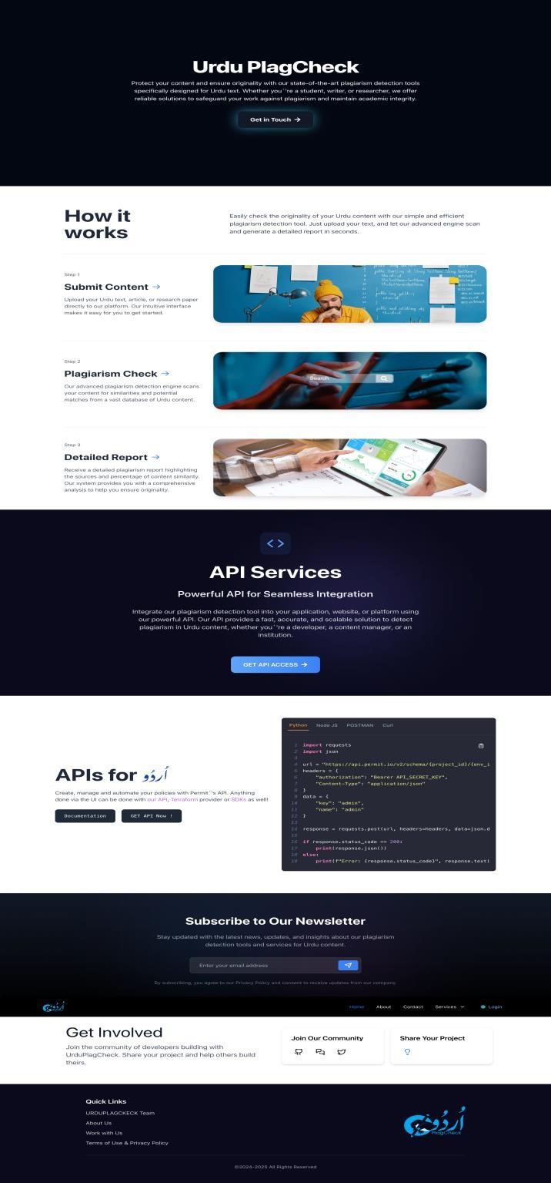
Figure 91 Home Page

6.2 Contact Us:
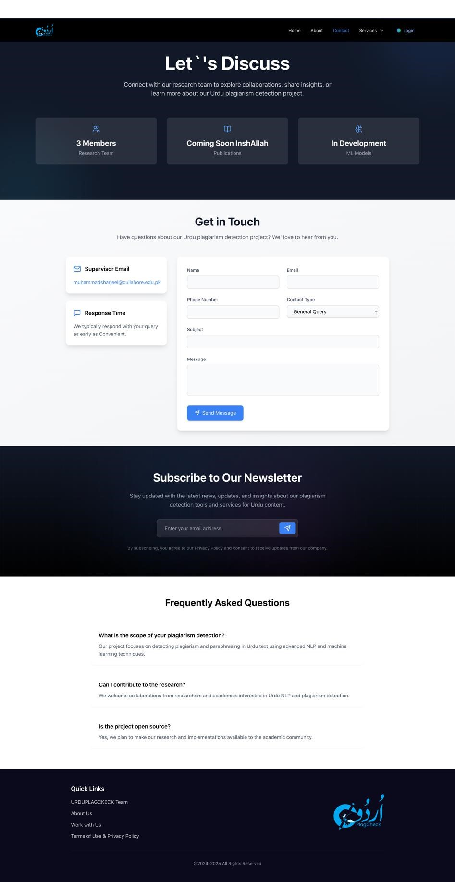
Figure 92 Contact us page

6.3 About:
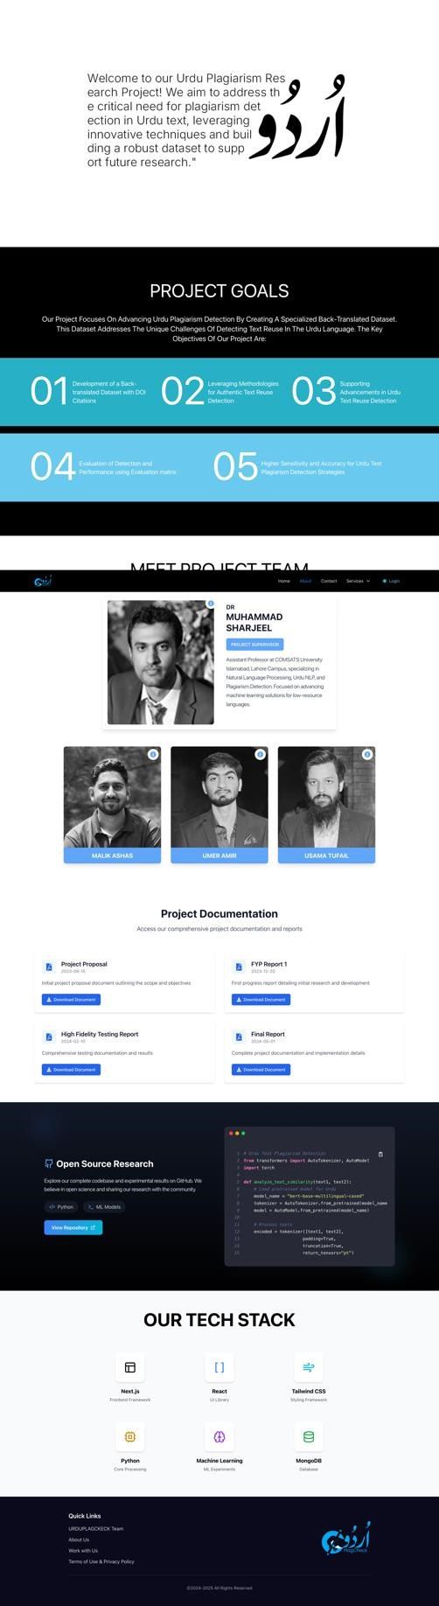
Figure 93 About Page

6.4 Login:
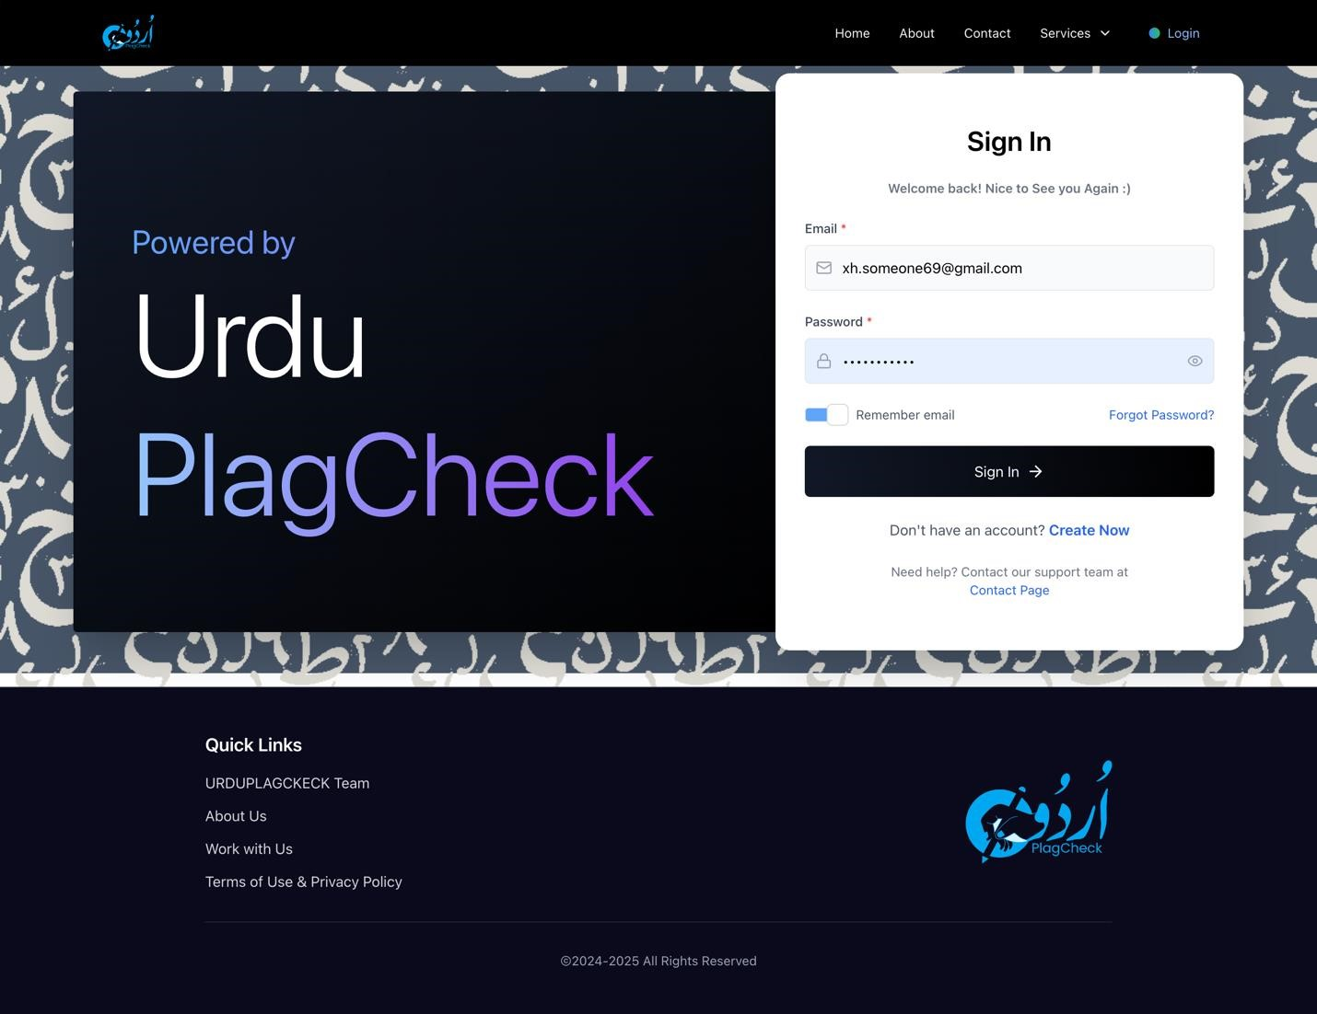
Figure 94 Login Page

6.5 Text Reuse Detection:
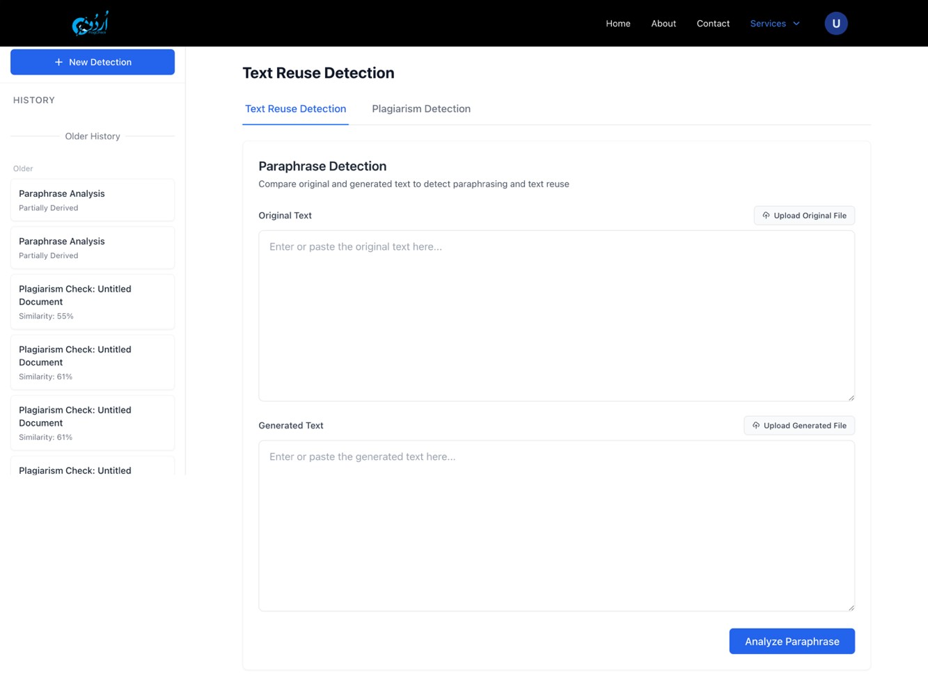
Figure 95 Text Reuse Detection

6.6 API Service:
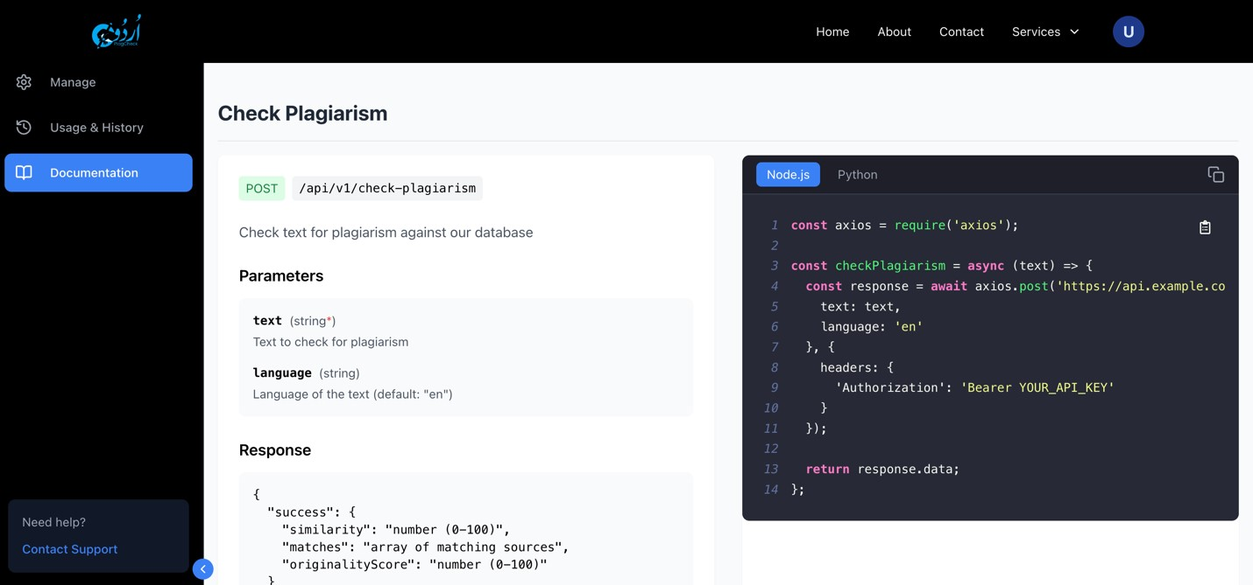
Figure 96 API Service

6.7 Plagiarism Detection:
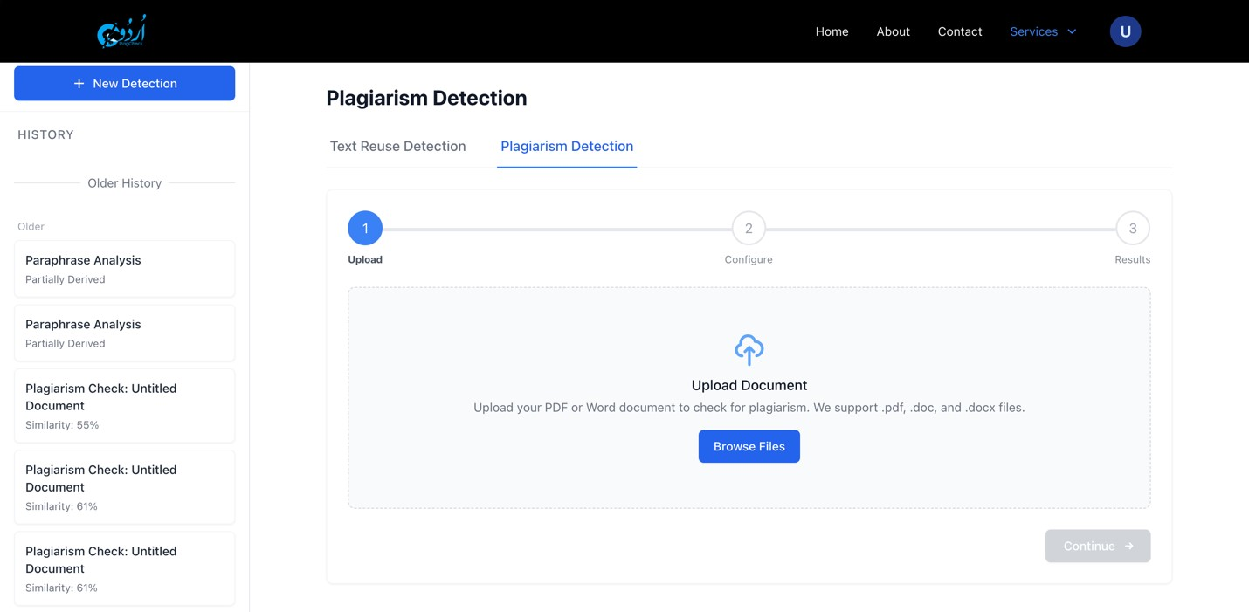
Figure 97 Plagiarism Detection

6.8 User Management:
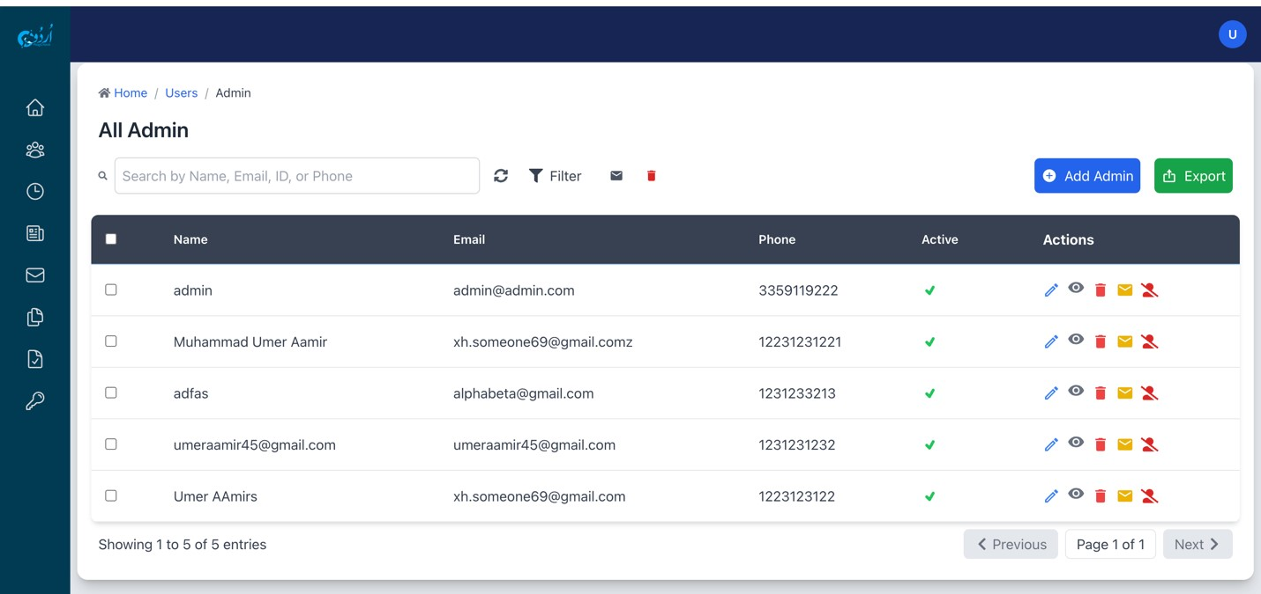
Figure 98 User Management

6.9 Admin Dashboard:
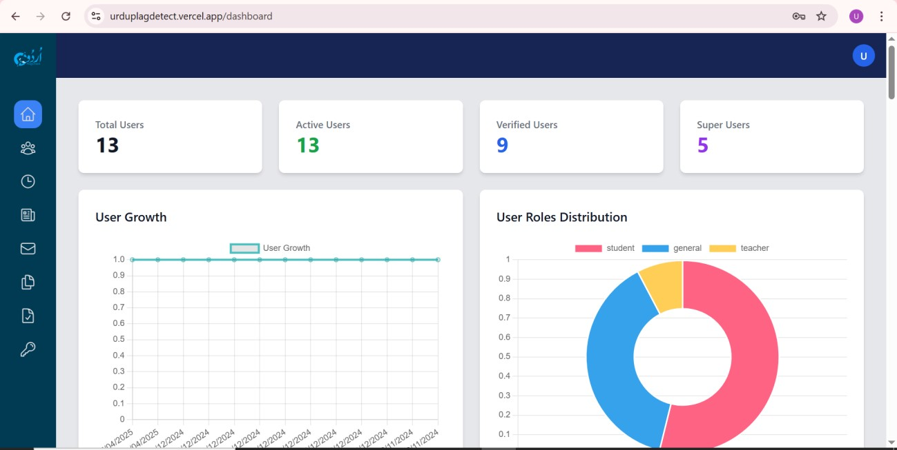
Figure 99 Admin Dashboard

References
[1]Areeba, “Medium,” Medium, 19 September 2024. [Online]. Available: https://medium.com/languagelab/urdu-a-rich-mix-of-multiple-languages-80d9027d9f5e.
- M. A. S. N. Shameem Yousuf, “A review of plagiarism detection based on Lexical and Semantic Approach,” in International Conference on Emerging Trends in Communication, Control, Signal Processing & Computing Applications (C2SPCA), 2013.
- M. A. M. S. Usman Khan, “Urdu Natural Language Processing Issues and Challenges: A Review Study,” Springer Nature, 2020.
- R. M. ,. A. A. R. ,. S.-U. H. Hafiz Rizwan Iqbal, “Urdu paraphrase detection: A novel DNN-based implementation using a semi-automatically generated corpus,” Cambridge Press, 2023.
- I. M. M. S. M. A. A. R. M. A. N. Hamza Hafeez, “Urdu Short Paraphrase Detection at Sentence Level,” ACM, 2023.
- M. S. R. M. A. N. P. R. Sara Sameen, “Measuring Short Text Reuse For The Urdu Language,” IEEE, 2017.
[7]“Run AI,” [Online]. Available: https://www.run.ai/guides/gpu-deeplearning#:~:text=Why%20Use%20GPUs%20for%20Deep,without%20sacrificing%20efficiency%20 or%20power.

Plagiarism Report:

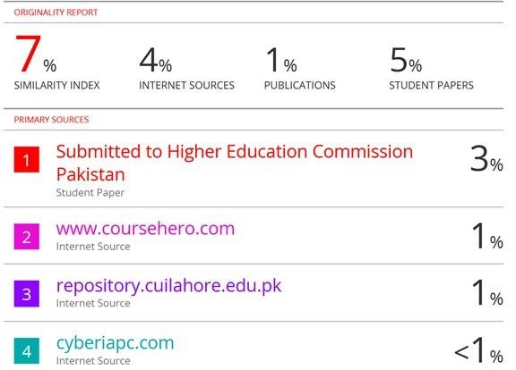
Figure 100 - Report

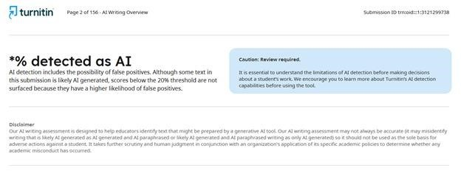
Figure 101- AI Report

